- Register the application with Twitter
  - Followed instructions from here: http://iag.me/socialmedia/how-to-create-a-twitter-app-in-8-easy-steps/
  - Note: You will have to verify your Twitter account with a phone number.
- Set up PHP Script
  - The script needs to be running an up to date version of PHP. If PHP is not up to date, you will not get any output.
  - I installed a MAMP server, which can be downloaded here: https://www.mamp.info/en/
  - Copy GetTweets.php to server
  - Download the TwitterAPIExchange.php from: https://github.com/J7mbo/twitter-api-php and copy it to the same folder as GetTweets.php. This makes the authorization work.
  - Alter GetTweets.php.
    - Add your keys to the settings array in lines 12 to 15.
    - Alter the searchon variable to be whatever you want to search on Twitter
      - Note: It must be one word or hashtag with no spaces
  - Run GetTweets.php. I found it easiest to run from Terminal or Putty, since there should be no output to the screen.
  - Output
    - The script will generate three output files in a folder called Data. Having this folder makes it easier to copy the files from application to application.
    - information.txt
      - Contains four lines of basic information: the word or hashtag that was searched on, the number of tweets that were found, and the dates and times of the first and last tweet
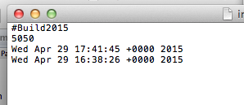
Example of information.txt
    - tweets.txt
      - Each tweet is on its own line. Any tweets containing line breaks are excluded so that the file does not get messed up.
      - Metadata pertaining to each tweet is tab delimited
      - Keeps track of date, user, number of retweets, number of favorites, and the text of the tweet
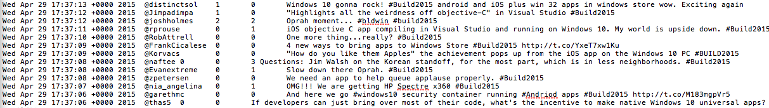
Example of tweets.txt

    - input.txt
      - Identical to tweets.txt, except the text of the tweet does not contain any punctuation to make it easier on the C++ application.
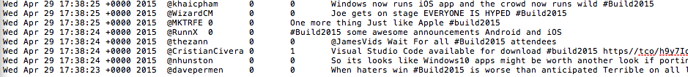
Example of input.txt

- Copy Data folder to C++ application
- Run C++ application
  - ignored_words.txt contains a list of all of the words that the application should ignore. This can be easily modified by adding words to the end of the text file
  - Sometimes, the C++ application will crash because too many entries get added to a hash table
    - There are a couple of lines of code in the main function that are there for testing. Uncomment these lines and find when you see the sudden spike in entries in the hash table. Remove that line from input.txt and tweets.txt
  - Data Structures
    - Hash Tables
      - Class was written by Dave Ferris
    - Heaps
      - I created a maximum heap template class that can be used to keep track of the top retweeted and favorited tweets
  - Output
    - All of these files will be written to the Data folder
    - information.txt
      - The first four lines remain identical to how it was when it was initially brought in from the PHP script
      - Additional lines are added to add the number of unique words, users, and hashtags that were found among the tweets
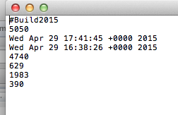
Example of updated information.txt

    - words.txt
      - Each line contains the top word, followed by a tab, and then a comma delimited list of the line numbers where the word is found
      - The closer the word is to the beginning of the file, the higher the rank of the word.
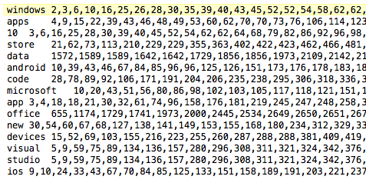
Example of words.txt

    - users.txt
      - Similar to words.txt
    - hashtags.txt
      - Similar to words.txt
    - mentions.txt
      - Similar to words.txt
    - retweets.txt
      - Contains lines of ordered pairs where the first number in the ordered pair represents the line number and the second number represents the number of retweets
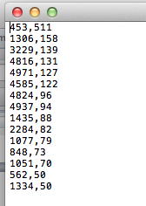
Example of retweets.txt

    - favorites.txt
      - Similar to favorites.txt
- Copy Data folder to C# application
- Run C# application

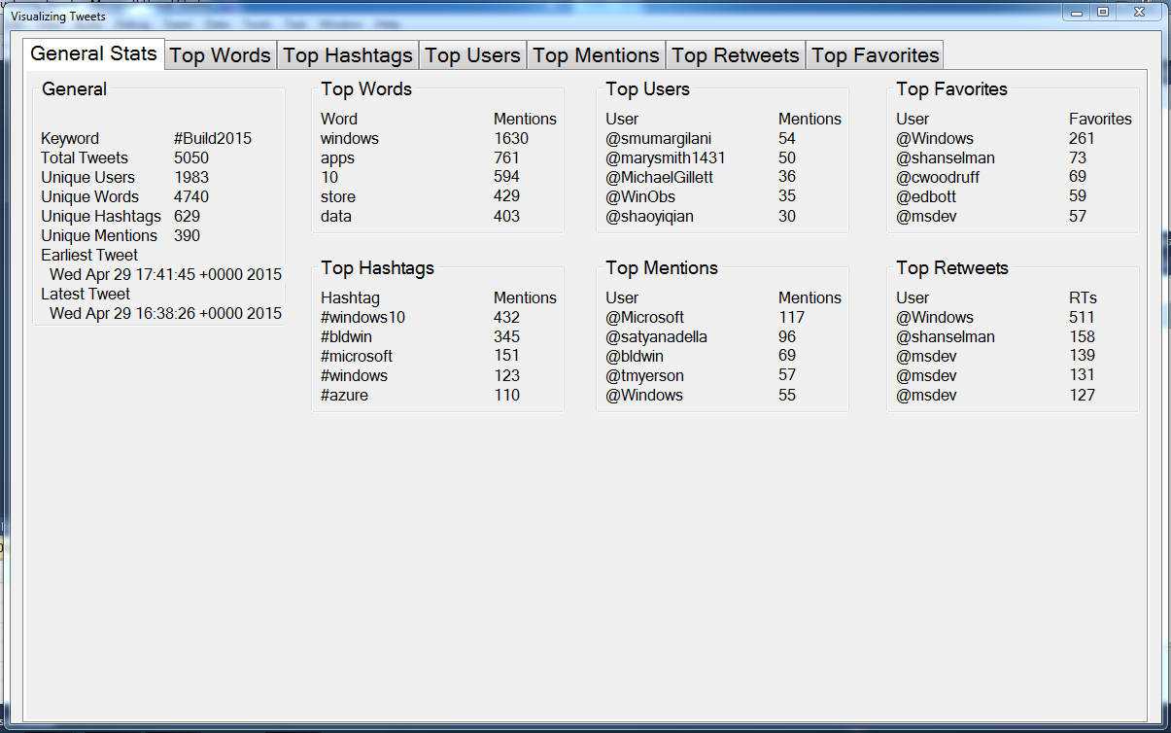
This is the main screen that will pop up when the application first opens. It gives an overview of the information that is presented in the application. If there is a problem opening any of the files a message box will pop up and the application will close.

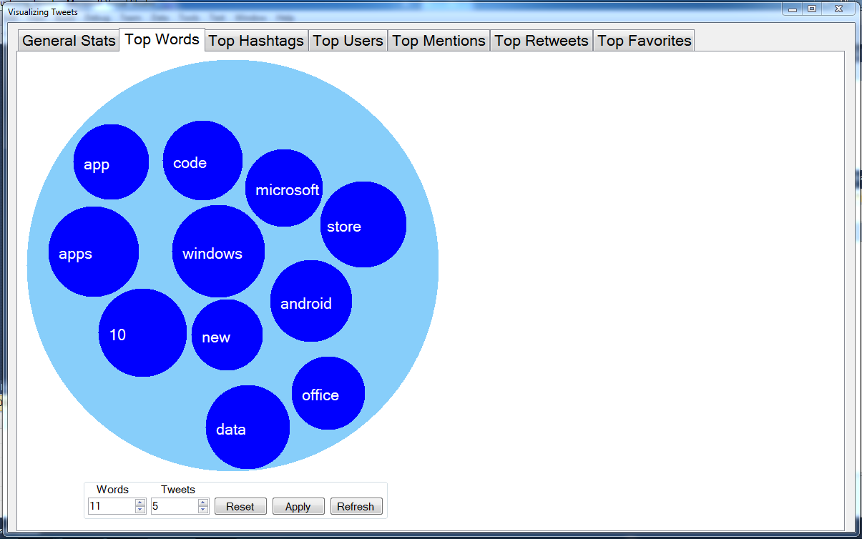
This is the Top Words tab. The Top Hashtags, Top Users, and Top Mentions tabs all work similar to this tab. By default, five words will be showing. You can use the controls at the bottom of the screen to adjust how many words you want to display. Clicking on the Reset button, will set everything back to its default.

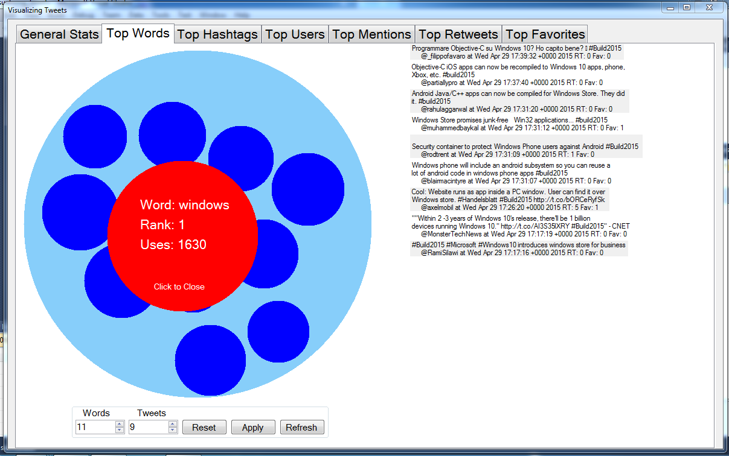
When you click on a word, a large red circle will appear and all of the other words will be hidden. The red circle will contain information about the word. On the right of the screen, tweets containing the word will appear. You can adjust the amount of tweets displayed using the control button at the bottom of the screen. You can click the Refresh button to get a new set of tweets.

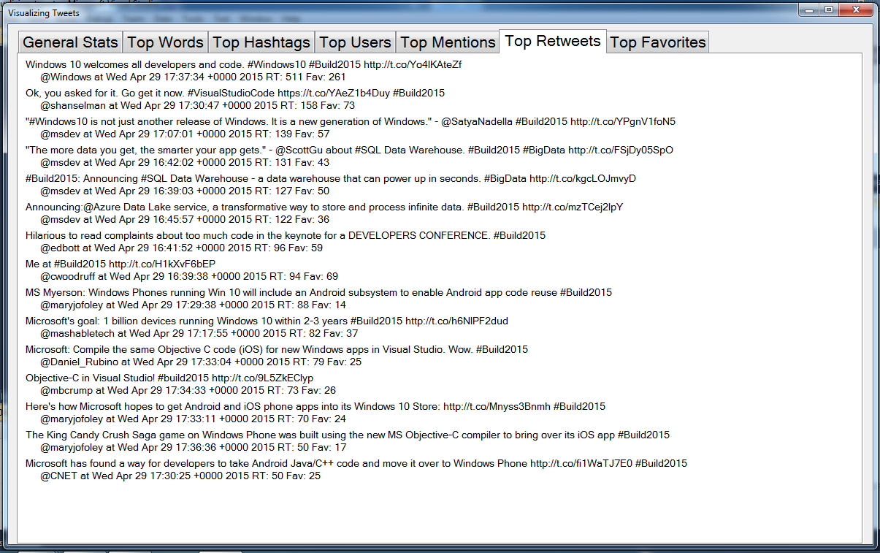
The Top Retweets tab provides a list of the most retweeted tweets that were recovered. The Top Favorites tab behaves similarly.

