Computer Science Project Showcase Application
Cody Schober
CSCI Senior Capstone
Dr. Pankratz
May 12, 2016

Table of Contents
Introduction 3
Definition of Project Requirements 3
Using this App 4
Installing on Android 4
From the Browser 4
From the Project Zip 4
How to Search 5
How to Bookmark 7
Modifying this App 8
Installing Android Studio 8
Opening the Project 8
Locations and Descriptions of Files 10
Running the App on the Emulator 11
Creating a New APK Build 13
Updating the Project Database 13
Project Code and Documentation 15
Models Directory Files 15
MainActivity.java 15
Results.java 20
BlogView.java 27
Bookmarks.java 32
ProjectModel.java 39
Drawable Files Directory 42
Side_nav_bar.xml 42
Layout Files Directory 42
Activity_blog_view.xml 42
Activity_main.xml 43
Activity_results.xml 44
App_bar_blog.xml 44
App_bar_main.xml 45
App_bar_result.xml 46
Content_blog_view.xml 47
Content_main.xml 47
Content_results.xml 51
Nav_header_main.xml 52
Result_list.xml 52
Menu Files Directory 53
Nav_bar.xml 53
Values File Directory 54
Colors.xml 54
Strings.xml 54
Project Defenses 56
Gantt Chart 59
Project Journal 60
April 7th Blog Entry 60
April 8th Blog Entry 61
April 9th Blog Entry 62
April 10th Blog Entry 69
April 11th Blog Entry 70
April 14th Blog Entry 70
April 17th Blog Entry 72
April 22nd Blog Entry 72
April 23rd Blog Entry 73
April 25th Blog Entry 74
April 26th Blog Entry 74
April 28th Blog Entry 75
May 1st Blog Entry 75
May 5th Blog Entry 76
May 8th Blog Entry 76
May 9th Blog Entry 76
May 10th Blog Entry 77
May 11th Blog Entry 77
Class Presentation 78
The Future of this Project 86
Things that Still Need to be Done 86
Things that Could be Done in the Future 87
Resume 89
Philosophy of Computer Science 93
Career and Future Plans 94
Relevant Links and Resources 95

Introduction
For over 15 years, Computer Science Seniors at St. Norbert College have tackled a large variety of Capstone projects. Within the CompSci02 server, there lies a vast wealth of information that future Seniors could very well utilize to help them advance their projects. However, due to the format of the website, it can be extremely difficult to search through and track down these projects.
That is where the Comp Sci Project Search application for Android comes in.
The goal of this application is to give students a tool to help them search through the Comp Sci Project sites based on search terms that they define.

Definition of Project Requirements
Project Summary: Develop an Android Application that can search, view, and save Senior Project Sites.

General Requirements:
- Include a browsing feature.
- Easily search on year, student, and topic (and if possible, keyword as well).
- Book mark feature.
- Pay attention to the UI.
- Easily expandable to additional years.

Using this App

Installing on Android

From the Browser
- Go to http://compsci02.snc.edu/cs460/2016/schocm/project.html
- Navigate to the area with a picture listing “Download the App”. It should be the picture on the left.

- Tap on the picture to begin the download.
  - If you are downloading the application over an Android device, tapping on the file once the download has completed will start the installation process.
  - If you are not downloading the application over your phone, you will need to move the file onto your phone.

From the Project Zip
- Navigate to the root of the Project Directory
- Move the file labeled “app.apk” to a location of your choosing on your android device.
- Navigate to it on the Android device, and tap it to begin the installation.

How to Search
There are four different search parameters someone can apply when using the application. If a user wishes to bring up all of the results at once, leave the search fields blank, and select “Let’s Find It!”. Users can enter part of a word or a phrase in order to bring up all results that contain that word or phrase. If the user wants to clear out all of the fields while using the search, tapping on “Clear Fields” will make this happen.
There are two search fields that need a little more explaining than the others. The first is the Year field. As the user may notice, there are two parts to the Year search: Start Year, and End Year. Leaving these fields blank will search all years. If a user enters a value in only for start year, the application will bring up all projects from that date onwards. Likewise, if a user enters a value for End Year and leaves Start Year blank, all projects up until the given year will be displayed. Entering values for both fields will bring up all projects between those two years, and entering the same value for both fields will bring up all projects in that individual year.
The second field that requires some explanation is the Keywords field. Given how the JSON database is formatted, users are more likely to find results entering a single word rather than a whole phrase. This is because most of the keyword phrases have been broken up into individual keywords. There are some phrases stored in the database, but a user is more likely to get their desired results entering a single keyword rather than a phrase.
When a user finds a project that they want to view, all they need to do is tap on the list item to view it. A Web View will be brought up within the app that will display the project site.
If a user wishes to navigate back to the Search page, they can either navigate to it using the back button, or they can tap the hamburger in the top left corner to bring up the navigation drawer. Tapping on the item labeled “Home” will take the user back to the Search page.

How to Bookmark
If a user finds a site that they wish to save, they only need to tap the star in the bottom right corner. If the user has already bookmarked the site, tapping on the icon again will cause that bookmark to be removed. Currently, there is no way to effectively manage bookmarks, such as ordering them, removing them from the Bookmarks page, and being able to put certain bookmarks in the navigation drawer.
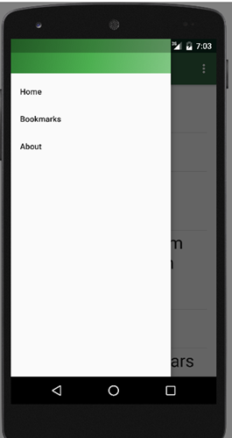
To view the bookmarks saved on the app, tap on the hamburger on the top left corner and select “Bookmarks” from the given list. The user will then be taken to a list similar in appearance and functionality as the Search Results page. All bookmarks are displayed in the order that they are saved, and tapping on the bookmark list item will take the user to the website.

Modifying this App

Installing Android Studio
- Go to the Android Studio website (Link can be found in the “Relevant Links and Resources” section)
- Select “Download Android Studio for Windows”. The download itself is free and does not require any registration or payment to use.
- Once the download is complete, run the executable and follow the installation instructions.

Opening the Project
- Open Android Studio
- Select File > Open

- Navigate to the file location for the project folder, and select it. Either double click on the project, or select “Open” at the bottom of the window to open the project.

Locations and Descriptions of Files
Manifests – Defines the home activity and the names for each activity as they are loaded.
Java – Contains all of the java files that build and run the app.
Res drawable – Contains all of the custom-defined shapes in the app
Res layout – Holds layouts that are used throughout the various app activities.
Res Menu – Holds menu definitions that are used within the app
Res Mipmap – Holds the app icon definitions (What you see on your phone and the icon you would tap to load the app).
Res Values – Holds defined settings, themes, and values that are used across the entire app.

Running the App on the Emulator
Run Run

OR

Tap on the Green Play Button on the top toolbar

To create a new emulator session, select “Launch Emulator” at the bottom of the dialog, and select which Android Virtual Device Build you would like to use.

If your emulator is already running, select it and press OK

Creating a New APK Build
Go to the top toolbar, select “Build” and then go down to “Build APK”

Updating the Project Database
- Open and Log in WinSCP
- Navigate to /usr/local/data/html/cs460/2016/schocm/Project and open “database.txt”

- Scroll to the end of the file, and add your project in the following format:
{
Previous Project…
}, The comma after the previous project is essential
{
"author" : "student name",
"year" : year,
"topic" : "project name",
"url" : "url to project’s main page",
"keywords" : "separate each keyword using commas"
}
The user will need the ability to write to and modify the database in the project site directory in order to add projects to it.
- When done adding projects, save the file and exit out of it.
  - As a warning, ensure that the file is still in the proper JSON format when done adding your projects. If it isn’t, the application will break when it tries to parse the database into JSON.

Project Code and Documentation

Models Directory Files

MainActivity.java
/*
File Name: MainActivity.java
Purpose: Sets up the Search Page Activity, Contains function calls to the navigation drawer and to go to the Results Page
Related Files Used: activity_main.xml, content_main.xml, app_bar_main.xml
Activities Accessed: Bookmarks.java, Results.java
Listed Functions: ToResults, OnCreate, onBackPressed, onNavigationItemSelected
Other Notes: This is the Home Activity, as in this is the first activity that is loaded when the user boots up the app
*/
package com.example.codys.compsciproject;
import android.content.Context;
import android.content.ContextWrapper;
import android.content.Intent;
import android.os.Bundle;
import android.view.View;
import android.support.design.widget.NavigationView;
import android.support.v4.view.GravityCompat;
import android.support.v4.widget.DrawerLayout;
import android.support.v7.app.ActionBarDrawerToggle;
import android.support.v7.app.AppCompatActivity;
import android.support.v7.widget.Toolbar;
import android.view.MenuItem;
import android.widget.EditText;
import android.widget.Toast;
import java.io.File;
import java.io.FileOutputStream;
import java.io.IOException;
public class MainActivity extends AppCompatActivity
implements NavigationView.OnNavigationItemSelectedListener
{
/*
Function Name: ToResults
Purpose: When the "Go To Results" button is pressed, this function creates a bundle, loads all the values from the
search fields into the bundle, and then calls the Results activity while sending the bundle on to Results
Function Type: Void
Parameters Used: View x(Refers to content_main and the fields in it, and x is a placeholder for the second view word
as to avoid confusion with this explanation)
Related Files: content_main.xml, Results.java
Other Notes: A warning is raised with all of the uses of the EditText variable current in if statements. These
warnings have been handled with the catch loop towards the end.
*/
public void ToResults(View view)
{
EditText current = null;
Bundle ResBund = new Bundle();
try
{
/* ResBund.putInt and ResBund.putString refer to taking the value held in the given field and adding it to the
ResBund bundle defined above. After the try block, it will be packaged with the Results activity and
called with it.
*/
// Grab the start year EditText field
current = (EditText) findViewById(R.id.startyear);
if (current.getText().toString().trim().length() == 0)
ResBund.putInt("SEARCH_YEARSTART", 0);
else
ResBund.putInt("SEARCH_YEARSTART", Integer.parseInt(current.getText().toString()));
// Grab the end year EditText field
current = (EditText) findViewById(R.id.endyear);
if (current.getText().toString().trim().length() == 0)
ResBund.putInt("SEARCH_YEAREND", 9999);
else
ResBund.putInt("SEARCH_YEAREND", Integer.parseInt(current.getText().toString()));
// Grab the author EditText field
current = (EditText) findViewById(R.id.author);
if (current.getText().toString().trim().length() == 0)
ResBund.putString("SEARCH_STUDENT", " ");
else
ResBund.putString("SEARCH_STUDENT", current.getText().toString());
// Grab the project name EditText field
current = (EditText) findViewById(R.id.project_name);
if (current.getText().toString().trim().length() == 0)
ResBund.putString("SEARCH_TOPIC", " ");
else
ResBund.putString("SEARCH_TOPIC", current.getText().toString());
// Grab the keywords EditText field
current = (EditText) findViewById(R.id.keyword);
if (current.getText().toString().trim().length() == 0)
ResBund.putString("SEARCH_KEYWORD", " ");
else
ResBund.putString("SEARCH_KEYWORD", current.getText().toString());
}
catch(NullPointerException e)
{
e.printStackTrace();
}
Intent result_page = new Intent(this, Results.class);
result_page.putExtras(ResBund); // Package the bundle with the Results activity
startActivity(result_page); // Call the Results activity
}
/*
Function Name: ClearFields
Purpose: When the "Clear Fields" button has been pressed, set all of the EditText fields back to blank
Function Type: Void
Parameters Used: View x(Refers to content_main and the fields in it, and x is a placeholder for the second view word
as to avoid confusion with this explanation)
Related Files: content_main.xml
Other Notes: A warning is raised with all of the uses of the EditText variable current in if statements. These
warnings have been handled with the catch loop towards the end. In addition, this function is derived from
the ToResults function
*/
public void ClearFields(View view)
{
EditText current = null;
try
{
// Grab the start year EditText field
current = (EditText) findViewById(R.id.startyear);
if (current.getText().toString().trim().length() != 0)
current.setText("");
// Grab the end year EditText field
current = (EditText) findViewById(R.id.endyear);
if (current.getText().toString().trim().length() != 0)
current.setText("");
// Grab the author EditText field
current = (EditText) findViewById(R.id.author);
if (current.getText().toString().trim().length() != 0)
current.setText("");
// Grab the project name EditText field
current = (EditText) findViewById(R.id.project_name);
if (current.getText().toString().trim().length() != 0)
current.setText("");
// Grab the keywords EditText field
current = (EditText) findViewById(R.id.keyword);
if (current.getText().toString().trim().length() != 0)
current.setText("");
// Let the user know all fields have been cleared
Toast.makeText(getApplicationContext(), "All fields have been cleared",
Toast.LENGTH_LONG).show();
}
catch(NullPointerException e)
{
e.printStackTrace();
}
}
/*
Function Name: OnCreate
Purpose: Initializes the activity. Also, if the internal database does not exist, create it
Function Type: Void
Parameters Used: Bundle savedInstanceState (Refers to any data that was sent to this activity)
Related Files: content_main.xml, activity_main.xml, app_bar_main.xml, nav_bar.xml, bookmarks.txt
Other Notes:
*/
@Override
protected void onCreate(Bundle savedInstanceState)
{
super.onCreate(savedInstanceState);
// All we need to do is call activity_main, because it contains a call to content_main and app_bar_main as well
setContentView(R.layout.activity_main);
// Set up the toolbar at the top of the screen
Toolbar toolbar = (Toolbar) findViewById(R.id.toolbar);
setSupportActionBar(toolbar);
// Grab the navigation drawer to apply open and close functions to it
DrawerLayout drawer = (DrawerLayout) findViewById(R.id.drawer_layout);
ActionBarDrawerToggle toggle = new ActionBarDrawerToggle(
this, drawer, toolbar, R.string.navigation_drawer_open, R.string.navigation_drawer_close);
// Sets up the navigation drawer to detect when the user taps on the hamburger (three bars in the top left corner)
if(drawer != null)
drawer.addDrawerListener(toggle);
// Allows the drawer to be opened and closed
toggle.syncState();
// Sets the item click events for the navigation drawer
NavigationView navigationView = (NavigationView) findViewById(R.id.nav_view);
if(navigationView != null)
navigationView.setNavigationItemSelectedListener(this);
// This is the check to confirm a file exists
String filepath = "MyFileStorage";
ContextWrapper contextWrapper = new ContextWrapper(getApplicationContext());
File directory = contextWrapper.getDir(filepath, Context.MODE_PRIVATE);
File file = new File(directory, "bookmarks.txt");
//file.delete(); // Used during testing to clear the bookmarks file.
if(!file.exists())
{
// If the internal bookmarks file does not exist, create it
try
{
FileOutputStream bm_file_out = new FileOutputStream(file);
bm_file_out.close();
}
catch (IOException e)
{
e.printStackTrace();
}
}
}
/*
Function Name: onBackPressed
Purpose: If the navigation drawer is open, the back button will allow it to be closed
Function Type: Void
Parameters Used: None
Related Files: activity_main.xml, app_bar_main.xml, nav_bar.xml
Other Notes: None
*/
@Override
public void onBackPressed()
{
DrawerLayout drawer = (DrawerLayout) findViewById(R.id.drawer_layout);
if(drawer != null) {
if (drawer.isDrawerOpen(GravityCompat.START)) {
drawer.closeDrawer(GravityCompat.START);
} else {
super.onBackPressed();
}
}
}
/*
Function Name: onNavigationItemSelected
Purpose: Sets up Navigation Drawer item click events for the current activity
Function Type: Boolean
Parameters Used: MenuItem item (Refers to the navigation drawer that item that was selected)
Related Files: nav_bar.xml, activity_main.xml, app_bar_main.xml
Other Notes: The "Statement with empty body" warning does not cause any problems. Thus, the
warning is suppressed using the SuppressWarnings override at the beginning.
*/
@SuppressWarnings("StatementWithEmptyBody")
@Override
public boolean onNavigationItemSelected(MenuItem item)
{
// Gets the id of the menu item selected
int id = item.getItemId();
if (id == R.id.nav_search)
{
// If "Home" was selected, call the activity
Intent search_page = new Intent(this, MainActivity.class);
startActivity(search_page);
}
else if (id == R.id.nav_bookmarks)
{
// If "Bookmarks" was selected, call the activity
Intent bookmark_page = new Intent(this, Bookmarks.class);
startActivity(bookmark_page);
}
else if (id == R.id.nav_about)
{
// If "About" was selected, display the toast containing the app information
Toast.makeText(getApplicationContext(), R.string.about_string,
Toast.LENGTH_LONG).show();
}
// Grab the drawer itself
DrawerLayout drawer = (DrawerLayout) findViewById(R.id.drawer_layout);
// As long as the drawer exists, close it
if(drawer != null)
drawer.closeDrawer(GravityCompat.START);
return true;
}
}

Results.java
/*
File Name: Results.java
Purpose: Sets up the Results Page Activity, Contains function calls to the navigation drawer and to go to the Blog View page
Also contains threads and calls to the projects database stored on CompSci02.
Related Files Used: activity_results.xml, content_results.xml, app_bar_results.xml, result_list.xml
Activities Accessed: Bookmarks.java, BlogView.java, MainActivity.java
Listed Functions: OnCreate, onBackPressed, doInBackground, onPostExecute, ProjectAdapter, getView, onNavigationItemSelected
Other Notes: This file uses an adaption of the JSON parsing and list template methods presented by Hishaam Muneer in his
tutorial. Please see http://www.youtube.com/user/hishamdbnd for more information on how to do this
*/
package com.example.codys.compsciproject;
import android.content.Context;
import android.content.Intent;
import android.os.Bundle;
import android.support.design.widget.NavigationView;
import android.support.v4.view.GravityCompat;
import android.support.v4.widget.DrawerLayout;
import android.support.v7.app.ActionBarDrawerToggle;
import android.support.v7.app.AppCompatActivity;
import android.support.v7.widget.Toolbar;
import android.view.LayoutInflater;
import android.os.AsyncTask;
import android.view.MenuItem;
import android.view.View;
import android.view.ViewGroup;
import android.widget.AdapterView;
import android.widget.ArrayAdapter;
import android.widget.ListView;
import android.widget.TextView;
import android.widget.Toast;
import com.example.codys.compsciproject.models.ProjectModel;
import org.json.JSONArray;
import org.json.JSONException;
import org.json.JSONObject;
import java.io.BufferedReader;
import java.io.IOException;
import java.io.InputStream;
import java.io.InputStreamReader;
import java.net.HttpURLConnection;
import java.net.URL;
import java.util.ArrayList;
import java.util.List;
public class Results extends AppCompatActivity
implements NavigationView.OnNavigationItemSelectedListener{
private ListView ResultList;
private int search_yearstart;
private int search_yearend;
private String search_student;
private String search_topic;
private String search_keyword;
/*
Function Name: OnCreate
Purpose: Initializes the activity. Also, if the internal database does not exist, create it
Function Type: Void
Parameters Used: Bundle savedInstanceState (Refers to any data that was sent to this activity)
Related Files: content_results.xml, activity_results.xml, app_bar_results.xml, nav_bar.xml
Other Notes:
*/
@Override
protected void onCreate(Bundle savedInstanceState)
{
super.onCreate(savedInstanceState);
// All we need to do is call activity_results, because it contains a call to content_results and app_bar_results as well
setContentView(R.layout.activity_results);
// Set up the toolbar at the top of the screen
Toolbar toolbar = (Toolbar) findViewById(R.id.toolbar);
setSupportActionBar(toolbar);
// Grab the navigation drawer to apply open and close functions to it
DrawerLayout drawer = (DrawerLayout) findViewById(R.id.drawer_layout);
ActionBarDrawerToggle toggle = new ActionBarDrawerToggle(
this, drawer, toolbar, R.string.navigation_drawer_open, R.string.navigation_drawer_close);
// Sets up the navigation drawer to detect when the user taps on the hamburger (three bars in the top left corner)
if(drawer != null)
drawer.addDrawerListener(toggle);
// Sets the item click events for the navigation drawer
NavigationView navigationView = (NavigationView) findViewById(R.id.nav_view);
if(navigationView != null)
navigationView.setNavigationItemSelectedListener(this);
// Allows the drawer to be opened and closed
toggle.syncState();
// Grabs the list from content_results.xml
ResultList = (ListView)findViewById(R.id.ProjectResults);
// Get the bundle sent to it by MainActivity and load it into the variables
Bundle fromMain = getIntent().getExtras();
search_yearstart = fromMain.getInt("SEARCH_YEARSTART");
search_yearend = fromMain.getInt("SEARCH_YEAREND");
search_student = fromMain.getString("SEARCH_STUDENT");
search_topic = fromMain.getString("SEARCH_TOPIC");
search_keyword = fromMain.getString("SEARCH_KEYWORD");
// Execute new JSON thread, sending the url to it
new JSONTask().execute("http://compsci02.snc.edu/cs460/2016/schocm/Project/database.txt");
}
/*
Function Name: onBackPressed
Purpose: If the navigation drawer is open, the back button will allow it to be closed
Function Type: Void
Parameters Used: None
Related Files: activity_results.xml, app_bar_results.xml, nav_bar.xml
Other Notes: None
*/
@Override
public void onBackPressed()
{
DrawerLayout drawer = (DrawerLayout) findViewById(R.id.drawer_layout);
if(drawer != null) {
if (drawer.isDrawerOpen(GravityCompat.START)) {
drawer.closeDrawer(GravityCompat.START);
} else {
super.onBackPressed();
}
}
}
/*
Class Name: JSONTask
Purpose: Contains the foreground and background threads for the database accessing, parsing, and list loading
Related Files: content_blog_view.xml, activity_blog_view.xml, result_list.xml, database.txt (on CompSci02)
*/
public class JSONTask extends AsyncTask<String, String, List<ProjectModel> >
{
/*
Function Name: doInBackground
Purpose: Runs before PostExecute, accesses the external project database held on CompSci02 and parses it
Function Type: List<ProjectModel>
Parameters Used: String... params (Contains the parameters sent to it by the AsyncTask)
Related Files: content_results.xml, activity_results.xml, result_list.xml
Other Notes: The function type is List<ProjectModel> because it returns the filtered ProjectModel list to the
foreground thread. AsyncTask is the Android method used to establish a foreground and background thread.
*/
@Override
protected List<ProjectModel> doInBackground(String... params)
{
//HttpURLConnection is what Android uses to connect to an external source
HttpURLConnection connection = null;
BufferedReader reader = null;
try
{
// Set up and connect to the url we defined
URL url = new URL(params[0]);
connection = (HttpURLConnection) url.openConnection();
connection.connect();
// Set up the stream to get data from the database
InputStream stream = connection.getInputStream();
reader = new BufferedReader(new InputStreamReader(stream));
StringBuilder buffer = new StringBuilder();
String line;
// As long as there is information in database.txt, read it in
while ((line = reader.readLine()) != null)
{
buffer.append(line);
}
// Convert the information we read in from database.txt into a string
String finalJson = buffer.toString();
// Convert the information into JSON
JSONObject parentObject = new JSONObject(finalJson);
// Split the JSON information up into an array
JSONArray parentArray = parentObject.getJSONArray("projects");
// FoundProjects is what will be returned to the foreground thread
List<ProjectModel> FoundProjects = new ArrayList<>();
ProjectModel current;
// Go through each item in the JSON Array
for(int i=0; i<parentArray.length(); i++)
{
// Load the current JSON object into ProjectModel
JSONObject finalObject = parentArray.getJSONObject(i); // Grabs all of the variables with each project entry
current = new ProjectModel();
current.setAuthor(finalObject.getString("author"));
current.setYear(finalObject.getInt("year"));
current.setTopic(finalObject.getString("topic"));
current.setUrl(finalObject.getString("url"));
current.setKeywords(finalObject.getString("keywords"));
// Take the search terms from MainActivity and see if we should add the current ProjectModel to
// the list to send to the foreground thread.
if(current.getTopic().toLowerCase().contains(search_topic.toLowerCase()) || search_topic.equals(" "))
{
if(current.getAuthor().toLowerCase().contains(search_student.toLowerCase()) || search_student.equals(" "))
{
if(current.getKeywords().toLowerCase().contains(search_keyword.toLowerCase()) || search_keyword.equals(" "))
{
if(current.getYear() <= search_yearend && current.getYear() >= search_yearstart)
{
FoundProjects.add(current);
}
}
}
}
}
return FoundProjects;
}
catch (IOException | JSONException e)
{
e.printStackTrace();
}
finally
{
// Close any remaining open streams
if(connection != null)
connection.disconnect();
try
{
if(reader != null)
reader.close();
}
catch (IOException e)
{
e.printStackTrace();
}
}
// The null is returned only if we failed to open the file
return null;
}
/*
Function Name: onPostExecute
Purpose: Runs after the thread parsing the projects JSON database is done. Calls ProjectAdapter and
loads the resulting item entries into the list in content_results.xml. Also sets the onClick
event for each of the items in the list.
Function Type: Void
Parameters Used: List<ProjectModel> result (Contains the parsed and filtered results from the background thread)
Related Files: content_results.xml, activity_results.xml, result_list.xml
Other Notes: This function runs when the background thread is done.
*/
@Override
protected void onPostExecute(final List<ProjectModel> result)
{
super.onPostExecute(result);
// Call ProjectAdapter and set up the list with the result_list.xml template and the project information
ProjectAdapter adapter = new ProjectAdapter(getApplicationContext(), R.layout.result_list, result);
ResultList.setAdapter(adapter);
ResultList.setOnItemClickListener(new AdapterView.OnItemClickListener()
{
/*
Function Name: onItemClick
Purpose: Bundles the information for each project with its corresponding list item, and sets the call to BlogView
for each of the items
Function Type: Void
Parameters Used: AdapterView<?> parent (). View x (), int position, long id
Related Files: content_results.xml, activity_results.xml, result_list.xml
Other Notes: This function does run on every item in the list in content_results.xml
*/
@Override
public void onItemClick(AdapterView<?> parent, View view, int position, long id)
{
// Get the project at the listed position
ProjectModel thisProject = result.get(position);
Intent intent = new Intent(Results.this, BlogView.class);
Bundle BlogBund = new Bundle();
// Bundle all of the project information with the given list item
BlogBund.putString("LIST_PROJECT", thisProject.getTopic());
BlogBund.putString("LIST_URL", thisProject.getUrl());
BlogBund.putInt("LIST_YEAR", thisProject.getYear());
BlogBund.putString("LIST_NAME", thisProject.getAuthor());
// Send the project information on to BlogView
intent.putExtras(BlogBund);
startActivity(intent);
}
});
}
}
/*
Class Name: ProjectAdapter
Purpose: Contains the ProjectAdapter definition, and is responsible for loading information into the
list in content_results
Related Files: content_results.xml, activity_results.xml, result_list.xml
Other Notes: To help the reader understand what an ArrayAdapter is, when a list of scrollable items is
displayed, such as the one we have in this activity, the data is populated into it using an adapter.
The ArrayAdapter utilizes ListView and ArrayList in order to populate a list with a defined data
source or template. In this case, it is the template defined in result_list.xml
*/
public class ProjectAdapter extends ArrayAdapter<ProjectModel>
{
public List<ProjectModel> AllProjects; // The list of projects
private int resource; // The list item index
private LayoutInflater inflater; // Contains the custom list item template we defined
public ProjectAdapter(Context context, int resource, List<ProjectModel> objects)
{
super(context, resource, objects);
AllProjects = objects;
this.resource = resource;
inflater = (LayoutInflater)getSystemService(LAYOUT_INFLATER_SERVICE);
}
/*
Function Name: getView
Purpose: Takes the results of the JSON parsing, loads it into the template defined in result_list, and loads
a copy into each slot of the list in content_results.xml
Function Type: View
Parameters Used: int position (The index in the list in content_results.xml), view convertView
(contains result_list.xml), ViewGroup parent (contains a reference to the main view for
Results, and all sub references including the one to result_list.xml)
Related Files: result_list.xml, activity_results.xml, content_results.xml
Other Notes: While it contains no for loop, it executes on every item within AllProjects
*/
@Override
public View getView(int position, View convertView, ViewGroup parent)
{
if(convertView == null)
convertView = inflater.inflate(resource, null);
// Text fields from result_list.xml
TextView project_title;
TextView student_name;
TextView year_value;
// Grab each of the fields in result_list.xml
project_title = (TextView)convertView.findViewById(R.id.project_title);
student_name = (TextView)convertView.findViewById(R.id.student_name);
year_value = (TextView)convertView.findViewById(R.id.grad_year);
// Take the information from the projects and load them into the fields in result_list.xml
if(project_title != null)
project_title.setText(AllProjects.get(position).getTopic());
if(student_name != null)
student_name.setText(AllProjects.get(position).getAuthor());
if(year_value != null)
year_value.setText(String.valueOf(AllProjects.get(position).getYear()));
// Send the project's version of result_list back to onPostExecute
return convertView;
}
}
/*
Function Name: onNavigationItemSelected
Purpose: Sets up Navigation Drawer item click events for the current activity
Function Type: Boolean
Parameters Used: MenuItem item (Refers to the navigation drawer that item that was selected)
Related Files: nav_bar.xml, activity_results.xml, app_bar_results.xml
Other Notes: The "Statement with empty body" warning does not cause any problems. Thus, the
warning is suppressed using the SuppressWarnings override at the beginning.
*/
@SuppressWarnings("StatementWithEmptyBody")
@Override
public boolean onNavigationItemSelected(MenuItem item)
{
// Gets the id of the menu item selected
int id = item.getItemId();
if (id == R.id.nav_search)
{
// If "Home" was selected, call the activity
Intent search_page = new Intent(this, MainActivity.class);
startActivity(search_page);
}
else if (id == R.id.nav_bookmarks)
{
// If "Bookmarks" was selected, call the activity
Intent bookmark_page = new Intent(this, Bookmarks.class);
startActivity(bookmark_page);
}
else if (id == R.id.nav_about)
{
// If "About" was selected, display the toast containing the app information
Toast.makeText(getApplicationContext(), R.string.about_string,
Toast.LENGTH_LONG).show();
}
// Grab the drawer itself
DrawerLayout drawer = (DrawerLayout) findViewById(R.id.drawer_layout);
// As long as the drawer exists, close it
if(drawer != null)
drawer.closeDrawer(GravityCompat.START);
return true;
}
}

BlogView.java
/*
File Name: BlogView.java
Purpose: Sets up the Blog View Activity, Contains function calls to the navigation drawer and displaying the website
Related Files Used: activity_blog_view.xml, content_blog_view.xml, app_bar_blog_view.xml
Activities Accessed: Bookmarks.java, MainActivity.java
Listed Functions: OnCreate, shouldOverrideUrlLoading, SavePage, onNavigationItemSelected
Other Notes: Originally, this displayed a fragment. However, I was able to change it so that the blog was displayed
within the content_blog_view file instead of the fragment.
*/
package com.example.codys.compsciproject;
import android.annotation.SuppressLint;
import android.content.Context;
import android.content.ContextWrapper;
import android.content.Intent;
import android.os.Bundle;
import android.support.design.widget.NavigationView;
import android.support.v4.view.GravityCompat;
import android.support.v4.widget.DrawerLayout;
import android.support.v7.app.ActionBarDrawerToggle;
import android.support.v7.app.AppCompatActivity;
import android.support.v7.widget.Toolbar;
import android.view.MenuItem;
import android.view.View;
import android.webkit.WebSettings;
import android.webkit.WebView;
import android.webkit.WebViewClient;
import android.widget.Toast;
import java.io.BufferedReader;
import java.io.File;
import java.io.FileInputStream;
import java.io.FileNotFoundException;
import java.io.FileOutputStream;
import java.io.IOException;
import java.io.InputStreamReader;
public class BlogView extends AppCompatActivity
implements NavigationView.OnNavigationItemSelectedListener{
String url; // Url of the project site
String project; // Name of the project
int year; // Year of the project
String author; // Author of the project
WebView blogView; // WebView that the blog will be displayed in
/*
Function Name: OnCreate
Purpose: Initializes the activity.
Function Type: Void
Parameters Used: Bundle savedInstanceState (Refers to any data that was sent to this activity)
Related Files: content_blog_view.xml, activity_blog_view.xml, app_bar_blog_view.xml, nav_bar.xml, bookmarks.txt
Other Notes: SetJavaScript is suppressed to prevent the warning on enabling javascript in the webview from
popping up. The warning does not indicate a major problem, nor is it even a problem.
*/
@SuppressLint("SetJavaScriptEnabled")
@Override
protected void onCreate(Bundle savedInstanceState) {
super.onCreate(savedInstanceState);
// All we need to do is call activity_blog_view, because it contains a call to content_blog_view and app_bar_blog_view as well
setContentView(R.layout.activity_blog_view);
// Grabs the data from Results / Bookmarks and loads it into the activity variables
Bundle fromList = getIntent().getExtras();
url = fromList.getString("LIST_URL");
project = fromList.getString("LIST_PROJECT");
year = fromList.getInt("LIST_YEAR");
author = fromList.getString("LIST_NAME");
// Captures the webview held in content_blog_view.xml
blogView = (WebView)findViewById(R.id.webView);
// Set the settings for webview
if(blogView != null)
{
blogView.setWebViewClient(new CustomWebViewClient());
WebSettings webSetting = blogView.getSettings();
webSetting.setJavaScriptEnabled(true); // Enable javascript on the websites
webSetting.setBuiltInZoomControls(true); // Allow zoom in/out methods
webSetting.setUseWideViewPort(true); // Shows the website as it would in the browser
webSetting.setLoadWithOverviewMode(true); // Load the site completely zoomed out
blogView.loadUrl(url);
}
// Set up the toolbar at the top of the screen
Toolbar toolbar = (Toolbar) findViewById(R.id.toolbar);
setSupportActionBar(toolbar);
// Grab the navigation drawer to apply open and close functions to it
DrawerLayout drawer = (DrawerLayout) findViewById(R.id.drawer_layout);
ActionBarDrawerToggle toggle = new ActionBarDrawerToggle(
this, drawer, toolbar, R.string.navigation_drawer_open, R.string.navigation_drawer_close);
// Sets up the navigation drawer to detect when the user taps on the hamburger (three bars in the top left corner)
if(drawer != null)
drawer.addDrawerListener(toggle);
// Sets the item click events for the navigation drawer
NavigationView navigationView = (NavigationView) findViewById(R.id.nav_view);
if(navigationView != null)
navigationView.setNavigationItemSelectedListener(this);
// Allows the drawer to be opened and closed
toggle.syncState();
}
/*
Class Name: CustomWebViewClient
Purpose: Contains the call to open the website
Related Files: content_blog_view.xml, activity_blog_view.xml
*/
private class CustomWebViewClient extends WebViewClient
{
/*
Function Name: shouldOverrideUrlLoading
Purpose: Loads the website within the web view component in content_blog_view.xml
Function Type: Boolean
Parameters Used: WebView view (Contains the ), String url (contains the url to the project site
Related Files: content_blog_view.xml, activity_blog_view.xml
Other Notes: The approach utilized for the blog view is based on the fragment approach.
Because I was able to implement the blog view within content_blog_view, I was able to cut down
on the amount of code and files used.
*/
@Override
public boolean shouldOverrideUrlLoading(WebView view, String url)
{
view.loadUrl(url);
return true;
}
}
/*
Function Name: onBackPressed
Purpose: If the navigation drawer is open, the back button will allow it to be closed. Otherwise, if
the user has navigated within the website they are viewing, the back button will take them to the
previous page.
Function Type: Void
Parameters Used: None
Related Files: activity_blog_view.xml, app_bar_blog_view.xml, nav_bar.xml, content_blog_view.xml
Other Notes: None
*/
@Override
public void onBackPressed()
{
DrawerLayout drawer = (DrawerLayout) findViewById(R.id.drawer_layout);
if(drawer != null && drawer.isDrawerOpen(GravityCompat.START))
drawer.closeDrawer(GravityCompat.START);
else if(blogView.canGoBack())
blogView.goBack();
else
super.onBackPressed();
}
/*
Function Name: SavePage
Purpose: When the picfab icon (The yellow circle with the star) is tapped in the bottom right corner of the screen,
the information with the blog is saved to the internal bookmarks text file.
Function Type: Void
Parameters Used: View x(Refers to content_main and the fields in it, and x is a placeholder for the second view word
as to avoid confusion with this explanation)
Related Files: bookmarks.txt, activity_blog_view.xml,
Other Notes:
*/
public void SavePage(View view)
{
try
{
String Result; // Will be used to grab each line from the file
String filepath = "MyFileStorage"; // Filepath to the internal database
ContextWrapper contextWrapper = new ContextWrapper(getApplicationContext()); // Grabs the process the app is running in
File directory = contextWrapper.getDir(filepath, Context.MODE_APPEND); // Sets a file to the path to where the actual database is stored
File file = new File(directory, "bookmarks.txt"); // Path to the actual database
FileInputStream bm_file_in = new FileInputStream(file); // Stream to get information from the file
InputStreamReader inputStreamReader = new InputStreamReader(bm_file_in);
BufferedReader buff_read = new BufferedReader(inputStreamReader);
StringBuilder buff_string = new StringBuilder();
// While there is information in the file, read it into the result string
while((Result = buff_read.readLine()) != null)
{
// Add the string to the buffer, then move on to the next
buff_string.append(Result);
buff_string.append("\r\n");
}
bm_file_in.close();
String finalJson = buff_string.toString(); // Convert the buffer to a string
String new_entry = "{" + project + ";" + url + ";" + author + ";" + Integer.toString(year) + "}" + "\r\n";
String to_toast;
// Check if the bookmark is already in the file. Since the url is a unique value with each project, this is what
// the program searches for.
if(finalJson.contains(url))
{
// If the file only had one entry in it, clear it. Otherwise, replace the entry in the string with a blank
to_toast = "Site has been removed from Bookmarks";
if(finalJson.trim().length() == 0)
finalJson = "";
else
finalJson = finalJson.replace(new_entry,"");
}
else
{
// If the bookmarks file was not empty, append the new entry onto what is there. Otherwise, set the new entry
// as the finalJson string.
to_toast = "Project successfully saved to Bookmarks";
if(finalJson.trim().length() != 0)
finalJson = finalJson + new_entry;
else
finalJson = new_entry;
}
if(file.delete()) // Clear the internal file
{
FileOutputStream bm_file_out = new FileOutputStream(file);
bm_file_out.write(finalJson.getBytes());
bm_file_out.close();
// Used for the purpose of testing, ensuring that everything is saved to the bookmarks file in the right format
/* Toast.makeText(getApplicationContext(), finalJson,
Toast.LENGTH_LONG).show(); */
Toast.makeText(getApplicationContext(), to_toast,
Toast.LENGTH_LONG).show();
}
else
{
Toast.makeText(getApplicationContext(), "Error, internal database cleaning was unsuccessful",
Toast.LENGTH_LONG).show();
}
}
catch (FileNotFoundException e)
{
e.printStackTrace();
}
catch (IOException e)
{
e.printStackTrace();
}
}
/*
Function Name: onNavigationItemSelected
Purpose: Sets up Navigation Drawer item click events for the current activity
Function Type: Boolean
Parameters Used: MenuItem item (Refers to the navigation drawer that item that was selected)
Related Files: nav_bar.xml, activity_blog_view.xml, app_bar_blog_view.xml
Other Notes: The "Statement with empty body" warning does not cause any problems. Thus, the
warning is suppressed using the SuppressWarnings override at the beginning.
*/
@SuppressWarnings("StatementWithEmptyBody")
@Override
public boolean onNavigationItemSelected(MenuItem item)
{
// Gets the id of the menu item selected
int id = item.getItemId();
if (id == R.id.nav_search)
{
// If "Home" was selected, call the activity
Intent search_page = new Intent(this, MainActivity.class);
startActivity(search_page);
}
else if (id == R.id.nav_bookmarks)
{
// If "Bookmarks" was selected, call the activity
Intent bookmark_page = new Intent(this, Bookmarks.class);
startActivity(bookmark_page);
}
else if (id == R.id.nav_about)
{
// If "About" was selected, display the toast containing the app information
Toast.makeText(getApplicationContext(), R.string.about_string,
Toast.LENGTH_LONG).show();
}
// Grab the drawer itself
DrawerLayout drawer = (DrawerLayout) findViewById(R.id.drawer_layout);
// As long as the drawer exists, close it
if(drawer != null)
drawer.closeDrawer(GravityCompat.START);
return true;
}
}

Bookmarks.java
/*
File Name: Bookmarks.java
Purpose: Sets up the bookmarks page, Contains function calls to the navigation drawer and to go to the Blog View activity
Related Files Used: activity_results.xml, content_results.xml, app_bar_results.xml, bookmarks.txt
Activities Accessed: Bookmarks.java, MainActivity.java, BlogView.java
Listed Functions: OnCreate, onBackPressed, doInBackground, onPostExecute, ProjectAdapter, getView, onNavigationItemSelected
Other Notes: Since both the Bookmarks and Results file are almost the same, with the exception of how data is accessed
and processed, the Results display and template files are used, cutting down on the amount of files used by half
*/
package com.example.codys.compsciproject;
import android.content.Context;
import android.content.ContextWrapper;
import android.content.Intent;
import android.os.Bundle;
import android.support.design.widget.NavigationView;
import android.support.v4.view.GravityCompat;
import android.support.v4.widget.DrawerLayout;
import android.support.v7.app.ActionBarDrawerToggle;
import android.support.v7.app.AppCompatActivity;
import android.support.v7.widget.Toolbar;
import android.view.LayoutInflater;
import android.os.AsyncTask;
import android.view.MenuItem;
import android.view.View;
import android.view.ViewGroup;
import android.widget.AdapterView;
import android.widget.ArrayAdapter;
import android.widget.ListView;
import android.widget.TextView;
import android.widget.Toast;
import com.example.codys.compsciproject.models.ProjectModel;
import java.io.BufferedReader;
import java.io.File;
import java.io.FileInputStream;
import java.io.IOException;
import java.io.InputStreamReader;
import java.util.ArrayList;
import java.util.Arrays;
import java.util.List;
public class Bookmarks extends AppCompatActivity
implements NavigationView.OnNavigationItemSelectedListener{
private ListView ResultList; // Contains the list from content_results.xml
private Boolean empty_bm; // Used as a flag, indicating if there are bookmarks or not
/*
Function Name: OnCreate
Purpose: Initializes the activity. Also, if the internal database does not exist, create it
Function Type: Void
Parameters Used: Bundle savedInstanceState (Refers to any data that was sent to this activity)
Related Files: content_main.xml, activity_main.xml, app_bar_main.xml, nav_bar.xml, bookmarks.txt
Other Notes: The use of the result files is not a typo or error. Please see the above
for more information.
*/
@Override
protected void onCreate(Bundle savedInstanceState)
{
super.onCreate(savedInstanceState);
// All we need to do is call activity_bookmarks, because it contains a call to content_main and app_bar_main as well
setContentView(R.layout.activity_results);
// Set up the toolbar at the top of the screen
Toolbar toolbar = (Toolbar) findViewById(R.id.toolbar);
setSupportActionBar(toolbar);
// Grab the navigation drawer to apply open and close functions to it
DrawerLayout drawer = (DrawerLayout) findViewById(R.id.drawer_layout);
ActionBarDrawerToggle toggle = new ActionBarDrawerToggle(
this, drawer, toolbar, R.string.navigation_drawer_open, R.string.navigation_drawer_close);
// Sets up the navigation drawer to detect when the user taps on the hamburger (three bars in the top left corner)
if (drawer != null)
drawer.addDrawerListener(toggle);
// Sets the item click events for the navigation drawer
NavigationView navigationView = (NavigationView) findViewById(R.id.nav_view);
if(navigationView != null)
navigationView.setNavigationItemSelectedListener(this);
// Allows the drawer to be opened and closed
toggle.syncState();
// List from content_results we will be storing the projects into
ResultList = (ListView) findViewById(R.id.ProjectResults);
// Set the bool indicating if there are bookmarks or not to false
empty_bm = false;
// Create the background thread to open and process the internal database
new JSONTask().execute();
}
/*
Function Name: onBackPressed
Purpose: If the navigation drawer is open, the back button will allow it to be closed
Function Type: Void
Parameters Used: None
Related Files: activity_main.xml, app_bar_main.xml, nav_bar.xml
Other Notes: The use of the result files is not a typo or error. Please see the
above for more information.
*/
@Override
public void onBackPressed()
{
DrawerLayout drawer = (DrawerLayout) findViewById(R.id.drawer_layout);
if (drawer != null) {
drawer.closeDrawer(GravityCompat.START);
} else {
super.onBackPressed();
}
}
/*
Class Name: JSONTask
Purpose: Contains the foreground and background threads for the database accessing, parsing, and list loading
Related Files: content_blog_view.xml, activity_blog_view.xml, result_list.xml, database.txt (on CompSci02)
*/
public class JSONTask extends AsyncTask<String, String, List<ProjectModel>>
{
/*
Function Name: doInBackground
Purpose: Runs before PostExecute, accesses the internal project database and sends it on to the foreground
Function Type: List<ProjectModel>
Parameters Used: String... params (Contains the parameters sent to it by the AsyncTask)
Related Files: content_results.xml, activity_results.xml, result_list.xml
Other Notes: The function type is List<ProjectModel> because it returns the filtered ProjectModel list to the
foreground thread. AsyncTask is the Android method used to establish a foreground and background thread.
This utilizes a method similar to what is outlined in Results, but is ultimately different due to what kind
of information is being accessed and what is being done with that information.
*/
@Override
protected List<ProjectModel> doInBackground(String... params)
{
try
{
String Result; // Will be used to grab each line from the file
String filepath = "MyFileStorage"; // Filepath to the internal database
ContextWrapper contextWrapper = new ContextWrapper(getApplicationContext()); // Grabs the process the app is running in
File directory = contextWrapper.getDir(filepath, Context.MODE_APPEND); // Sets a file to the path to where the actual database is stored
File file = new File(directory, "bookmarks.txt"); // Path to the actual database
FileInputStream bm_file_in = new FileInputStream(file); // Stream to get information from the file
InputStreamReader inputStreamReader = new InputStreamReader(bm_file_in);
BufferedReader buff_read = new BufferedReader(inputStreamReader);
StringBuilder buff_string = new StringBuilder();
// While we can get information from the file, read it into the buffer.
while ((Result = buff_read.readLine()) != null)
{
buff_string.append(Result);
buff_string.append("\r\n");
}
bm_file_in.close();
// Convert the buffer to a string.
String finalJson = buff_string.toString();
// As long as there are bookmarks, let's do something
if (finalJson.trim().length() != 0)
{
// Split up the string into an array based on the endline delimiter
List<String> bm_array = new ArrayList<>(Arrays.asList(finalJson.split("\\r?\\n")));
List<ProjectModel> FoundProjects = new ArrayList<>(); // List we will be sending on to the foreground thread
String current_line; // Stores the string in the bm_array we are currently looking at
String[] current_array; // Will be used to split up the information in current_line
ProjectModel current_project; // ProjectModel object that will hold the information for the project we are looking at
for (int i = 0; i < bm_array.size(); i++) {
current_line = bm_array.get(i); // Grabs all of the variables with each project entry
current_line = current_line.replace("{", ""); // Remove the left side bracket for the entry
current_line = current_line.replace("}", ""); // Remove the right side bracket for the entry
current_array = current_line.split(";"); // Split up the string into its individual values
// Load the project information into the ProjectModel
current_project = new ProjectModel();
current_project.setAuthor(current_array[2]);
current_project.setYear(Integer.parseInt(current_array[3]));
current_project.setTopic(current_array[0]);
current_project.setUrl(current_array[1]);
current_project.setKeywords("bookmarked");
// Add the current ProjectModel to the ProjectModel list
FoundProjects.add(current_project);
}
return FoundProjects;
}
}
catch(IOException e)
{
e.printStackTrace();
}
// If bookmarks is empty, set the bool to true
empty_bm = true;
return null;
}
/*
Function Name: onPostExecute
Purpose: Runs after the thread parsing the project in Bookmarks is done. Calls ProjectAdapter and
loads the resulting item entries into the list in content_results.xml. Also sets the onClick
event for each of the items in the list.
Function Type: Void
Parameters Used: List<ProjectModel> result (Contains the parsed and filtered results from the background thread)
Related Files: content_results.xml, activity_results.xml, result_list.xml
Other Notes: This function runs when the background thread is done. Also, the use of the result files is not
a typo or error. Please see the above for more information.
*/
@Override
protected void onPostExecute(final List<ProjectModel> result)
{
// If the user doesn't have any bookmarks saved, let them know
if(empty_bm)
{
Toast.makeText(getApplicationContext(), "There are no bookmarks currently saved",
Toast.LENGTH_LONG).show();
return;
}
super.onPostExecute(result);
// Call ProjectAdapter and set up the list with the result_list.xml template and the project information
ProjectAdapter adapter = new ProjectAdapter(getApplicationContext(), R.layout.result_list, result);
ResultList.setAdapter(adapter);
ResultList.setOnItemClickListener(new AdapterView.OnItemClickListener()
{
/*
Function Name: onItemClick
Purpose: Bundles the information for each project with its corresponding list item, and sets the call to BlogView
for each of the items
Function Type: Void
Parameters Used: AdapterView<?> parent (). View x (), int position, long id
Related Files: content_results.xml, activity_results.xml, result_list.xml
Other Notes: This function does run on every item in the list in content_results.xml. Also, the use of the result
files is not a typo or error. Please see the above for more information.
*/
@Override
public void onItemClick(AdapterView<?> parent, View view, int position, long id)
{
// Get the project at the listed position
ProjectModel thisProject = result.get(position);
Intent intent = new Intent(Bookmarks.this, BlogView.class);
Bundle BlogBund = new Bundle();
// Bundle all of the project information with the given list item
BlogBund.putString("LIST_PROJECT", thisProject.getTopic());
BlogBund.putString("LIST_URL", thisProject.getUrl());
BlogBund.putInt("LIST_YEAR", thisProject.getYear());
BlogBund.putString("LIST_NAME", thisProject.getAuthor());
// Send the project information on to BlogView
intent.putExtras(BlogBund);
startActivity(intent);
}
});
}
}
/*
Function Name: getView
Purpose: Takes the results of the JSON parsing, loads it into the template defined in result_list, and loads
a copy into each slot of the list in content_results.xml
Function Type: View
Parameters Used: int position (The index in the list in content_results.xml), view convertView
(contains result_list.xml), ViewGroup parent (contains a reference to the main view for
Results, and all sub references including the one to result_list.xml)
Related Files: result_list.xml, activity_results.xml, content_results.xml
Other Notes: While it contains no for loop, it executes on every item within AllProjects. Also, the use of
the result files is not a typo or error. Please see the above for more information.
*/
public class ProjectAdapter extends ArrayAdapter<ProjectModel>
{
public List<ProjectModel> AllProjects;
private int resource;
private LayoutInflater inflater;
public ProjectAdapter(Context context, int resource, List<ProjectModel> objects)
{
super(context, resource, objects);
AllProjects = objects;
this.resource = resource;
inflater = (LayoutInflater)getSystemService(LAYOUT_INFLATER_SERVICE);
}
/*
Function Name: getView
Purpose: Takes the results of the JSON parsing, loads it into the template defined in result_list, and loads
a copy into each slot of the list in content_results.xml
Function Type: View
Parameters Used: int position (The index in the list in content_results.xml), view convertView
(contains result_list.xml), ViewGroup parent (contains a reference to the main view for
Results, and all sub references including the one to result_list.xml)
Related Files: result_list.xml, activity_results.xml, content_results.xml
Other Notes: While it contains no for loop, it executes on every item within AllProjects. Also, the use of the
result files is not a typo or error. Please see the above for more information.
*/
@Override
public View getView(int position, View convertView, ViewGroup parent)
{
if(convertView == null)
convertView = inflater.inflate(resource, null);
// Text fields from result_list.xml
TextView project_title;
TextView student_name;
TextView year_value;
// Grab each of the fields in result_list.xml
project_title = (TextView)convertView.findViewById(R.id.project_title);
student_name = (TextView)convertView.findViewById(R.id.student_name);
year_value = (TextView)convertView.findViewById(R.id.grad_year);
// Take the information from the projects and load them into the fields in result_list.xml
if(project_title != null)
project_title.setText(AllProjects.get(position).getTopic());
if(student_name != null)
student_name.setText(AllProjects.get(position).getAuthor());
if(year_value != null)
year_value.setText(String.valueOf(AllProjects.get(position).getYear()));
// Send the project's version of result_list back to onPostExecute
return convertView;
}
}
/*
Function Name: onNavigationItemSelected
Purpose: Sets up Navigation Drawer item click events for the current activity
Function Type: Boolean
Parameters Used: MenuItem item (Refers to the navigation drawer that item that was selected)
Related Files: nav_bar.xml, activity_results.xml, app_bar_results.xml
Other Notes: The "Statement with empty body" warning does not cause any problems. Thus, the
warning is suppressed using the SuppressWarnings override at the beginning. Also, the use
of the result files is not a typo or error. Please see the above for more information.
*/
@SuppressWarnings("StatementWithEmptyBody")
@Override
public boolean onNavigationItemSelected(MenuItem item)
{
// Gets the id of the menu item selected
int id = item.getItemId();
if (id == R.id.nav_search)
{
// If "Home" was selected, call the activity
Intent search_page = new Intent(this, MainActivity.class);
startActivity(search_page);
}
else if (id == R.id.nav_bookmarks)
{
// If "Bookmarks" was selected, call the activity
Intent bookmark_page = new Intent(this, Bookmarks.class);
startActivity(bookmark_page);
}
else if (id == R.id.nav_about)
{
// If "About" was selected, display the toast containing the app information
Toast.makeText(getApplicationContext(), R.string.about_string,
Toast.LENGTH_LONG).show();
}
// Grab the drawer itself
DrawerLayout drawer = (DrawerLayout) findViewById(R.id.drawer_layout);
// As long as the drawer exists, close it
if(drawer != null)
drawer.closeDrawer(GravityCompat.START);
return true;
}
}

ProjectModel.java
/*
File Name: ProjectModel.java
Purpose: Contains and defines the custom ProjectModel class for storing project information
Related Files Used: Bookmarks.java, Results.java
Listed Functions: OnCreate, onBackPressed, doInBackground, onPostExecute, ProjectAdapter, getView, onNavigationItemSelected
Other Notes: This class was set up and defined using the built-in class constructor creator options in Android Studio. To
learn more about this, please see the documentation at the Android Studio Developers site.
*/
package com.example.codys.compsciproject.models;
public class ProjectModel
{
private String author;
private int year;
private String topic;
private String url;
private String keywords;
/*
Function Name: getAuthor
Purpose: Returns the value in author
Function Type: String
Parameters Used: None
Related Files: None
Other Notes: None
*/
public String getAuthor() {
return author;
}
/*
Function Name: setAuthor
Purpose: Sets the value for author
Function Type: Void
Parameters Used: String author (The value to set author to)
Related Files: None
Other Notes: None
*/
public void setAuthor(String author) {
this.author = author;
}
/*
Function Name: getYear
Purpose: Returns the value in year
Function Type: int
Parameters Used: None
Related Files: None
Other Notes: None
*/
public int getYear() {
return year;
}
/*
Function Name: setYear
Purpose: Sets the value for year
Function Type: Void
Parameters Used: int year (The value to set year to)
Related Files: None
Other Notes: None
*/
public void setYear(int year) {
this.year = year;
}
/*
Function Name: getTopic
Purpose: Returns the value in topic (The project name)
Function Type: String
Parameters Used: None
Related Files: None
Other Notes: None
*/
public String getTopic() {
return topic;
}
/*
Function Name: setTopic
Purpose: Sets the value for topic (Project Name)
Function Type: Void
Parameters Used: String topic (The value to set topic to)
Related Files: None
Other Notes: None
*/
public void setTopic(String topic) {
this.topic = topic;
}
/*
Function Name: getUrl
Purpose: Returns the value in url
Function Type: String
Parameters Used: None
Related Files: None
Other Notes: None
*/
public String getUrl() {
return url;
}
/*
Function Name: setUrl
Purpose: Sets the value for url
Function Type: Void
Parameters Used: String url (The value to set url to)
Related Files: None
Other Notes: None
*/
public void setUrl(String url) {
this.url = url;
}
/*
Function Name: getKeywords
Purpose: Returns the value in keywords
Function Type: String
Parameters Used: None
Related Files: None
Other Notes: None
*/
public String getKeywords() {
return keywords;
}
/*
Function Name: setKeywords
Purpose: Sets the value for keywords
Function Type: Void
Parameters Used: String Keywords (The value to set keywords to)
Related Files: None
Other Notes: None
*/
public void setKeywords(String keywords) {
this.keywords = keywords;
}
}

Drawable Files Directory

Side_nav_bar.xml
<!--
File Name: side_nav_bar.xml
Purpose: Contains the color and formatting for the top bar in the navigation drawer
Related Files: nav_header_main.xml
Other Notes: nav_header_main is the only file that uses this one, but nav_header_main is utilized
by many different files
-->
<shape xmlns:android="http://schemas.android.com/apk/res/android"
android:shape="rectangle">
<gradient
android:angle="135"
android:centerColor="#4CAF50"
android:endColor="#2E7D32"
android:startColor="#81C784"
android:type="linear" />
</shape>

Layout Files Directory

Activity_blog_view.xml
<?xml version="1.0" encoding="utf-8"?>
<!--
File Name: activity_blog_view.xml
Purpose: Loads the navigation drawer into the Blog View activity
Related Files: app_bar_blog.xml, nav_header_main.xml, BlogView.java
Other Notes: None
-->
<android.support.v4.widget.DrawerLayout xmlns:android="http://schemas.android.com/apk/res/android"
xmlns:app="http://schemas.android.com/apk/res-auto"
xmlns:tools="http://schemas.android.com/tools"
android:id="@+id/drawer_layout"
android:layout_width="match_parent"
android:layout_height="match_parent"
android:fitsSystemWindows="true"
tools:openDrawer="start">
<!--
Add the content and layouts defined in app_bar_blog
-->
<include
layout="@layout/app_bar_blog"
android:layout_width="match_parent"
android:layout_height="match_parent" />
<!--
Add the Navigation Drawer to the left side
-->
<android.support.design.widget.NavigationView
android:id="@+id/nav_view"
android:layout_width="wrap_content"
android:layout_height="match_parent"
android:layout_gravity="start"
android:fitsSystemWindows="true"
app:headerLayout="@layout/nav_header_main"
app:menu="@menu/nav_bar" />
</android.support.v4.widget.DrawerLayout>

Activity_main.xml
<?xml version="1.0" encoding="utf-8"?>
<!--
File Name: activity_main.xml
Purpose: Loads the navigation drawer into the Search Page activity
Related Files: app_bar_main.xml, nav_header_main.xml, MainActivity.java
Other Notes: None
-->
<android.support.v4.widget.DrawerLayout xmlns:android="http://schemas.android.com/apk/res/android"
xmlns:app="http://schemas.android.com/apk/res-auto"
xmlns:tools="http://schemas.android.com/tools"
android:id="@+id/drawer_layout"
android:layout_width="match_parent"
android:layout_height="match_parent"
android:fitsSystemWindows="true"
tools:openDrawer="start">
<!--
Add the content and layouts defined in app_bar_main
-->
<include
layout="@layout/app_bar_main"
android:layout_width="match_parent"
android:layout_height="match_parent" />
<!--
Add the Navigation Drawer to the left side
-->
<android.support.design.widget.NavigationView
android:id="@+id/nav_view"
android:layout_width="wrap_content"
android:layout_height="match_parent"
android:layout_gravity="start"
android:fitsSystemWindows="true"
app:headerLayout="@layout/nav_header_main"
app:menu="@menu/nav_bar" />
</android.support.v4.widget.DrawerLayout>

Activity_results.xml
<?xml version="1.0" encoding="utf-8"?>
<!--
File Name: activity_results.xml
Purpose: Loads the navigation drawer into the activity
Related Files: app_bar_results.xml, nav_header_main.xml, Results.java
Other Notes: This activity is used both for Results.java and Bookmarks.java
-->
<android.support.v4.widget.DrawerLayout xmlns:android="http://schemas.android.com/apk/res/android"
xmlns:app="http://schemas.android.com/apk/res-auto"
xmlns:tools="http://schemas.android.com/tools"
android:id="@+id/drawer_layout"
android:layout_width="match_parent"
android:layout_height="match_parent"
android:fitsSystemWindows="true"
tools:openDrawer="start">
<!--
Add the content and layouts defined in app_bar_result
-->
<include
layout="@layout/app_bar_result"
android:layout_width="match_parent"
android:layout_height="match_parent" />
<!--
Add the Navigation Drawer to the left side
-->
<android.support.design.widget.NavigationView
android:id="@+id/nav_view"
android:layout_width="wrap_content"
android:layout_height="match_parent"
android:layout_gravity="start"
android:fitsSystemWindows="true"
app:headerLayout="@layout/nav_header_main"
app:menu="@menu/nav_bar" />
</android.support.v4.widget.DrawerLayout>

App_bar_blog.xml
<?xml version="1.0" encoding="utf-8"?>
<!--
File Name: app_bar_blog.xml
Purpose: Loads the content, toolbar, and picfab icon into the BlogView activity
Related Files: activity_blog_view.xml, content_blog_view.xml, BlogView.java, nav_header_main.xml
Other Notes: None
-->
<android.support.design.widget.CoordinatorLayout xmlns:android="http://schemas.android.com/apk/res/android"
xmlns:app="http://schemas.android.com/apk/res-auto"
xmlns:tools="http://schemas.android.com/tools"
android:layout_width="match_parent"
android:layout_height="match_parent"
android:fitsSystemWindows="true"
tools:context="com.example.codys.compsciproject.BlogView">
<!--
Set up the overlay for the top bar
-->
<android.support.design.widget.AppBarLayout
android:layout_width="match_parent"
android:layout_height="wrap_content"
android:theme="@style/AppTheme.AppBarOverlay">
<!--
Adds the actual toolbar to the top of the page.
-->
<android.support.v7.widget.Toolbar
android:id="@+id/toolbar"
android:layout_width="match_parent"
android:layout_height="?attr/actionBarSize"
android:background="?attr/colorPrimary"
app:popupTheme="@style/AppTheme.PopupOverlay" />
</android.support.design.widget.AppBarLayout>
<!--
Adds the content in content_blog_view.xml into the activity
-->
<include layout="@layout/content_blog_view" />
<!--
Adds the bookmarks button to the bottom right corner of the screen
-->
<android.support.design.widget.FloatingActionButton
android:id="@+id/fab"
android:layout_width="wrap_content"
android:layout_height="wrap_content"
android:layout_gravity="bottom|end"
android:layout_margin="@dimen/fab_margin"
android:src="@android:drawable/star_big_off"
app:backgroundTint="@color/fabGold"
android:onClick="SavePage" />
</android.support.design.widget.CoordinatorLayout>

App_bar_main.xml
<?xml version="1.0" encoding="utf-8"?>
<!--
File Name: app_bar_main.xml
Purpose: Loads the content and toolbar into the Search Page activity
Related Files: activity_main.xml, content_main.xml, MainActivity.java, nav_header_main.xml
Other Notes: None
-->
<android.support.design.widget.CoordinatorLayout xmlns:android="http://schemas.android.com/apk/res/android"
xmlns:app="http://schemas.android.com/apk/res-auto"
xmlns:tools="http://schemas.android.com/tools"
android:layout_width="match_parent"
android:layout_height="match_parent"
android:fitsSystemWindows="true"
tools:context="com.example.codys.compsciproject.MainActivity">
<!--
Set up the overlay for the top bar
-->
<android.support.design.widget.AppBarLayout
android:layout_width="match_parent"
android:layout_height="wrap_content"
android:theme="@style/AppTheme.AppBarOverlay">
<!--
Adds the actual toolbar to the top of the page.
-->
<android.support.v7.widget.Toolbar
android:id="@+id/toolbar"
android:layout_width="match_parent"
android:layout_height="?attr/actionBarSize"
android:background="?attr/colorPrimary"
app:popupTheme="@style/AppTheme.PopupOverlay" />
</android.support.design.widget.AppBarLayout>
<!--
Adds the content in content_main.xml into the activity
-->
<include layout="@layout/content_main" />
</android.support.design.widget.CoordinatorLayout>

App_bar_result.xml
<?xml version="1.0" encoding="utf-8"?>
<!--
File Name: app_bar_result.xml
Purpose: Loads the content and toolbar into the Results and Bookmarks activities
Related Files: activity_result.xml, content_result.xml, Results.java, nav_header_main.xml
Other Notes: This is used by both the Results and Bookmarks activities
-->
<android.support.design.widget.CoordinatorLayout xmlns:android="http://schemas.android.com/apk/res/android"
xmlns:app="http://schemas.android.com/apk/res-auto"
xmlns:tools="http://schemas.android.com/tools"
android:layout_width="match_parent"
android:layout_height="match_parent"
android:fitsSystemWindows="true"
tools:context="com.example.codys.compsciproject.MainActivity">
<!--
Set up the overlay for the top bar
-->
<android.support.design.widget.AppBarLayout
android:layout_width="match_parent"
android:layout_height="wrap_content"
android:theme="@style/AppTheme.AppBarOverlay">
<!--
Adds the actual toolbar to the top of the page.
-->
<android.support.v7.widget.Toolbar
android:id="@+id/toolbar"
android:layout_width="match_parent"
android:layout_height="?attr/actionBarSize"
android:background="?attr/colorPrimary"
app:popupTheme="@style/AppTheme.PopupOverlay" />
</android.support.design.widget.AppBarLayout>
<!--
Adds the content in content_results.xml into the activity
-->
<include layout="@layout/content_results" />
</android.support.design.widget.CoordinatorLayout>

Content_blog_view.xml
<?xml version="1.0" encoding="utf-8"?>
<!--
File Name: content_blog_view.xml
Purpose: Defines the content in BlogView
Related Files: activity_blog_view.xml, app_bar_blog.xml, BlogView.java, nav_header_main.xml
Other Notes: None
-->
<RelativeLayout xmlns:android="http://schemas.android.com/apk/res/android"
xmlns:app="http://schemas.android.com/apk/res-auto"
xmlns:tools="http://schemas.android.com/tools"
android:layout_width="match_parent"
android:layout_height="match_parent"
android:paddingBottom="10dp"
android:paddingLeft="10dp"
android:paddingRight="10dp"
android:paddingTop="10dp"
app:layout_behavior="@string/appbar_scrolling_view_behavior"
tools:context="com.example.codys.compsciproject.BlogView"
tools:showIn="@layout/activity_blog_view">
<!--
Set up the Web View for displaying the project blogs
-->
<WebView
android:layout_width="match_parent"
android:layout_height="match_parent"
android:id="@+id/webView"
android:layout_alignParentTop="true"
android:layout_alignParentLeft="true"
android:layout_alignParentStart="true" />
</RelativeLayout>

Content_main.xml
<?xml version="1.0" encoding="utf-8"?>
<!--
File Name: content_main.xml
Purpose: Defines the content in the Search Activity
Related Files: activity_main.xml, app_bar_main.xml, MainActivity.java, nav_header_main.xml
Other Notes: None
-->
<LinearLayout xmlns:android="http://schemas.android.com/apk/res/android"
android:orientation="vertical"
xmlns:app="http://schemas.android.com/apk/res-auto"
xmlns:tools="http://schemas.android.com/tools"
android:layout_width="match_parent"
android:layout_height="match_parent"
android:paddingBottom="@dimen/activity_vertical_margin"
android:paddingLeft="@dimen/activity_horizontal_margin"
android:paddingRight="@dimen/activity_horizontal_margin"
android:paddingTop="@dimen/activity_vertical_margin"
app:layout_behavior="@string/appbar_scrolling_view_behavior"
tools:context="com.example.codys.compsciproject.MainActivity"
tools:showIn="@layout/app_bar_main">
<!--
Each TableRow from here on out is used to store multiple bits of information into a single
slot of the linear layout. Without it, I would only be able to place one control per line
-->
<TableRow
android:layout_width="wrap_content"
android:layout_height="wrap_content"
android:layout_gravity="center_horizontal"
android:textAlignment="center"
android:layout_marginBottom="10dp">
<!--
Text at the top of the Search Page (Not the one in the toolbar)
-->
<TextView
android:layout_width="wrap_content"
android:layout_height="wrap_content"
android:textAppearance="?android:attr/textAppearanceLarge"
android:text="@string/main_title_text"
android:id="@+id/textView2"
android:textSize="25sp"
android:textAlignment="center"
android:layout_gravity="center_horizontal" />
</TableRow>
<TableRow
android:layout_width="match_parent"
android:layout_height="wrap_content"
android:layout_marginBottom="10dp">
<!--
Control saying "Year"
-->
<TextView
android:layout_width="wrap_content"
android:layout_height="wrap_content"
android:textAppearance="?android:attr/textAppearanceMedium"
android:text="@string/main_year_text"
android:id="@+id/textView3"
android:layout_marginEnd="10dp"
android:textSize="20sp" />
<!--
EditText field for Start Year (Where the user would enter their desired start year)
-->
<EditText
android:layout_width="wrap_content"
android:layout_height="wrap_content"
android:inputType="number"
android:ems="10"
android:id="@+id/startyear"
android:hint="@string/main_year_s_hint"
android:width="100dp" />
<!--
Control saying "to"
-->
<TextView
android:layout_width="wrap_content"
android:layout_height="wrap_content"
android:textAppearance="?android:attr/textAppearanceSmall"
android:text="@string/main_year_dash"
android:id="@+id/textView6"
android:layout_marginStart="20dp"
android:textSize="25sp" />
<!--
EditText field for End Year (Where the user would enter their desired end year)
-->
<EditText
android:layout_width="wrap_content"
android:layout_height="wrap_content"
android:inputType="number"
android:ems="10"
android:id="@+id/endyear"
android:hint="@string/main_year_e_hint"
android:width="100dp"
android:layout_marginStart="20dp" />
</TableRow>
<TableRow
android:layout_width="match_parent"
android:layout_height="wrap_content"
android:layout_marginBottom="10dp">
<!--
Control saying "Author"
-->
<TextView
android:layout_width="wrap_content"
android:layout_height="wrap_content"
android:textAppearance="?android:attr/textAppearanceMedium"
android:text="@string/main_author_text"
android:id="@+id/author_txt"
android:textSize="20sp"
android:layout_marginEnd="10dp" />
<!--
EditText field for Student Name (Where the user would enter their desired student name)
-->
<EditText
android:layout_width="match_parent"
android:layout_height="wrap_content"
android:id="@+id/author"
android:hint="@string/main_author_hint" />
</TableRow>
<TableRow
android:layout_width="match_parent"
android:layout_height="wrap_content"
android:layout_marginBottom="10dp">
<!--
Control saying "Project Name"
-->
<TextView
android:layout_width="130dp"
android:layout_height="wrap_content"
android:textAppearance="?android:attr/textAppearanceMedium"
android:text="@string/main_project_text"
android:id="@+id/textView4"
android:textSize="20sp"
android:width="100dp" />
<!--
EditText field for Project Name (Where the user would enter their desired project name)
-->
<EditText
android:layout_width="wrap_content"
android:layout_height="wrap_content"
android:id="@+id/project_name"
android:hint="@string/main_project_hint"
android:width="230dp" />
</TableRow>
<TableRow
android:layout_width="match_parent"
android:layout_height="wrap_content"
android:layout_marginBottom="20dp">
<!--
Control saying "Keywords"
-->
<TextView
android:layout_width="wrap_content"
android:layout_height="wrap_content"
android:textAppearance="?android:attr/textAppearanceMedium"
android:text="@string/main_keywords_text"
android:id="@+id/textView5"
android:textSize="20sp"
android:layout_marginEnd="10dp" />
<!--
EditText field for Keyword (Where the user would enter their desired keyword)
-->
<EditText
android:layout_width="match_parent"
android:layout_height="wrap_content"
android:id="@+id/keyword"
android:hint="@string/main_keywords_hint"
android:width="220dp" />
</TableRow>
<TableRow
android:layout_width="wrap_content"
android:layout_height="wrap_content"
android:layout_gravity="center_horizontal">
<!--
Button that will take the user to the Results page
-->
<Button
android:layout_width="wrap_content"
android:layout_height="wrap_content"
android:text="@string/main_toresults"
android:id="@+id/button"
android:onClick="ToResults"
android:textSize="20sp"
android:layout_gravity="center_horizontal" />
</TableRow>
<!--
Button that will clear all of the search fields
-->
<Button
android:layout_width="wrap_content"
android:layout_height="wrap_content"
android:text="@string/main_clear"
android:id="@+id/clear_button"
android:layout_gravity="center_horizontal"
android:onClick="ClearFields" />
</LinearLayout>

Content_results.xml
<?xml version="1.0" encoding="utf-8"?>
<!--
File Name: content_results.xml
Purpose: Defines the content in the Results and Bookmarks Activity
Related Files: activity_results.xml, app_bar_result.xml, Results.java, Bookmarks.java, nav_header_main.xml
Other Notes: This is used both with the the Bookmarks and Results Activities
-->
<RelativeLayout xmlns:android="http://schemas.android.com/apk/res/android"
xmlns:app="http://schemas.android.com/apk/res-auto"
xmlns:tools="http://schemas.android.com/tools"
android:layout_width="match_parent"
android:layout_height="match_parent"
android:paddingBottom="@dimen/activity_vertical_margin"
android:paddingLeft="@dimen/activity_horizontal_margin"
android:paddingRight="@dimen/activity_horizontal_margin"
android:paddingTop="@dimen/activity_vertical_margin"
app:layout_behavior="@string/appbar_scrolling_view_behavior"
tools:context="com.example.codys.compsciproject.Results"
tools:showIn="@layout/app_bar_result">
<!--
The list that will contain all of the projects
-->
<ListView
android:layout_width="wrap_content"
android:layout_height="wrap_content"
android:id="@+id/ProjectResults"
android:layout_alignParentTop="true"
android:layout_alignParentLeft="true"
android:layout_alignParentStart="true" />
</RelativeLayout>

Nav_header_main.xml
<?xml version="1.0" encoding="utf-8"?>
<!--
File Name: nav_header_main.xml
Purpose: Sets up the bar located at the top of the app
Related Files: side_nav_bar.xml, activity_blog_view.xml, activity_main.xml, activity_results.xml
Other Notes: None
-->
<LinearLayout xmlns:android="http://schemas.android.com/apk/res/android"
android:layout_width="match_parent"
android:layout_height="60dp"
android:background="@drawable/side_nav_bar"
android:gravity="bottom"
android:orientation="vertical"
android:paddingBottom="@dimen/activity_vertical_margin"
android:paddingLeft="@dimen/activity_horizontal_margin"
android:paddingRight="@dimen/activity_horizontal_margin"
android:paddingTop="@dimen/activity_vertical_margin"
android:theme="@style/ThemeOverlay.AppCompat.Dark">
</LinearLayout>

Result_list.xml
<?xml version="1.0" encoding="utf-8"?>
<!--
File Name: result_list.xml
Purpose: Defines the template for each item in the list in content_results.xml
Related Files: content_results.xml
Other Notes: Any text values set will be replaced in Bookmarks.java and Results.java when
the list in content_results.xml is loaded.
-->
<LinearLayout xmlns:android="http://schemas.android.com/apk/res/android"
android:layout_width="match_parent"
android:layout_height="match_parent"
android:orientation="vertical">
<!--
Control for the title of the project
-->
<TextView
android:layout_width="wrap_content"
android:layout_height="wrap_content"
android:textAppearance="?android:attr/textAppearanceLarge"
android:text="@string/result_default_project"
android:id="@+id/project_title"
android:textSize="30sp" />
<LinearLayout
android:orientation="horizontal"
android:layout_width="match_parent"
android:layout_height="wrap_content">
<!--
Control for the name of the student
This uses main_author_hint to avoid defining multiple variables with the same value
-->
<TextView
android:layout_width="wrap_content"
android:layout_height="wrap_content"
android:textAppearance="?android:attr/textAppearanceMedium"
android:text="@string/main_author_hint"
android:id="@+id/student_name" />
<!--
Control for the dash separating student name and year
-->
<TextView
android:layout_width="wrap_content"
android:layout_height="wrap_content"
android:textAppearance="?android:attr/textAppearanceSmall"
android:text="@string/result_dash"
android:layout_marginStart="10dp"
android:layout_marginEnd="10dp"
android:id="@+id/dash"
android:textSize="20sp" />
<!--
Control for the project year
This uses main_year_text to avoid defining multiple variables with the same value
-->
<TextView
android:layout_width="wrap_content"
android:layout_height="wrap_content"
android:textAppearance="?android:attr/textAppearanceMedium"
android:text="@string/main_year_text"
android:id="@+id/grad_year" />
</LinearLayout>
</LinearLayout>

Menu Files Directory

Nav_bar.xml
<?xml version="1.0" encoding="utf-8"?>
<!--
File Name: nav_bar.xml
Purpose: Defines the items in the navigation drawer
Related Files: activity_blog_view.xml, activity_main.xml, activity_results.xml
Other Notes: None
-->
<menu xmlns:android="http://schemas.android.com/apk/res/android">
<group android:checkableBehavior="single">
<item
android:id="@+id/nav_search"
android:title="@string/nav_home_text" />
<item
android:id="@+id/nav_bookmarks"
android:title="@string/nav_book_text" />
<item
android:id="@+id/nav_about"
android:title="@string/nav_about_text" />
</group>
</menu>

Values File Directory

Colors.xml
<?xml version="1.0" encoding="utf-8"?>
<!--
File Name: colors.xml
Purpose: Defines the color scheme for the app
Related Files: All files in the layout directory
Other Notes: None
-->
<resources>
<color name="colorPrimary">#326342</color>
<color name="colorPrimaryDark">#092E20</color>
<color name="colorAccent">#9AEF3F</color>
<color name="fabGold">#fae017</color>
</resources>

Strings.xml
<!--
File Name: strings.xml
Purpose: Defines various strings used throughout the app
Related Files: content_main.xml, content_results.xml, nav_bar.xml, MainActivity.java,
Results.java, Bookmarks.java, BlogView.java
Other Notes: None
-->
<resources>
<string name="app_name">Comp Sci Project</string>
<string name="navigation_drawer_open">Open navigation drawer</string>
<string name="navigation_drawer_close">Close navigation drawer</string>
<string name="action_settings">Settings</string>
<string name="title_activity_internet_test">InternetTest</string>
<string name="title_activity_spit_out">SpitOut</string>
<string name="title_activity_results">Results</string>
<string name="title_activity_blog_view">BlogView</string>
<string name="title_activity_bookmarks">Bookmarks</string>
<string name="main_toresults">Let\'s Find It!</string>
<string name="main_clear">Clear Fields</string>
<string name="main_keywords_hint">Project Keywords</string>
<string name="main_keywords_text">Keywords</string>
<string name="main_project_text">Project Name</string>
<string name="main_project_hint">Name of Project</string>
<string name="main_title_text">Search for a Project</string>
<string name="main_year_text">Year</string>
<string name="main_year_s_hint">Start Year</string>
<string name="main_year_e_hint">End Year</string>
<string name="main_author_text">Author</string>
<string name="main_author_hint">Student Name</string>
<string name="main_year_dash">to</string>
<string name="result_default_project">Title of the Project</string>
<string name="result_dash">-</string>
<string name="nav_home_text">Home</string>
<string name="nav_book_text">Bookmarks</string>
<string name="nav_about_text">About</string>
<string name="about_string">
Comp Sci Project Search\n
Version 1.2\n
Created by Cody Schober\n
All Rights Reserved</string>
</resources>

Project Defenses
Why get the whole database?
The database itself is not very large. Despite spanning over fifteen years, there aren’t enough projects to come even remotely close to putting a dent into the loading and processing time of grabbing the whole file. In the future, but not the close future, would it be a good idea to parse it with PHP and then send the data over? Yes. Is it an issue right now? Not really.

Why not use PHP?
There were two reasons to me not using PHP. The first is the before-mentioned defense of why I grab the whole database. The second is that from my testing with Android Studio the first time around, I was more comfortable to program with that and stick with that. Due to the constraint with time, I believed the learning and testing how to access, parse and send information from a PHP file to an Android application would have added more time on than I had. Once again, would it be a good idea to switch over to PHP in the future? Yes. Is it an issue right now? Not really.

Why JSON?
I picked the JSON format for two primary reasons. First, it combines the best of what I’m looking for. While it is in a text file, the format of it is clean and organized, which makes it easy to manage. Second, Android Studio and PHP both have built-in support for it. Thus, if the move was made to parse the data on the server, it would be easy to implement.

Why not try to combine Bookmarks and Results into one Activity?
I did look into this, and I analyzed both files after completing them to see if it would have been possible. The big problem is that the background thread for Bookmarks is completely different from the background thread of Results. This is due to the files they are accessing, as the process to access an external file over the internet is different from the process to access a file stored internally on the app. Cleanly and efficiently condensing them would require more time than was available to me, but I have listed this as a potential update to the application.

Why not store all of the projects in a list on the app?
This was something else that I had also considered, but I could not do for the same reasons I could not do a dynamic Navigation Drawer. This would have required either a fragment approach, or extending all other activities from the main activity. Since my application is currently not set up like this, it would have taken a rebuilding of the app that required more time than I was able to give.
Looking into the future, however, if a future student were to implement a PHP parsing approach, maintaining a list on the app would be pointless, as each time you run the search it would change.

Why implement Web View as a Fragment?
I originally attempted to do the Web View within the Web View activity. However, doing this caused the Navigation Drawer Activity to stop working. The only way to get both the Navigation Drawer Activity and the Web View Activity to work in harmony, as I had discovered, was to set up a fragment that contained the activity for the web view, and then had the main activity with the navigation drawer call and display the fragment.
The fragment itself is stored in content_blog_view, and it replaces content with the call to web view. The class itself and all functions associated with it can be found in BlogView.java.

Why didn’t you implement the other activities as fragments / extensions?
When I first started the program, I was using the built-in Navigation View template for Android Studio, which I then further modified for usage across multiple activities. Unfortunately, what I did not know was that to implement activities as extensions of the main activity, or fragments that could be inserted in and out of the main activity, it required a large re-working of the application that I did not have time for. Thus, I was unable to implement this feature.

Why did you not capture the keywords when saving a site?
When saving a project to the internal database, the need to maintain the keywords becomes moot. Thus, to save up on space with the internal file, I do not save the keywords to the internal database. When initializing the ProjectModels, however, I do load a dummy value (“Bookmarks”) into the ProjectModel as to avoid any data integrity issues.

Why is the internal database not JSON?
I had attempted to implement the internal database as JSON at first. However, despite dedicating much time, testing and research to implementing it, I was unsuccessful. As a future update to this project, and marking it as an uncompleted component, I want to implement the internal bookmarks database as a JSON database, simply for the sake of keeping things consistent.

Why can you search by only one keyword?
I set up the projects database so that each keyword was individual. There are some phrases in there, but they are not in all of the projects. To have used multiple keywords would have required a multitude of requirements. First, the program would need to sort the keywords string into all possible combinations of words, as to find where both words are set to a phrase.

Why a static navigation drawer?
I wanted to implement a dynamic navigation drawer, where the bookmarks would be loaded into the navigation drawer. However, doing so would have required a different format and setup to the app. As is highlighted in “Why didn’t you implement the other activities as fragments / extensions” to get the navigation drawer to work would have required more time and effort than I was able to give.

Why is the list item template the way it is?
When I was following Hisham Muneer’s tutorial on JSON parsing, I loved the idea of using ArrayAdapter to create a custom list template. Using his tutorial as a guide on what to do, I designed a list item template that gave what I felt were the most important project details: The name of the project, the student who wrote that, and the year it was written. In the future, these list item templates could be more intricate and detailed, such as being able to bring up project abstracts when a user taps on a list item. However, what I have is simplistic and easy to understand, which makes it very attractive for this situation.

Why did you choose to do the Bookmarks and Results List the way you did?
Once again, as is highlighted in the “Why is the list item template the way it is” section, I liked Hisham Muneer’s tutorial and what he had, and I aimed to base mine off of his.

Why do you continuously access the internal file when loading the Bookmarks page?
I thought about keeping a list on the app, and updating both the list and the internal file when somebody adds a bookmark. Then, I could just load the list, instead of having to go to the file every time I go to the Bookmarks page. However, unlike with the Projects defense, my reason for continuously accessing the internal file is because I did not want to maintain data in two different sources. It was much more efficient and safer to save to and access all of the information in one central place on the application.

Gantt Chart

Project Journal
(Only the entries starting at the project reboot are listed)

April 7th Blog Entry
The project is taking a new direction and purpose.
For the past month, I have been attempting to learn and understand Unity for the purpose of developing the VR app. This was the second piece of software I picked up after I determined that developing with OpenGL in Android Studio was going to be like moving through mud. While going through the Unity stuff, I discovered that in order to do the animations required for project demonstrations, it would require the use of Blender. Thus, I started to learn how to use Blender as well. It was around this point that I determined that while I could complete the VR app, it would not be possible to do so within the time alotted.
I met with Dr. Pankratz and I explained the situation to him and requested that I potentially get a change with the project. The project has now dropped the VR aspect to it, and it is now an android app that showcases and demonstrates senior projects. I am to meet with Dr. Pankratz tomorrow morning with a layout of my app and what I have.
When I got home this morning, I immediately drafted up the images and design for my app. The app begins with a title screen, with a button that users can tap on to advance to the projects screen. On the projects screen, there are a list of project buttons that I would most likely make in Gimp (an example is listed below). These buttons would have the picture of the programmer, the name of the project, and the author of the project on those buttons. When a user selects a project, it will bring up the information on that project and the option to demo it. The demos, at this time, will be video walkthrough of the projects that are stored locally on the app. I do have access to screen recording software, a Snowball Microphone, and Adobe Premiere Elements for the use of creating high quality videos with commentary.
Another step I have taken is to review over the VR app requirements to see what I could potentially do, should I have the time and ability to add it on. Besides the existing requirement of demonstrating Comp Sci projects, there is the additional following I determined might be possible:
- Include an interactive game that teaches Comp Sci.
- Have the ability to navigate to external project sites on compsci02.
- Have something, like a video, that explains to users what Comp Sci is.
- Run programs designed by students, particularly those on Android.
- Have a listing of Comp Sci courses at SNC and descriptions of what they are.
I do have concerns with doing Number 4, if I decide to do it. My two primary issues is that including a whole Comp Sci project within my Comp Sci project could drastically increase the size of the app. Not only that, there are also issues of compatibility I would need to deal with if I implemented something like this in the application. Could it be done? Maybe, but I do not want to risk any time crunches associated with trying to figure out what to do.
The last bit of planning I did was with my timeline of goals. My first goal is to sucessfully set up and format ONE Comp Sci project to go from point A (Home Screen) to point B (Video demonstration), efficiently and successfully by April 14th. By April 17th, my goal is to use the process and code with the first goal to get at least three projects up on the app. The last for sure goal I have in place is to have "The Death of a VR App" essay done by May 8th. As I finish steps and get a better estimate on what I can do, and how much time I have to do them, I will add on additional goals that can fit into the short time span that I have.
With my general game plan laid out, and with my diagrams in place, I started to move ahead with the development of the app. Since I had already researched into and worked with Android Studio, and since it was also recommended by CJ, I decided to build the app in Android Studio. Due to my prior experience with it during the time span I was working on the VR app, I was able to get a significant amount of work done in a short time span. I have successfully completed the home screen, I got one project button up and working on the Projects screen, and I have begun work on setting up the Descriptions page for the first project. Since I am using Kyle's project, and he has already recorded several videos demonstrating his project, I used Adobe Elements to merge together the videos, give a little background on each part he was discussing, and improve the audio quality slightly. Once I get Kyle's project description page set up, I will move on with getting the video to work in the app.

April 8th Blog Entry
This morning, I met with Dr. Pankratz to show him my diagrams and where I was at with my work on the project. He gave me new guidelines that I needed to adapt and follow with my new project. I will list these requirements on the Project page.
I also took the time to plan out what I needed to do and when I needed to do it on a Gantt Chart. The Gantt chart will also be listed on the Project page.
In line with the new project requirements, I started up a new app. With the app, I used the Side Navigation Bar template to get a side bar pre-made. I did spend some time seeing if I could add a custom-made formatted side bar to the original application I had started to make, but the two methods I attempted were inefficient and caused the app to continuously crash, despite eliminating warnings and receiving no errors. Since time is of the essence, I chose to ignore it, created a new app, and used the Side Bar template to save time and effort.
Alongside creating a new app, I have also created the basic search screen for the app, with all of the search fields. It still requires proper formatting for the sake of good appearance, but my primary goal at this time is to ensure that the app works in being able to reach out to compsci02 and grab the information. Thus, it will happen, just not at this immediate moment.
I've also been looking into different ways I could access and format the data with student projects. Dr. Pankratz recommended that I used compsci02 to store the data for the Senior Projects on there, and then use PHP to have the server send the information back to the app for processing. Other things I have considered when picking an option include how easy it is to maintain and update the information, the format for the information, and the best way to access it.
Ideally, I want to store the information in a CSV file. The primary reasons for this is that data within a CSV can be better maintained and kept cleaner, I could parse the content based on cell, and in regards to keywords, I can keep the data together much better. Dr. Pankratz did recommend maintaining a simple text file, but keeping the data organized could become messy, and my focus with this is easy updating and management in the future. A third option I have considered, based on my Woodward experience with ColdFusion, is to store the data in an Access database. However, I have chosen not to go with this, simply because it could be more difficult for somebody to pick up and maintain.
From further research what I have found is that some people use a combination of PHP and JSON in order to fetch information from servers. I had researched into this to determine the best way to go out and access the information.

April 9th Blog Entry
I made more updates to the project site, and I also researched further into using JSON. After looking into my options, I have decided to store the information in a JSON database. While it doesn't have the cleanliness that a CSV or XLSX file has, what it does have is built-in Android Studio and PHP support, something that Excel does not have. After this, I then made the decision to reach out and grab the data from my Project site, and then process the data and show it within the app. Once again, this was for time and keeping things simple.
After creating a test file within a new directory on my Project site, I decided that my first objective was without trying to do any filtering, get the app to reach out to the project site, get the JSON file, and print it back out on the screen. After some tinkering around all day, I finally got the app to print out my test database.
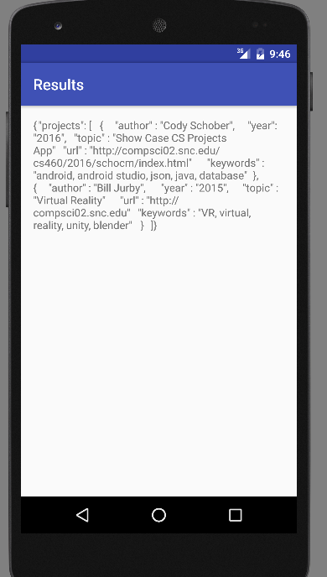
The next thing I attempted to do was to see if I could send the search parameters from main on to the Result activity. At first, I had a problem with getting the integers to transfer. The strings did get passed correctly, without any issues. I discoverd quickly that the reason the ints weren't passing correctly was because I was incorrectly passing them. After fixing my error, everything passed as it should.
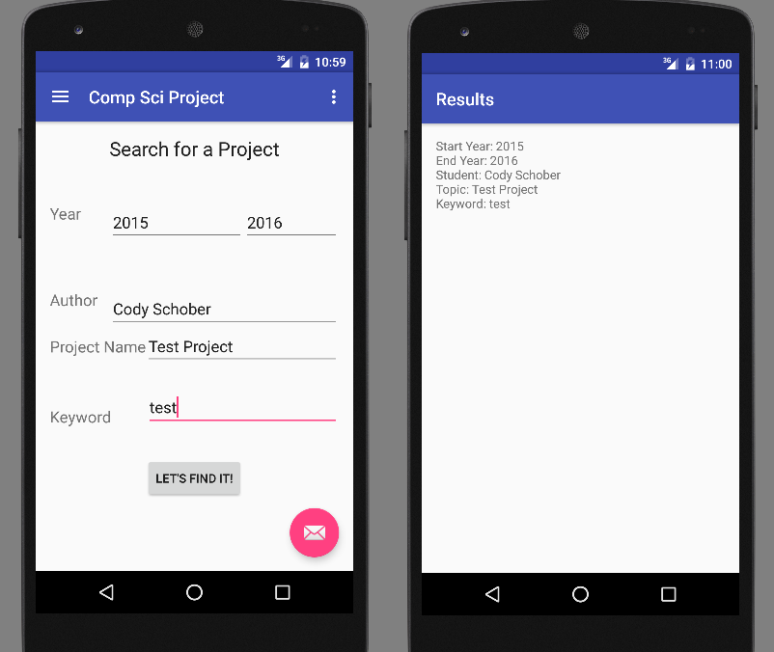
The last major thing I am focusing on before moving on to the formatting of the search results page is to ensure filtering works correctly. Currently, I have the activity accessing the external JSON database in a background thread, and this is due to the fact that Android does not support doing so in a foreground thread. The first thing I set about to do was to correctly parse the JSON data, since I had not done so already. As was previously stated, Android supports the ability to do this, so I imported JSON libraries to properly separate the data out. After applying proper JSON translating, I used a for loop to check if each item fell into my filter options. If no filter options were listed, then all items are displayed. After some testing, I have confirmed that the search is operating the way that it should. Below are a few test cases I performed:
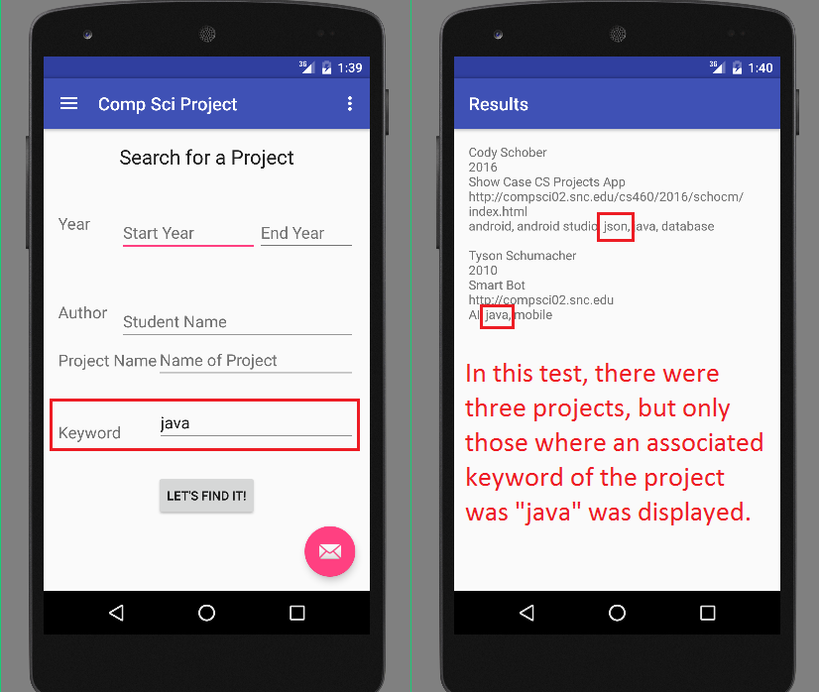
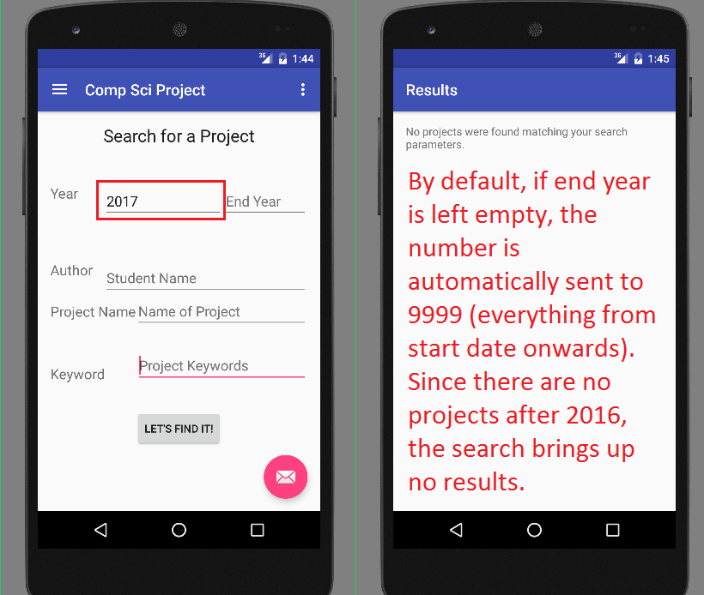
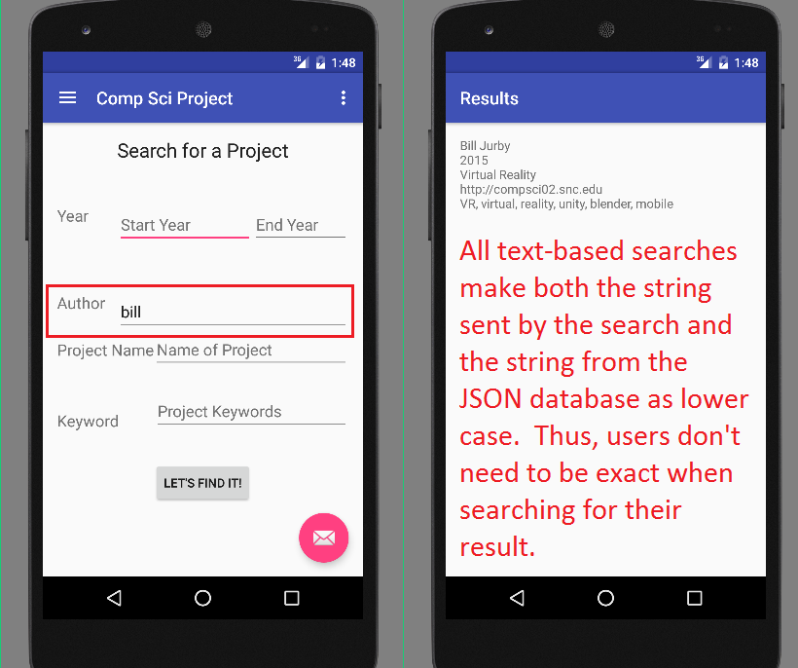
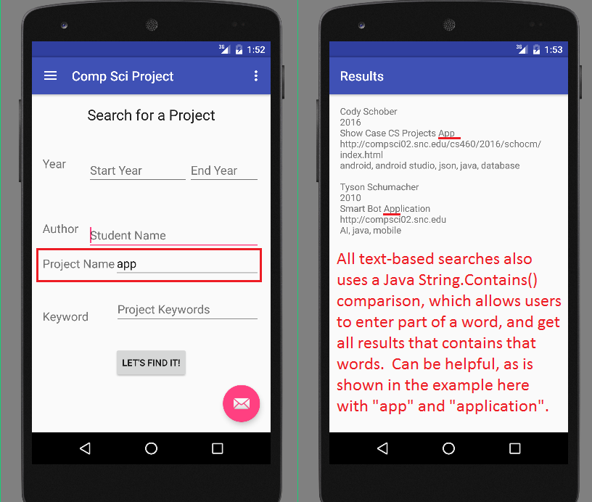
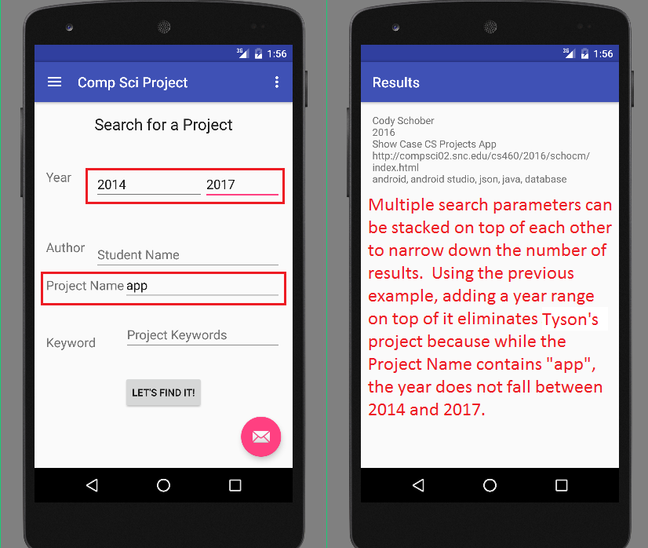

April 10th Blog Entry
Since I am ahead of the schedule I created for myself, I decided that today I would focus more on cleaning up some of the app visuals and making things look a lot better. I changed the color scheme, moved around and changed the formating of some of the text, and I got the style and format of the results list set up. However, there is a problem with it the list view in that the first result displays properly, but the rest of the results do not. I have been working on getting this error corrected, and once I do I will move on to accomplishing the next part: Getting a list entry selection to open up the project site url.
Another thing I have done is more research on all of the other parts of the project I will be working on. Specifically, I looked into displaying an external web page, creating a bookmark button, and permanently adding bookmarks to the side menu tab. What I determined was that I would send the main URL and name of the project on to an external page viewer activity. From there, I would have a fab icon in the bottom right corner of the screen that the user can select in order to bookmark the page. With the name of the project and the url already available, I can easily add the bookmark to the side bar.

April 11th Blog Entry
I had my meeting with Dr. Pankratz this morning. There has been a change to the course schedule, being that the presentations have been moved out to May. Despite this, I want to stick to the previous project schedule that I had, simply to avoid any time crunches and efficiently finish on schedule.
Given my Ghantt chart and current progress, I am still ahead on my current schedule. I will take some time to knock out some of my other school and internship work in order to better focus my efforts on this class.

April 14th Blog Entry
Today we met in lab to discuss out current progress with our projects. I still have been unable to work out the list problem, so a few of the students looked over what I had and gave me some ideas on what to fix. The most likely problem, since the last item in my JSON database is being printed, is that the previous items are being overwritten and replaced by the next value. I have tried various fixes, including eliminating all warnings in the Results.java, but this has not resolved the issue yet. However, after some careful observation, I finally figured out what I was doing wrong, and I fixed the issue!
What was happening was that I had a view adapter to display a custom list. In the Result.java thread that processes the list entries, I was grabbing the view that held the list, but I was only calling the id of the first item when loading the projects into the list. After calling the id on the view I had created, the list was successfully populated the way that it should.
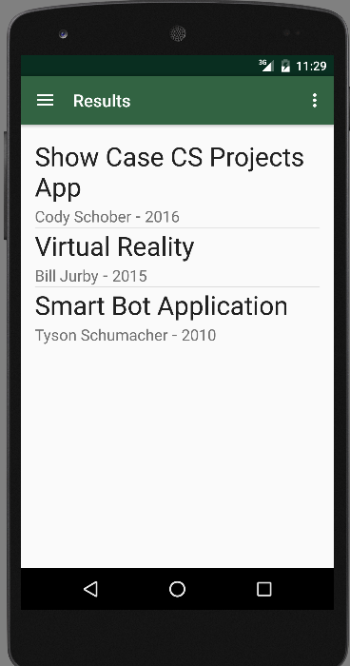
With this, I am officially done with the first two major tasks on my Gantt chart. Next, I need to be able to select a project and load the external project site. To do this, I will set an ItemClickListener for each item, and load the url for each project onto its corresponding list item. When the user taps on that item, it will boot up the project url. I will attempt to knock out two birds with one stone by doing this and having the project site load within the app.

April 17th Blog Entry
I am successfully able to load an external page within the app now. There is one problem with it that I am still trying to work out. When the external page loads, the toolbar that has all of the bookmarks and menu options dissapears. One issue, I know, is that I am trying to run two different activity templates in one app activity. Thus, my research right now is focused on how to set it up so that I can have both the external web view and toolbar drawer templates running at once within the same app activity.

April 22nd Blog Entry
It's been a very busy week with my business capstone and my POLI 410 Simulation. However, I have been able to accomplish a few things with my project. The first major thing was that I was finally able to get the navigation bar and the web view to work together. What I did was that I moved the web view out of the BlogView Activity and into an app fragment. Then, I set a frame layout in the activity that I would eventually replace with the fragment. By loading the url into the fragment, and calling that instead of within the main activity, I was successfully able to get both the web view activity AND the navigation bar activity to cooperate together.
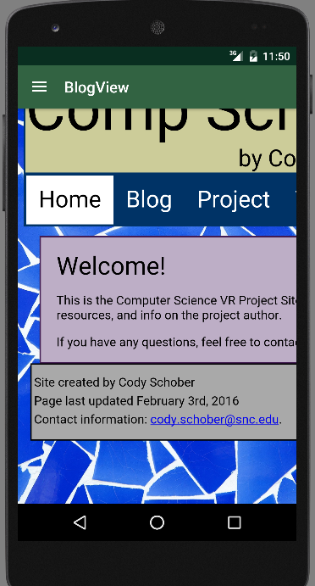

April 23rd Blog Entry
I am up in the North Woods this weekend, and thus have a terrible internet connection to do any real work. Fortunately, I did prepare ahead of time, and there is some stuff I have been able to work on. I saved the Senior Project listings for every single year recorded on Compsci02, and I was able to add the years up to 2005 into the database. Given how long that took, I will most likely push this off to one of the last things I do, as is listed on my Gantt Chart.
I also began writing my Senior presentation and defenses, including how I will coordinate my presentation and preparing for likely answers I would receive during the presentation itself. I also had some inspiration from an older project site I had gone through and took some time to write up some general programing philosophies that I follow by when I'm designing a solution for somebody.
The last thing I did was some cosmetic work on the app. I changed the navigation drawer to remove the basic Android Studio logo, and I redesigned the top part to look a little better. I also added a linear layout to the search page to better put everything into line.

April 25th Blog Entry
I have begun to put my bookmarks feature into action. The first thing I did was create a local JSON database in the resources folder of the android app. This way, if a user adds the app to their phone, their bookmarks will be local and tied to the app itself. Not only that, using JSON allows me to separate and maintain the information for the bookmarks as I desire, with the name of the project and the url to that project. With this, I have implemented the first part, being to call the internal JSON database and extract it. I am doing this only in the main activity, since that is the first activity that loads, and the same navigation drawer will be used across different sites.
Ultimately, my game plan will be to use Android Studios' built-in functionality to append new bookmarks to the resources file. To give users the option to add a bookmark, there will be a fab icon that they can press to add it. When it is added, I will dynamically add the menu item to the navigation drawer, and I will append the new JSON item to the internal database.
So far, I am able to dynamically add menu items to the navigation drawer. However, the items in the drawer are lost when switching over to another activity. After some further research, I discovered the reason why this isn't working is that I am incorrectly calling the "same" navigation drawer in multiple activities. What is happening is that the navigation drawer is being duplicated in each activity, and had thus looked the same before. I am in the process of figuring out how to make it so that one, single navigation drawer is shared across multiple activities. The primary method I am looking into right now is storing the navigation drawer in a fragment.

April 26th Blog Entry
I have been working throughout the course of today to create the navigation drawer needed, but I have largely been unsuccessful. What I am trying to do right now is set up and use the navigation drawer from the main activity, and then be able to go into other activities with this same navigation drawer.
What I have discovered today are two things: Either I need to re-design the application to implement each page as a fragment, and then have the main activity act as the initializer of the app, or I need to figure out a way to re-design my existing activities to be an extension of the main activity. Unfortunately, given how much time and success it took today to try and get something to work using the activity extension method, I do not think I would have enough time to create the dynamic navigation drawer I desire.
However, I do have a backup plan.
Utilizing a static navigation drawer, I can include a link to a Bookmarks activity. This activity, utilizing the same methods that the Results activity uses to bring up the contents of a JSON file, will display all of the bookmarks that the user has. When the user selects an activity, just like with the Results activity, it will send on the name of the project and the url to Blog View. In this way, I am utilizing existing code and methods to accomplish the bookmarks feature, which will give me time to finish the project and prepare my presentation and defense.
Looking at the situation, yes, I really want to design it so that the bookmarks show up in the navigation drawer, not have it pop up in another activity. However, since time is limited, I will just have to list it as a future update I would like to add to the project. What is important is ensuring that I have a working, in-line-with-the-guidelines solution I can deliver to the class next week.

April 28th Blog Entry
I created the activity and template that would summon the bookmark list. To save time, I'm utilizing the existing templates I created with the Results list. The reason I'm not using the existing Result file to alternate between searches and bookmarks is because the process to access an internal database, and that I'm not filtering any of the results, is different than what is in the Results file. I also updated the database on CompSci02 with the database that was on my computer. Over the weekend (more specifically, setting aside a whole day to focus on it and knock it out), I hope to be able to finish populating the database with information.
Besides this, I have done more work on planning and creating my presentation and defense.

May 1st Blog Entry
After bunkering down for the whole weekend, and slamming out some much needed progress on my final projects, I have finished the bookmarks feature of my Comp Sci project, and have thus completed the programming portion of the project. Interestingly enough, the end result for bookmarks almost utilizes a JSON approach. Despite my best efforts over the past few days, I could not get the program to read and write to an internal database, both when it was a JSON file and when it was a normal TXT file with the JSON database within it. So, for the sake of getting the project done, and being able to focus on addressing any potential kinks and getting the presentation finished, I took a different approach.
In the blog view activity, I created a "block" (stored in a string variable) in the following format:
{project, url, author, year}
Each entry is separated by an endline, and it is written to the file upon selecting the floating action bar icon. That is, as long as the user hasn't already added the bookmark before. The whole bookmarks internal file is read in first, and it is analyzed to determine if the url does not already exist in the file. If it doesn't, then the new entry is appended, and the old file is overwritten with the new information. In the bookmarks activity, this information is extracted from the file, loaded into ProjectModel objects, and then the normal process for displaying entries similar to those in the results activity is undergone.
Alongside finishing the bookmarks feature, I have done two other vital things: I finished the projects database, and I tested the app on the android phone given to me. Much to my happiness, the size of the database presents zero issues to the app being able to load the whole thing, if requested by the user, and I am quickly and effortlessly able to switch between different activities, web views, and the likes without issue.

May 5th Blog Entry
Today, I gave my project presentation. While I was unable to ever practice in the presentation room, practicing in a room with a similar setup helped very well. Overall, the presentation went very well, with the only issue having been that before I presented, Mobizen was not registering between the laptop and the phone. This proved to be a short issue, for once it was fixed it did not come up again.
Per the request of Dr. Pankratz, Dr. McVey, and several other students in the course, I have added a link to Mobizen in my site Resources, for those who would be interested in getting the software and app for their own usage. It is free, and all it requires is creating an account to use it.
Over the weekend, I plan on looking over my code and cleaning up any discrepancies or bits of concern. Alongside this, I also plan on finishing up the writing and documentation for the project as outlined in the "final documentation" document on the Google Drive.

May 8th Blog Entry
I managed to get a lot done over the weekend. Most of the documentation as outlined in the course syllabus has been completed. The only remaining things are to finish up the explanations on my Defenses, review over the website and apply any remaining updates, and ensure everything is accurate, and review over the code documentation to ensure I haven't missed anything. If anything else comes up between now and the Defense on Tuesday I will put an update up.

May 9th Blog Entry
I nearly have all of the documentation done. While going through the code and checking over some things, I actually found a few small modifications that have had a massive impact. The first of thes is the addition of a clear fields button on the MainActivity page of the app. Utilizing the existing ToResults function, I changed what the calls to the EditText fields were doing in order to set those values to blank. I have tested this component, and it is working. Another thing I did, looking over how I was adding projects to the bookmarks internal database, was that I could alter the method slightly to remove the bookmark, if it is in the database. I was able to implement and test this, and I have confirmed that it is working as it should, thus adding onto my app the ability to remove bookmarks. However, the issue remains of not having real bookmark management features as I desire. The last thing I did was that I reviewed over how I was calling the BlogView, and I determined that I could implement it within content_blog_view instead of having it in a fragment. Thus, I cleaned up the code and removed excess files, while still having the call to view the project sites work as it should.

May 10th Blog Entry
I gave my project defense today to Dr. McVey and Dr. Pankratz. Overall, it went very well, adding and answering to all of the design choices I made in this program really helped out with preparation.
One interesting thing they brought up was creating the ability to do a nested search, where after bringing up the Results list, users could perform another search on that list to bring up even narrower results. I did look into this, and I determined a methodology for going about with implementing this. It would require three components: Recursion, lists, and using the fragment approach outlined for creating a dynamic navigation drawer. To view more information on this, see the "Things that could be done in the future" section of the project documentation.
I am also finishing up the documentation tonight, and I plan on turning it all in tomorrow. If anything comes up, I will have another day in order to apply any corrections or changes. However, I do not believe I will need that extra time.

May 11th Blog Entry
Well, this is it.
Today, I’m turning in my project. Last night, I checked over and confirmed that everything is in check. When I turn this in to Dr. Pankratz this afternoon, it will mark the end of my days as a student at St. Norbert College. It’s been crazy and unreal over how quickly things seemed to pass on by. As it stands, though, I’m ready to move on to the real world.
To anyone reading this, I will be using my SNC email for all non-business communication. If there are any questions that you have about my project, or some assistance you would like on an aspect with your project, feel free to contact me at cody.schober@snc.edu. I will be more than happy to help you with whatever you need.

Class Presentation
Any additional notes on the presentation will be added underneath its relevant slide.

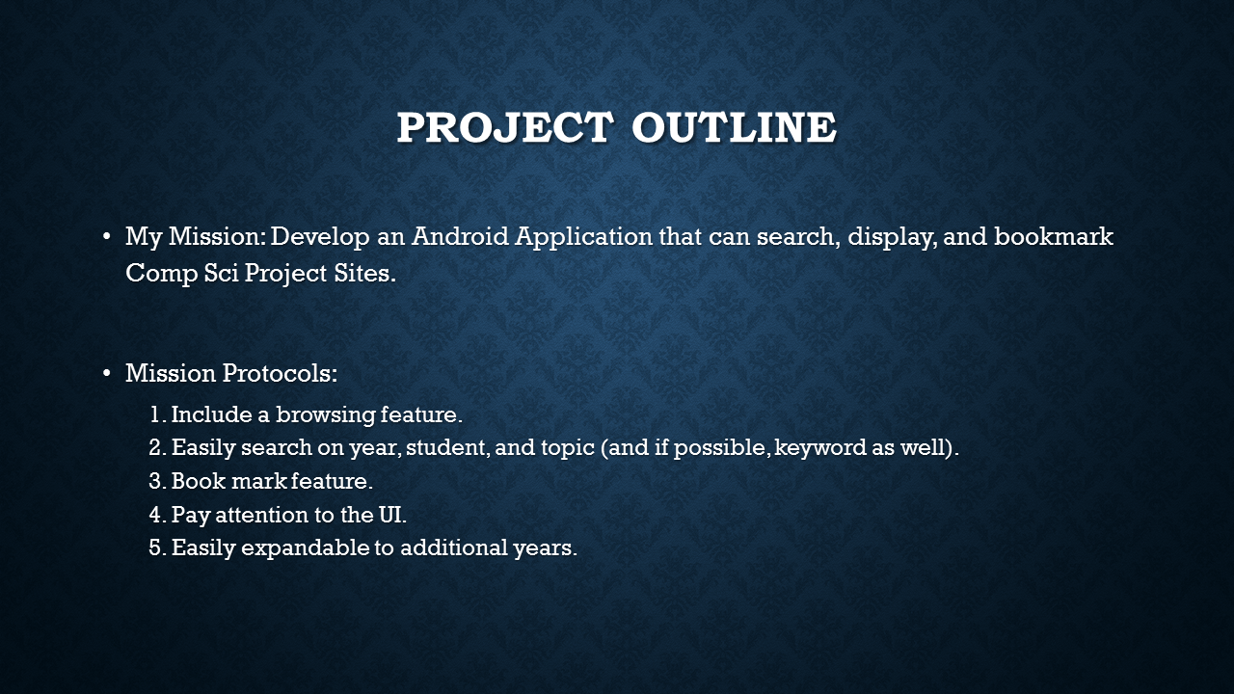
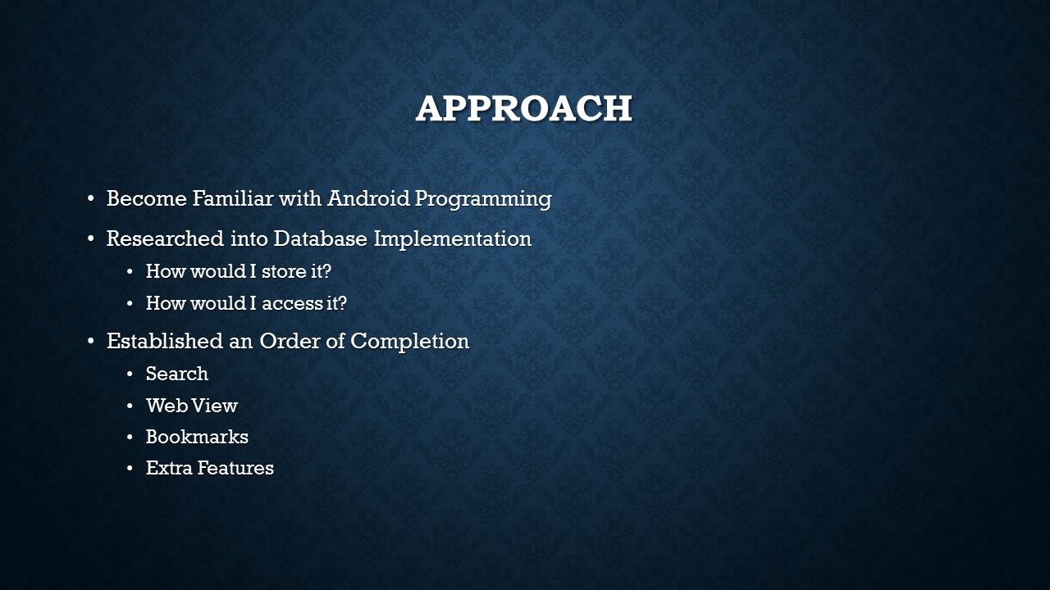
First step of my approach came from the original VR project. During February, I spent time learning about Android Programming and Android Studio. Even though I was unsuccessful with getting Open GL to work with Android Studio, that early work with it helped me get a running start with the project reboot.
The database implementation refers to how I would store the data for the projects and bookmarks. Would I store it in a JSON? Would I store it in a text file, a CSV file, or was there something else? Depending on what I picked, was there then something in Android Studio or PHP that could parse the file?
The Order of Completion was a set list of components that I said needed to be fleshed out by certain dates. Everything except the Bookmarks went according to the schedule, although the schedule I set for myself set me ahead of time, based on when presentations and defenses were.
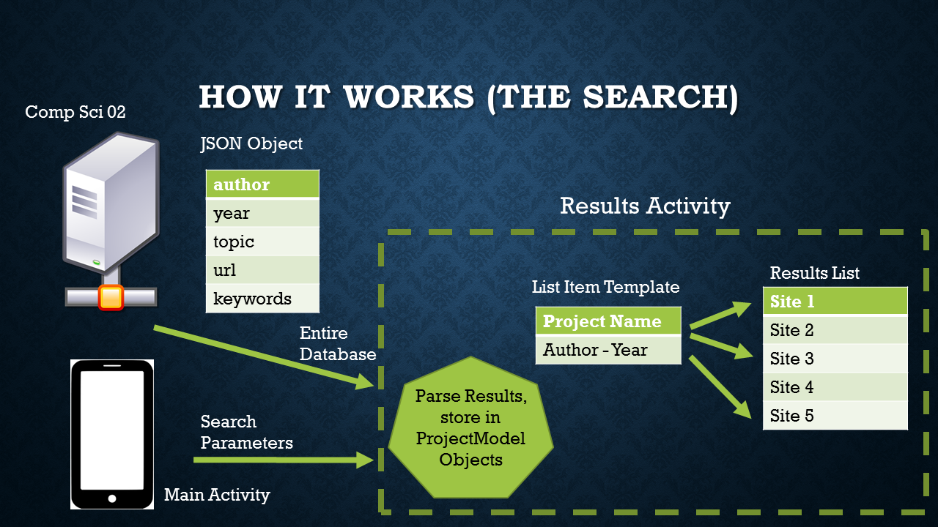
This is a chart showing the flow of information between Main Activity, CompSci02, and Results. The MainActivity, Results, BlogView, and Bookmarks activities are all separate, passing information to each other via Bundles when need be. The first activity that is called is MainActivity, as is defined in the AndroidManifest file. Once the user enters their search parameters and taps on the search button, the search information is bundled and sent to the Results activity. In the Results activity, the database is grabbed from CompSci02, parsed within the activity, and then loaded into the Results list. When a user taps on an item in the list, the information with that project is bundled and then sent on to the BlogView Activity.
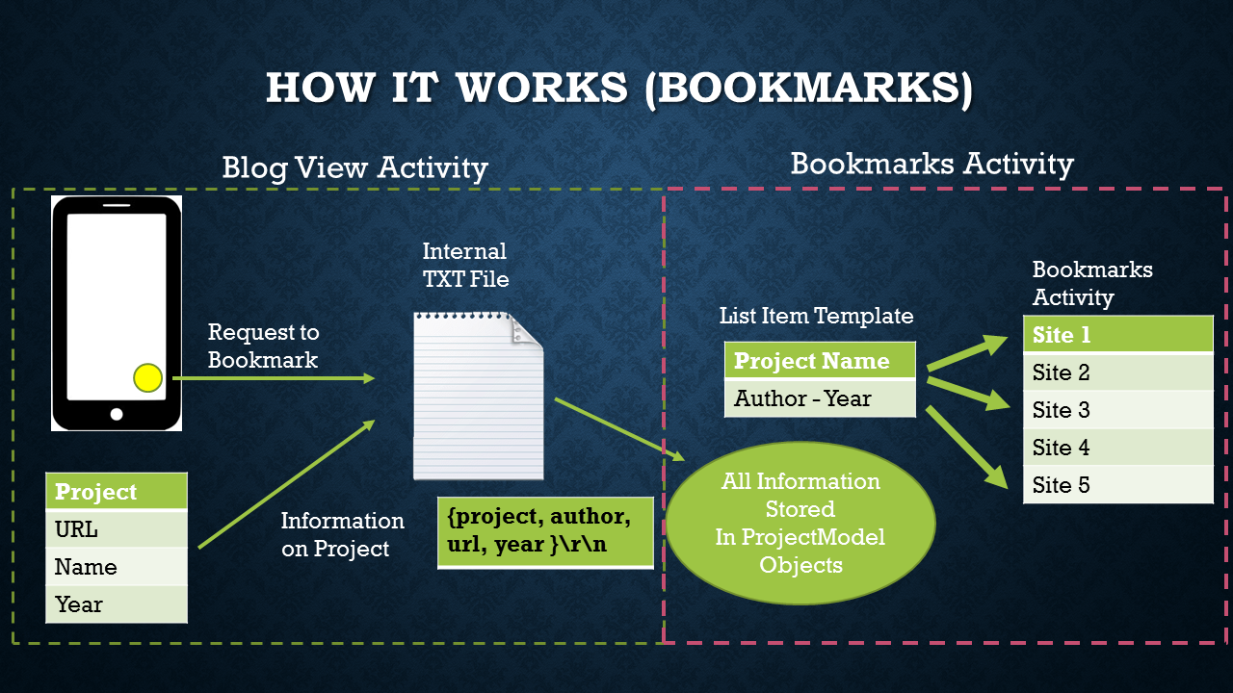
This is a chart showing the flow of information from Blog View to Bookmarks. When a user taps on the icon in the bottom right corner of the BlogView activity, the information with the project is saved to the bookmarks file. However, if the bookmark is already in the file, then the project information is removed from the file. When the user goes to the Bookmarks activity, a process very similar to the Results activity is executed. The only difference between the two is that the Results activity gets and external database and filters it, while the Bookmarks activity grabs an internal database and displays everything in it.

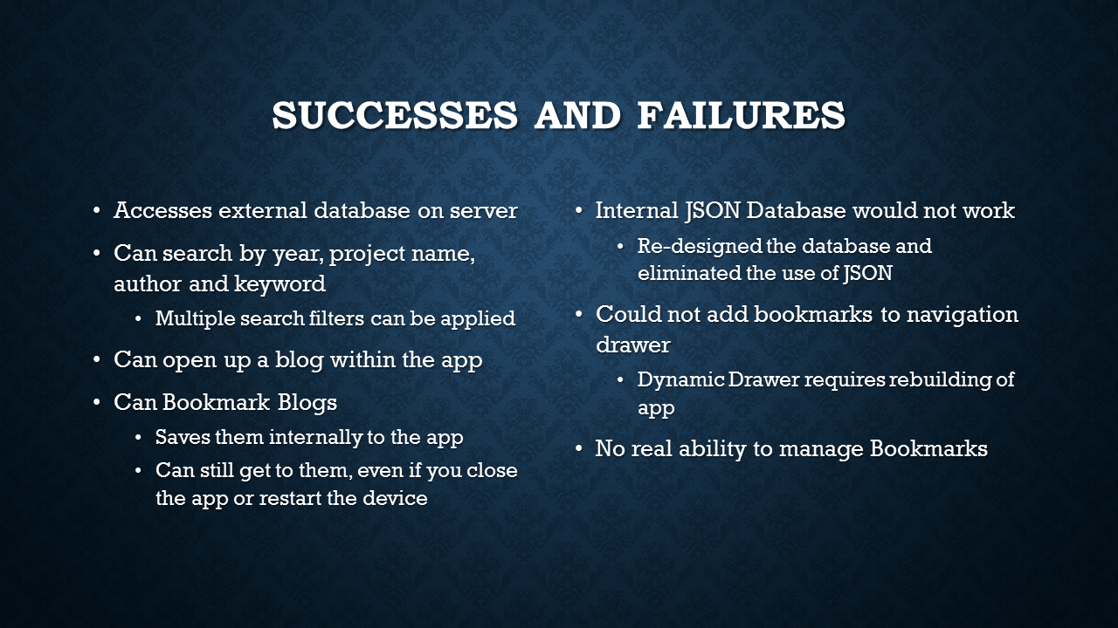
Since this presentation was given, the ability to remove bookmarks has been added. It was mentioned that this ability was not yet in place, so it was worth adding here that this functionality has since been added.

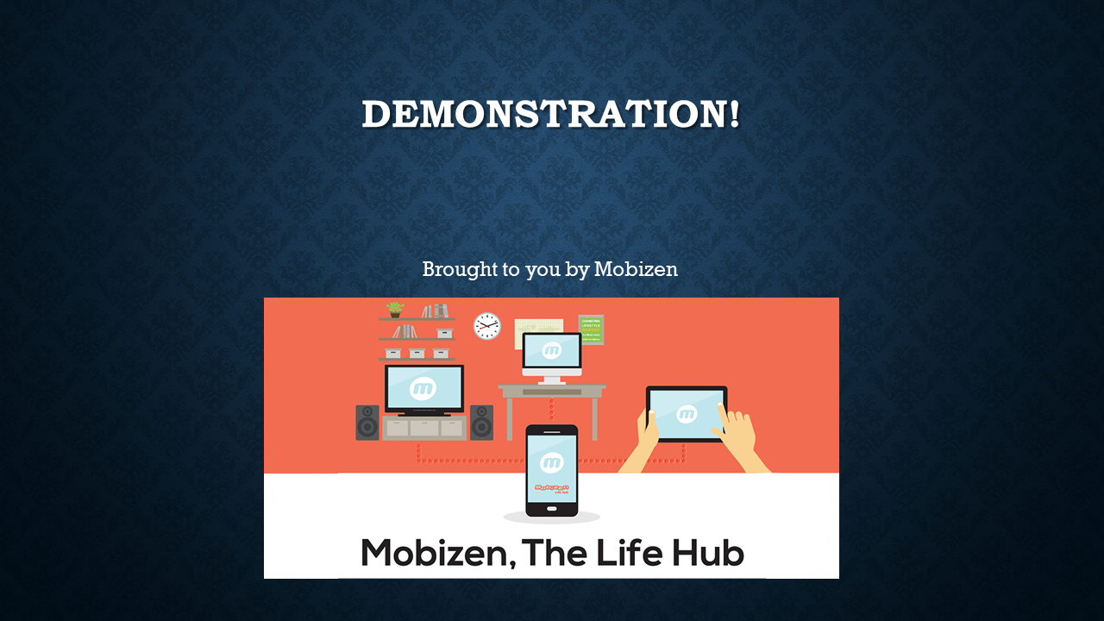
Mobizen was what I used to demonstrate the application over the projector without the use of a document camera. For more information on this, please see the Resources page at the back.

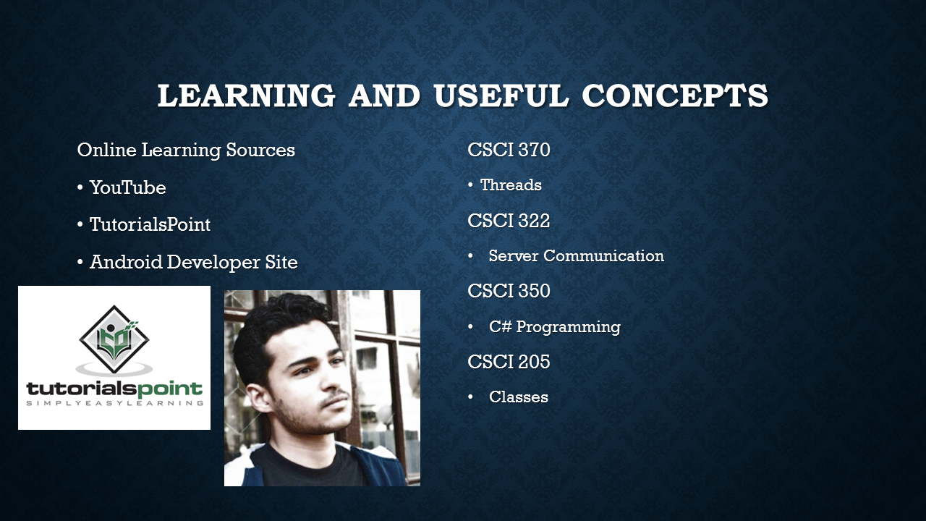
Specifically with YouTube, pictured is Hishaam Muneer. For more information on him, please see the Resources page at the back.

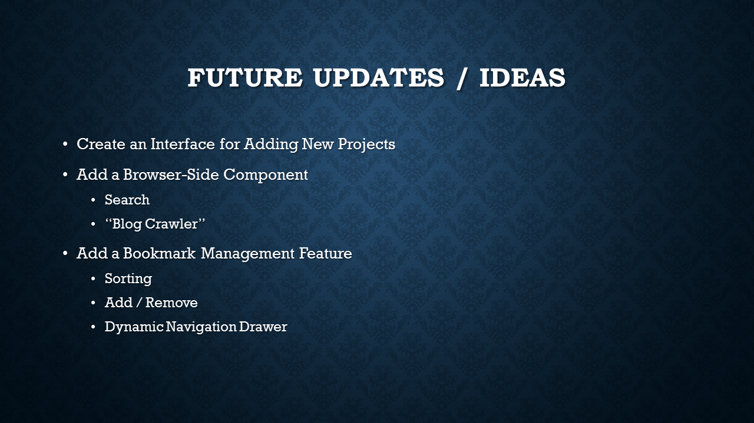
There are more features that I wished to have accomplished with this project, or that I think could be done in the future. All of these ideas are explained in the “The Future of this Project” Section.
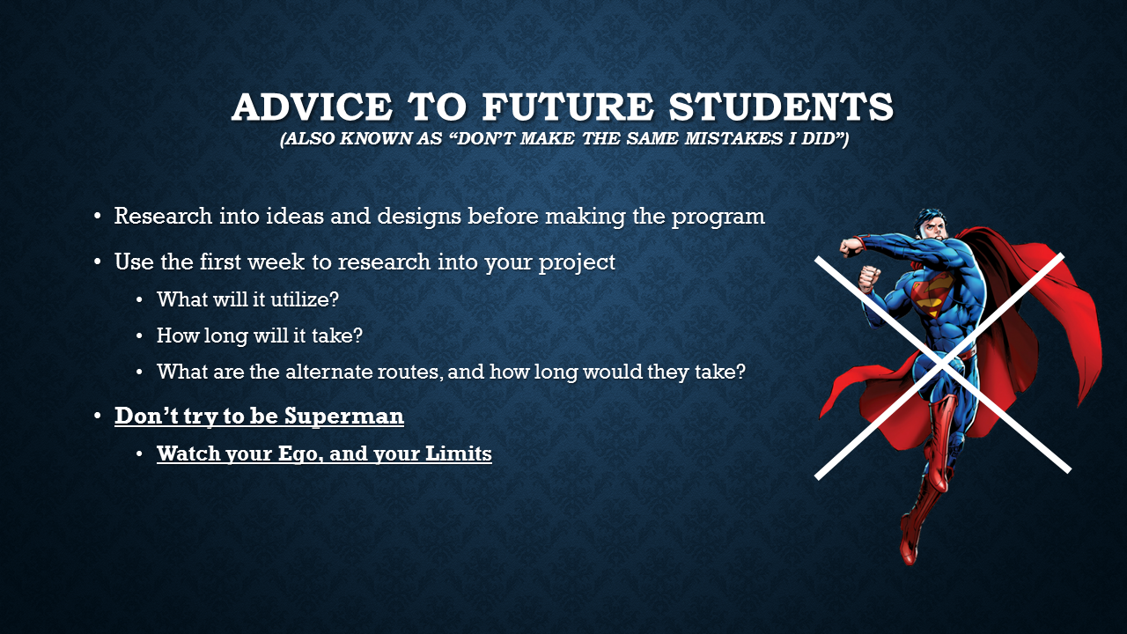
The first point is from the reboot of my project. While did have a diagram and a plan of attack, I did not realize that to implement a dynamic navigation drawer required a completely different app format. Thus, I recommended to future students to research into how they would implement ideas with their project. The second two points relate back to the VR project. The first of my big problems with the VR project was that I did not fully research into the specifics of the project. I researched into what I could use, what the generally accepted VR practices were, and so on, but I did not look into what it would take to learn how to use something like Unity, or what if there was anything more to that I needed to learn. The second problem was that I got so caught up with trying to make the project work, and learning it, that I did not realize that the whole project was going downhill fast.
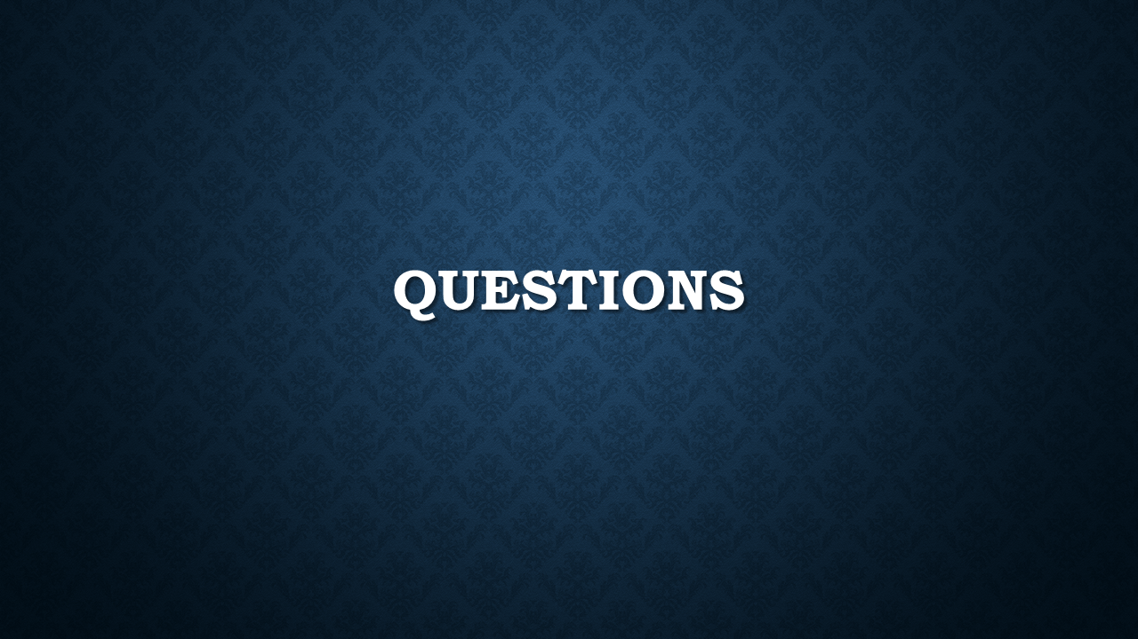

The Future of this Project

Things that Still Need to be Done
Add Bookmark Management Features
Currently, the ability to manage bookmarks on the app is pretty crude and basic. You can add them, view them, and then if you’re at the site, you can remove it from the bookmarks. However, a much better system, with more time and testing, could be implemented. For example, what if a user wanted to sort or re-arrange how their bookmarks appeared? What if the user didn’t want to navigate to the website in order to remove it from bookmarks? These are things that I wish I could have implemented, but I did not have the time to add in.

Implement a Dynamic Navigation Drawer
The drawer in the app right now is static. It was my original goal to be able to take all the bookmarks the user has and load them into the navigation drawer when the app boots up. However, in order to do this requires one of two app designs. The first is to have one main activity, and then implement all other activities as an extension of that activity. The second method is to have one main activity, and then switch out different views into the main activity via fragments. To implement either of these methods, with where I was at with the app, would have required too much time in order to implement.

Condense Results and Bookmarks down into one activity
Results and Bookmarks are separated right now, primarily because of how each of them accesses their respective files. Since bookmarks uses the same layout files as Results, I would like to eliminate Bookmarks all together. However, due to time constraints, I was not able to implement and test this.

Implement Common Functions in a Separate Class
This idea came about from analyzing the code on the Array Adapter. There are a lot of common functions throughout the program, such as the one that implements the Dynamic Navigation Drawer. I did look into this, and tried some things, but I was unable to get it to work. There were issues with calling and setting up the layout and onClick functions for one activity from within another java file.

Redesign the Internal Bookmarks Database as JSON
While the internal bookmarks database works right now, I would much rather have it as JSON. This is a matter of preference and keeping things uniform, as it does not make sense to be using two different types of database when the information in both of them is virtually the same.

Things that Could be Done in the Future
Create a Web Side to the Search Application
While the Android application is useful, some users may prefer to use their web browser to search for projects. With this in mind, it could prove to be a worthy project in itself to create a search site much like what you would see on Google. Users would have the ability to search by different Boolean expressions, advanced search terms, and the likes. Alongside this, a “blog crawler” similar to the one used by Google to parse through web pages to find results, could be created to search through individual pages in project sites to bring up results where the user’s search terms were found in that page. This could be incredibly useful for finding blog entries that reference a particular problem or topic, and what that student did in regards to it.

Create a Project Database Interface
Currently, the only way to add projects is to go to the database, manually add the project, and then save it. It would be much more convenient to have a form where students could go in, enter their own information for their project, and then add it themselves. There could also be another feature where a student could find one of their own projects and modify the information with it.

Implement a PHP Parsing Feature
Right now, the application grabs the whole project database and pulls it into the app. While this is not an issue right now, since the database is so small, it could slow down the app one day in the future. Thus, it would be better to send the search parameters to CompSci02, parse them in PHP, and send the results back to the app to be loaded into the results list.

Emulate Applications From Within the App
This was something that I had briefly looked into between the span of getting the project re-assignment and getting the guidelines for the new project. I had determined that it is possible to load Android applications from within an android application. One thing I had not looked into, but could prove useful, would be the ability to emulate applications from within the browser. This way, students could see and interact with projects without having to download and extract them.

Created a Nested Search Feature
This idea actually came from Dr. McVey and Dr. Pankratz. During the project defense, they brought up the idea of being able to do a search, and then be able to perform another search on the list on results. In essence, creating a nested search. No doubt, this would utilize recursion, and would involve having the ability to bring up the search fields at the top of the app when in the results page, thus causing a merger of the Results/Bookmarks Activities and the Main Activity. This would be possible by implementing the app as fragments, and this is something that I will be adding to the blog in case a future student was looking for a tip on how to do this. On top of this, a list would actually come in handy, because it can be used to store the results when a user wants to perform a nested search on those results. This list can be passed and handled using recursion. This is how I would implement it, if I was the one adding this feature on in the future.

Resume
Cody Schober
1220 Evergreen Avenue 608-295-2662
Beloit, WI 53511 cody.schober@snc.edu
Last Updated May 11, 2016

Education
- Bachelor of Science in Computer Science - May 2016, St. Norbert College, WI
- Bachelor of Business in Business Administration - May 2016, St. Norbert College, WI
- Accumulative GPA of 3.21

Future Plans
On June 8th, I will begin work at Acuity Insurance in Sheboygan, WI, as a Computer Programmer. Alongside this, I plan on joining my Chapter’s Board of Advisors and guiding them in managing relations with the alumni and carrying out Active Member projects.

Experience
IT Intern: Networking and Infrastructure | June 2014 – December 2014
IT Intern: Customer Service | December 2014 – May 2015
IT Intern: Analytics | May 2015 – May 2016
Woodward Inc. - Rockford, IL
- Collected and organized a database documenting Woodward server hardware which created the ability to easily detect servers with expiring warranties and development of more accurate budgets.
- Lead the building and rollout of over 100 new PCs at the Rockford plant.
- Taught myself C#, SharePoint, and Perl to make myself more versatile for the Woodward IT Department.
- Responded to a variety of hardware and software issues initiated through Footprints.
- Built numerous SharePoint project sites for Engineering and IT groups.
- Reduced the amount of active ColdFusion content within the elimination project scope from 30,000 to 14,000 applications, saving Woodward thousands in CFM maintenance costs.
- Implemented and educated other members on a variety of advanced methods to utilize Woodward’s third party software.
- Assisted the Prototype Network and Global Tax groups in rebuilding their older SharePoint sites using more efficient methods.
- Researched and thoroughly tested multiple SharePoint list filter web parts, eventually purchasing, introducing, and writing the Woodward manual to SharePointSapiens Power Filter.
- Traveled between multiple plants to communicate directly with the customers for my projects.
- Created and managed project communications between the members of IT.
- Wrote various training guides for software used at Woodward including Power Filter, iPass, and Citrix.
- Developed programs currently in use using an array of programming languages: C#, Perl, KornShell, Footprints, SharePoint 2010, SharePoint 2013, Nintex Forms, Nintex Workflows, Lightning Dataviewer, SharePointSapiens Power Filter, Oracle, VMWare, Linux, Remote Desktop, Google Apps.
- Issued a Woodward laptop and granted remote network access to allow my internship to continue when I returned to St. Norbert College.

Fundraising Chair | December 2013 – December 2014
Member Quality Board Member | April 2014 – December 2015
Senior Chair | December 2014 – April 2015
Website Chair | December 2014 – December 2015
Hegemon | April 2015 – December 2015
Histor | December 2015 – May 2016
Sigma Xi Chapter of Tau Kappa Epsilon – St. Norbert College, De Pere, WI
- Found and removed waste from Chapter Fundraising activities, increasing overall profit of individual events by several hundred dollars.
- Achieved a Chapter fundraising record in 2014 with over $8,000 raised for the Fraternity.
- Introduced new techniques in position transition that addressed long-time problems of inefficiently passing information from one chair to the next.
- Redesigned the website chair to include more public media outlets, including Facebook and Twitter, and to make it easier to maintain the website.
- Utilized Facebook marketing tools to expand the Chapter’s outreach and boost the audience to over 500 individuals, making it the largest SNC social media page.
- Implemented a new system within MQB where we recognized members who were doing positive things within the community.
- Redesigned the pledging process to have more emphasis on professional growth and to significantly reduce the level of stress on potential new members during the pledging process.
- Introduced a Sweetheart Appreciation Program that got more of the Active Chapter involved and bonding with our Sweetheart and affiliated sorority.
- Introduced new methods for recruitment that focus on engaging all members of the Chapter by facilitating proper communication with potential pledges and utilizing affiliate connections.
- Lead and coordinated the first major Chapter alumni event to be held at Titletown Brewing Company in Green Bay, Wisconsin.
- Took the before-mentioned alumni event and established it as our Chapter’s first annual event specifically designed for alumni.
- Created the Histor Board to train newer, less experienced members in the position of Histor and managing alumni relations.
- Lead the Chapter in networking with area TKE community and business leaders.
- Reconstructed the Chapter family tree, and restored over 20% of missing family lineage.
- Pushed the Chapter to reach out to other Chapters for inspiration, ideas and collaboration.
- Began and drove the effort to organize and bring together Tekes from all Chapters in the Green Bay, Appleton, Oshkosh, Sheboygan, and Manitowoc areas.
- Reached out to alumni and communicated with the Chapter to address major concerns and complaints among the alumni members.
- Redesigned the newsletter to be more professional, detailed, and appealing.
- Put the Chapter on track to bring back the Red Carnation Ball next year after being gone for over five years.
- Worked with the Pylortes to create our first Risk Management policy in over five years.
- Communicated with the International Headquarters, and wrote a piece, that was published in the Spring 2016 issue of the Fraternity Magazine.
- Lead the Chapter to make us eligible to receive Awards of Excellence for the first time in over five years.
- Represented our Chapter at the 2015 Tau Kappa Epsilon Conclave in New Orleans, LA.

Tau Kappa Epsilon Representative | January 2015 – May 2016
Website Chair | April 2015 – May 2016
InterFraternity Council – St. Norbert College, De Pere, WI
- Was chosen as the first Website Chair for the InterFraternity Council
- Contributed and helped in the planning of the Spring Semester’s Greek Week
- Worked with an affiliated sorority, Alpha Xi Delta, to plan and execute an all Greek and Social Group event for Winter Fest
- Encouraged both TKE and other campus Fraternities to improve relations between each other and address stereotypes in the SNC Greek Culture
- Was chosen as November 2015’s Greek of the Month
- Became the chief designer for all of IFC’s posters and online graphics

SNC Radio Technology Master | December 2012 – September 2014
SNC Radio – St. Norbert College, De Pere, WI
- Communicated with the college radio provider to upgrade the software and restore the broadcast, which had been inoperable for many months prior to my entering the position.
- Worked with the College to upgrade the technology used in the studio.
- Implemented new strategies that improved the social media image.

SHRM Member | January 2015 – May 2016
Website Chair | May 2015 – May 2016
Society of Human Resource Management – St. Norbert College, De Pere, WI
- Took over for the Public Relations Chair and Social Media Chair when there were none
- Wrote the newsletters for the group until we found somebody to take over in the Public Relations Chair
- Re-designed the group’s recruiting strategy to bring in more non-Human Resource Majors and fix the high turnover rate of members
- Helped increase the group’s social media presence in order to generate more interest in the group

Head Lifeguard | May 2010 – September 2013
Pearl Lake Beach – South Beloit, IL
- Responsible for overseeing and ensuring the safety of over 2,000 people.
- Communicate with other lifeguards to efficiently monitor all areas of the beach.
- Managed any problems and situations among guests at the lake.

ITS Service Desk Assistant | September 2013 – October 2014
Technology Department – St. Norbert College, De Pere, WI
- Assisted students and faculty with various technology issues.
- Researched, documented and presented solutions to new problems.
- Focused on eliminating issues with missing/incorrect information, averaging 300 corrected tickets a month.

Philanthropy and Service
- Raised over $600 for St. Jude in November 2015
- Organized and lead a statewide fundraiser for the Open Wings Learning Community in Kenosha, WI. The fundraiser itself occurred at St. Norbert, the Milwaukee School of Engineering, and UW Madison.
- Volunteered with Open Wings to help communicate with and educate children in the Autistic spectrum.
- Member of Habitat for Humanity
  - Volunteered in the ReStore and helped to build homes for low-income families
- Member of Imagine Beloit
  - Helped mobilize the youth to support and help pass a $70 million referendum for Beloit, WI, one of the largest in the state’s history
  - Managed the group’s website and Facebook page during the movement
- Project My Story
  - Created a movement to battle the stereotypes and misconceptions within SNC Greek Life
  - Interviewed with various members of fraternities and sororities that are now used by LSE for recruitment and education purposes.

Philosophy of Computer Science
“The programmers of tomorrow are the wizards of the future.”
These words were spoken in an interview by Gabe Newell, legendary founder of the computer entertainment titan known as Valve. This interview was first shown to me shortly before I began my Freshman Year at St. Norbert College. Through many programming and theory classes, long summers spent in internships, and late nights diving deep into the internet in a never-ending quest to learn more, I have never found a greater way to describe Computer Scientists.
To the average individual, the code behind a program that can count to ten can seem like a terrifying beast. It is a foreign language, a murky clump of letters and numbers that allows ordinary people to function in contemporary society. What’s even scarier for these people is that technology is constantly advancing. What was once commonplace for that user a few years ago is now obsolete, and this idea can turn people off to the idea of embracing technology and computers.
This, however, is what makes Computer Science so special.
Computer Science does not shy away from the towering tidal wave that is technological advancement, but rather, like the determined surfer, challenges the wave and strives to conquer it. The role of a computer scientists, or programmers in general, is to innovate and help build towards the future. It is about pushing the boundaries of programming and technology to areas previously thought inaccessible. However, the most important thing about Computer Science is that it is about humanity. It is about advancing the known concepts of programming and computer hardware so that mankind can have a higher quality of existence.
Now, can anyone dive into the realm of Computer Science? Some say that it requires intense knowledge of math, and others say that it requires a working understanding of technology. I, for one, believe that anyone has the ability to enter this field. Everyone has their own creative spark and talents within given areas. To say that someone is not smart enough to become a programmer is a gross thing to say. At one time, we were all inexperienced with technology, and we all would have been frightened by the language of computer scientists. As such, it is never too late, nor is it impossible, for someone to be introduced to this culture.
Computers are here to stay; that much is almost undeniable. With this, Computer Scientists are also here for the long haul. In the belief of Gabe Newell, programmers will continue to lead the charge, pushing our known boundaries of technology, and continue to work hard to make the science fiction of tomorrow the fact of today.

Career and Future Plans
(Defined and up to date as of May 11, 2016)
First and foremost my primary goal at the moment is to focus on my current job with Acuity and pay off my student loans. Once this is done, I will look into pursuing a further degree in either Business or Accounting. My reasons for doing this is because I am interested in serving in an IT Analyst position. Most IT Analyst jobs require in-depth accounting knowledge in order to pursue, hence why I would need the accounting degree. During my time with Woodward, I was able to serve in an IT Analyst Intern position, and the research and business focuses of the position intrigued me. I find my skill and fascination with learning, digging and number crunching to make me especially prime material to serve in such a position.
Right now, in terms of places I want to work, I want to stay with Acuity. It’s a good, solid company, with a work environment that can help further my skills and knowledge as a computer programmer. If I determine that I want to stay after working there for a period of time, then that is fantastic. If I don’t like it there for any reason, I would like to pursue a Global IT position in Woodward. Woodward is a reputable company that has treated me very well during my time there. Thus, I would not mind returning to that company to serve the engineers there once more.

Relevant Links and Resources
Mobizen - https://www.mobizen.com/?locale=en
Mobizen is a mirroring application for Android and iOS devices. It allows a user to display and control their phone from their computer monitor, and this was what I used to demonstrate my application during the project presentation.

Hisham Muneer’s Channel - https://www.youtube.com/user/hishamdbnd
Hisham Muneer is a YouTuber that has in-depth tutorials on JSON parsing, URL Connections, and Array Adapters for custom lists in Android Studio. It was this tutorial that I followed to create my Results and Bookmarks list and parse the Results JSON database in the Comp Sci Project Search application.

Tutorialspoint - http://www.tutorialspoint.com/
Tutorialspoint is an educational site that contains beginner, advanced, and expert tutorials on a massive variety of programming languages. When learning how to use Android Studio, I followed their tutorials on their website in order to learn and gain a better understanding of what I was working with.

Android Developer Site - http://developer.android.com/
This is the main site and hub for Android Developers. Here, users can find tutorials and sample applications to help educate themselves on mobile development. I used this site to learn how to set up the navigation drawer and set up the Blog View fragment to display the project sites.

Android Studio Download Page - http://developer.android.com/sdk/index.html
This is the page where users can find the download information for Android Studio. The software is free, and requires no registration in order to use.

