Hello user! This brief tutorial explains how to establish a working environment for the “self driving robot” project. The most recent iteration of the program is still loaded onto the robot itself, but I will still detail initialization of the IDE, “SimpleIDE,” within which program development occurs. Note that while one could modify code within a different environment, this IDE is still required to load new or modified programs onto the robot.

Running the Robot:
Usage of the robot itself as per the project’s final iteration is quite simple, and merely requires the robot’s “road” and the robot itself with sufficient battery power (five AA batteries). Position the robot upon its road and switch the power switch to position 2 (toward the white breadboard).

If the road used in the project’s presentation is unavailable, the robot will run upon a similar surface. Best results will be achieved with 1 inch black electrical tape placed upon a flat white surface. Additionally, the robot treats red/blue squares placed adjacent to the black tape, along its right-hand side, as special instructions. Red indicates a four-way stop, while blue indicates “highway” acceleration (ensure that ample forward road is allowed for highway behavior).

SimpleIDE:
This link covers basic installation steps for the SimpleIDE environment on windows:
http://learn.parallax.com/propeller-c-set-simpleide/windows

Download link for SimpleIDE on windows can be found here:
https://www.parallax.com/downloads/simpleide-propeller-c-software-windows

Connecting to a Computer for Modification:
Assuming that a program to load has first been prepared, what remains is merely to load the program onto the robot. The provided USB cable allows connection from a computer directly to the board itself. Once the robot is connected it is necessary to set the power switch to “position 1” (the middle position) to allow for reprogramming. Position 2 (toward the white breadboard) powers the robot entirely, which will run the loaded program--keep this in mind if the loaded program is intended to make the robot move.
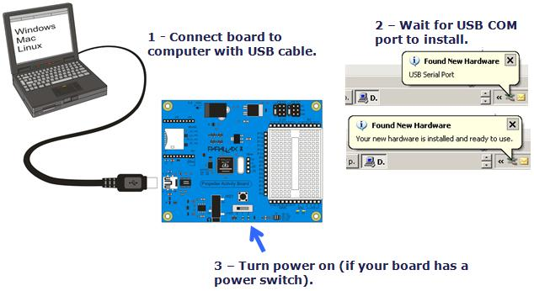

Once the robot is connected, the COM port should be selected from the dropdown. Next, simply hit the “Load to EEPROM and run” button. Once the program has finished loading, you may move the power switch back to position 0 and disconnect the robot. Now, whenever the robot’s power switch is set to position 2, the program loaded will be run.

