How to download and install
Stress Ball1.1
By Thomas Wolf

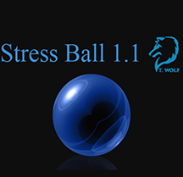

- You first want to enable debugging on your phone. Best way to do this is google your phone with key words like debugging. Or how to turn on debugging. I have a galaxy s7 and for most galaxy phones this is the same. It can be quite different from phone to phone as I had to turn on development mode first. Below is a helpful link for Galaxy s7 users
  - https://www.technipages.com/galaxy-s7-enable-usb-debugging

- Now if you don’t you will need to download and install Android Studios. This is free to do and can be found at the link below.
  - https://developer.android.com/studio/index.html

- There are many different sdks you can download for android studio deepening on how far back you what you app to be backwards compatible with. The best help I could have ever asked for was from a class on udemy for setting up android studio and learning a lot about its features. This class can be expensive but it does go on sale for around 15$ from time to time. Follow the link below if you need extra help setting up android studio properly.
  - https://www.udemy.com/master-android-7-nougat-java-app-development-step-by-step/learn/v4/content

- Now that you have android studios installed you can download my app from the website where you found this how to guide. It will be in a zip file. Unzip it and store it where you want on your pc.

In order to run my application you need to import the project. This can be done in 2 ways.
- From the main screen of android studio

- Or if you are a user and have a project open it can be done from within android studio

At this point once you click import go to the directory you have stored the file at and double click on the android Icon.
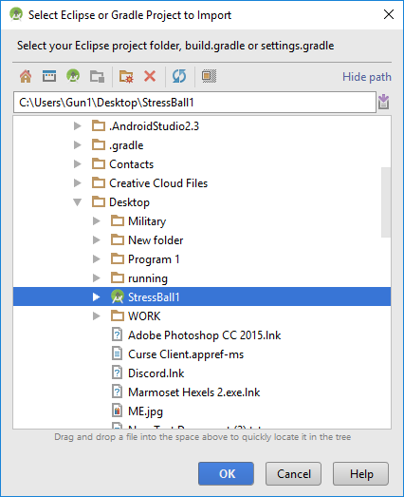

***Disclaimer***
Now that you have Stress Ball imported there are a few things I need to point out. First off I have turned off all the features that run oAuth2, as this would cause the app to crash right now. The reason for this is in the future I probably will not be updating my fitbit data very often and if a user tries to run oAuth2 nothing will be returned to the arrays and most features will crash.

So in the mean time I have saved some data files from previous runs and hardcoded those into the app so you can still see all the features work. In the code I have comments what to turn on when oAuth2 is working.
****

Once you have the app installed and your phone plugged into you pc unlocked and debugging turned on. Click the green play button in android studio.

A screen will pop up. If you have an emulator installed you can use that as well to run the app. I will be choosing my emulator for this run. Your phone will show up in connected devices once plugged in via usb.
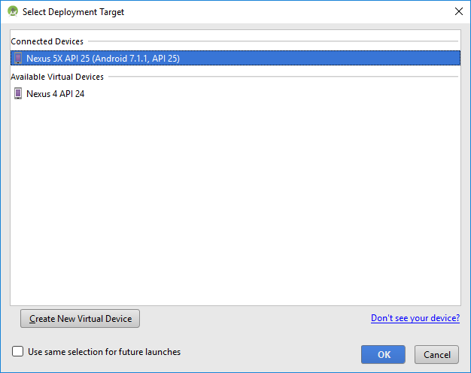

Now that the app is running it should look something like this
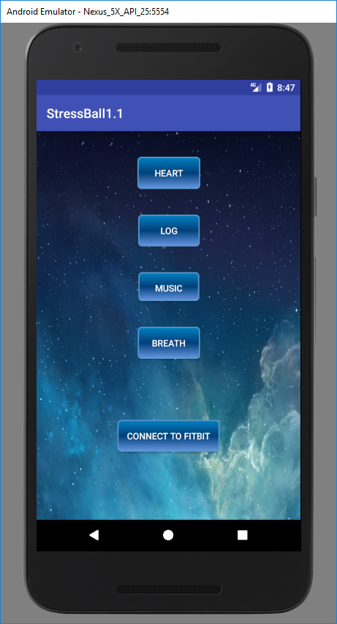

Heart Button …. Page 7
Log and Journal …. Page 8 and 9
Music …. Page 10
Breath …. Page 11
Connect to fit bit is one of the features in the app I shut down. But is used to make initial connection to fit bit app and will eventually be put into a settings activity

The Heart Button:
If you click on the heart button you will be redirected to the heart activity which will show you a visual of current heart rates monitored and as well as sleep, resting heart, and steps taken in a text field below the graph it will look something like this.

This Data is Hardcoded so it should look the same on your emulator/phone

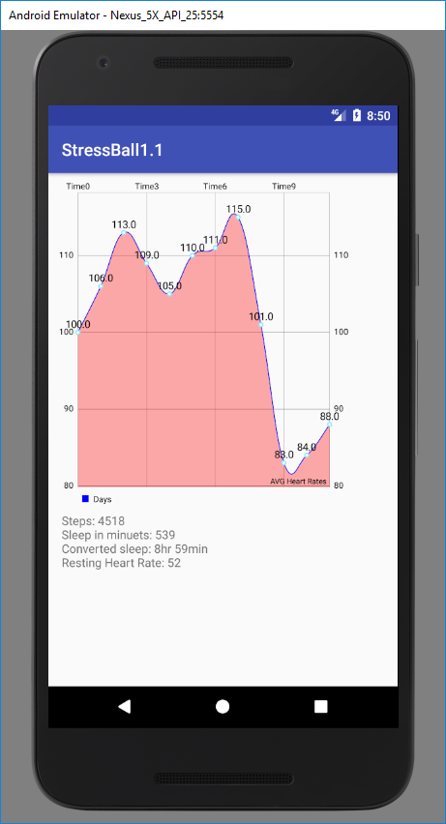

The Log Button:
The Journal activity will start. Here the user can look at previously saved log entries that populate in a spinner or drop down box. Once Load is clicked it will look at which file was selected from the drop down and display the contents below. If the user wishes to write about their current mood they can click on the new entry button and Journal about their day and the mood they are in to help find patterns in stress.

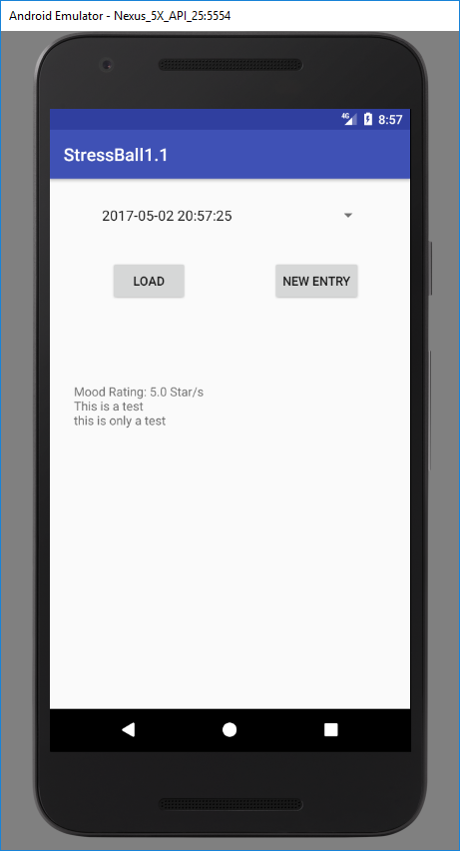

New Entry:
In the new entry activity a text box will get the focus so you can start writing about your day. Once you are done writing and the key board goes away you will have an option to rate your day with the starts below. Once saved is clicked the text field is wiped clean and you will receive a notification that it is saved. Once you return to the previous screen you will be able to select your save from the drop down menu.

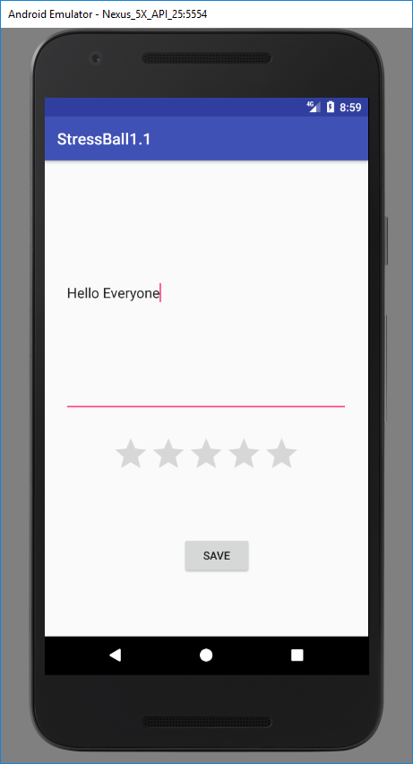

Music Button:
Once clicked the media player screen will appear. This is a simple media player which gives the user the option to calm down while listening to a variety of music from a thunder storm, to chill step. The user can pause the music and pick up where they left off or select a different song and play a new beat

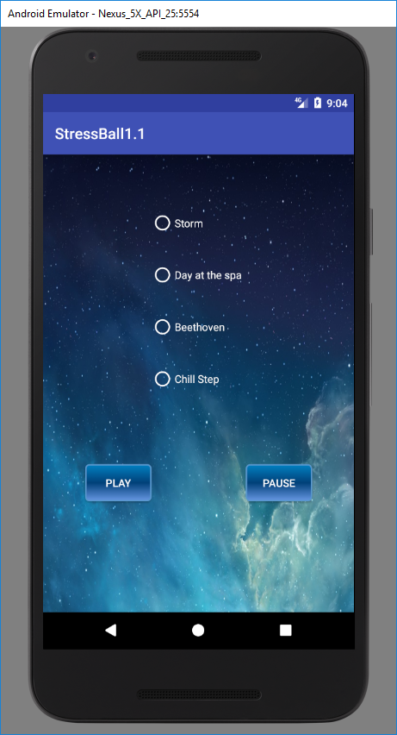

Breath Button:
This should be breath button however, the user will be able to take the chance to breathe with the app with two different breathing techniques. Unfortunately these are giffs at the moment and are brought to the screen using a random number generator. Depending on the number you may get one of two giffs.
Lines giff is a simple 5 second breathing technique where you breathe out as the line collapse and breathe in as they expand.

The balls is a more complicated breathing technique where you breath in as they expand hold your breath as they rotate and breath out as they collapse.

Below are example images of the two.

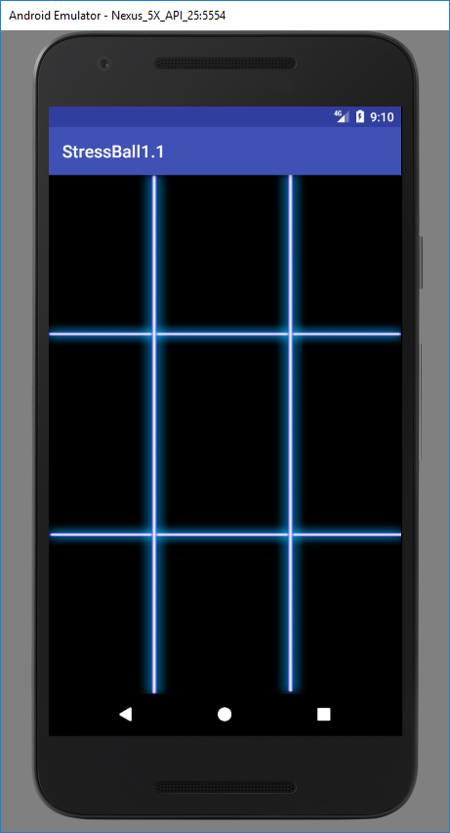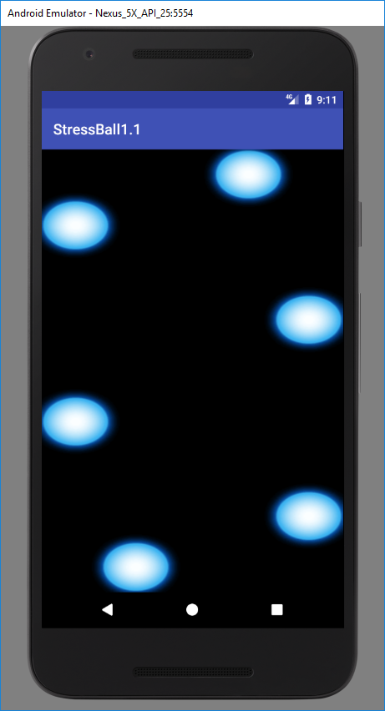

Thank you for installing my app I hope you enjoy it as much as I have

Respectfully,

Thomas Wolf

