Senior Capstone
Mike Stanaszak
Documentation

Schema of the Database
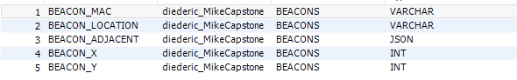
X / Y is how it’s displayed on the bitmap, static placement on the screen.
Beacon Adjacent is a column with JSON and is structured as follows:
{"0": {"MAC": macAddressNorth}, "1": {"MAC": macAddressEast}, "2": {"MAC": macAddressSouth}, "3": {"MAC": macAddressWest}}

Example Row:
'DD:34:02:06:73:18',
'STW013',
'{\"0\": {\"MAC\": \"DD:34:02:06:72:0D\"}, \"1\": {\"MAC\": null}, \"2\": {\"MAC\": null}, \"3\": {\"MAC\": null}}',
'700',
'300'

If Location has something in it, a varchar, it will be able to be routed to on the app. Otherwise, we treat it as a “passing beacon”. Or nobody can route to said beacon.

NOTE inside the Database Handler file, you will need to change the login info the SSH/Database credentials. These were removed due to it being a public site.

Rest of documentation can be found within the project files / plain files via comments/logs.

