EXPLANTION OF WHAT THE ROBOT IS “SEEING” (via Rviz)

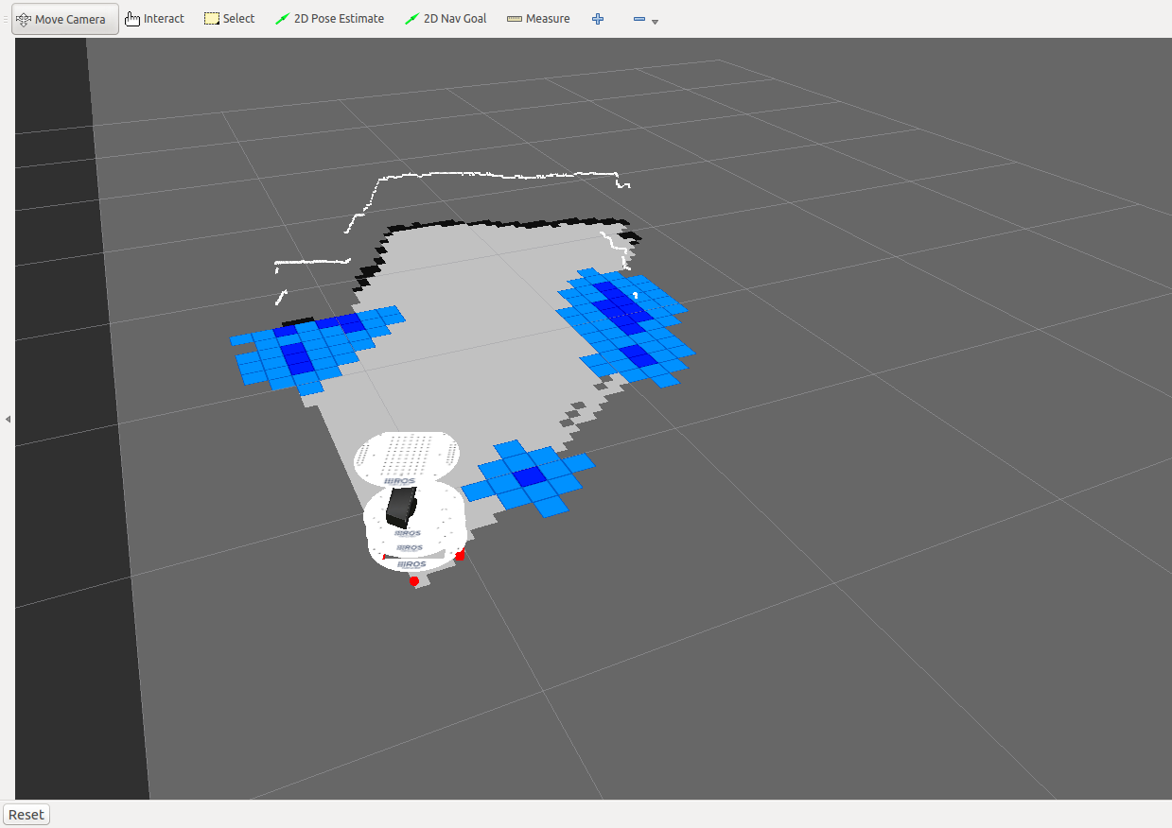
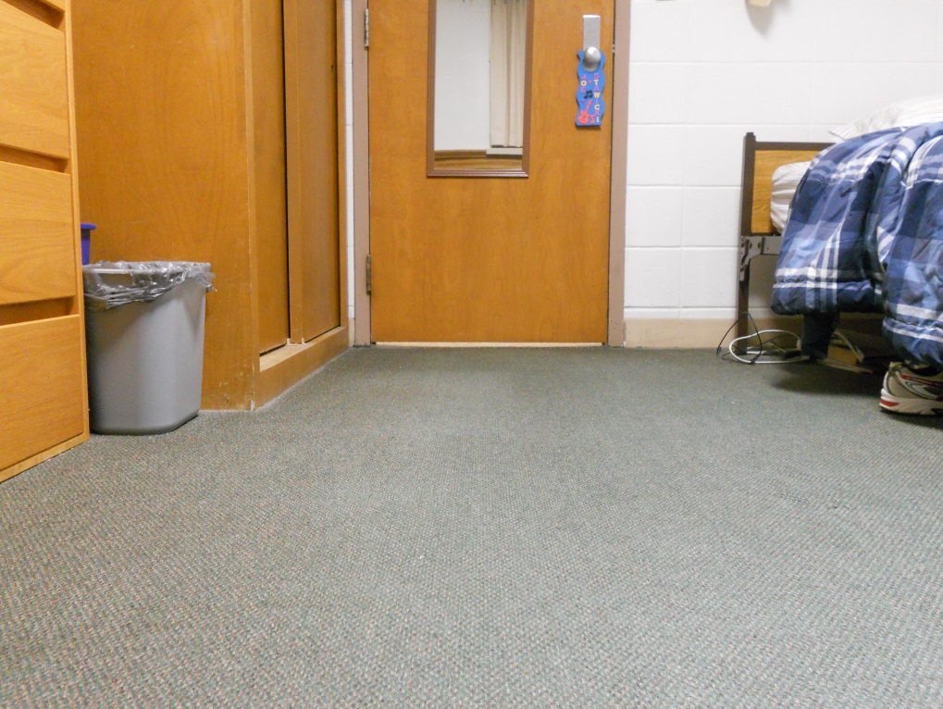

The white line on the right picture represents what the laser scanner of the Kinect sensor is seeing. It is supposed to be a 3D image, so it is above the actual map (giving it the 3D perspective). The darker blue represents an object and lighter blue represents that object “inflated,” like a safety net to the robot so it doesn’t get too close to an object. From this picture, the bed appears to be an object, the dresser is also seen as an object. The wall/door is also clearly visible, and marks the outer boundary of the room (the outer black line of the image). I highlighted object in the picture the same color as on the map to show where things appear in each.

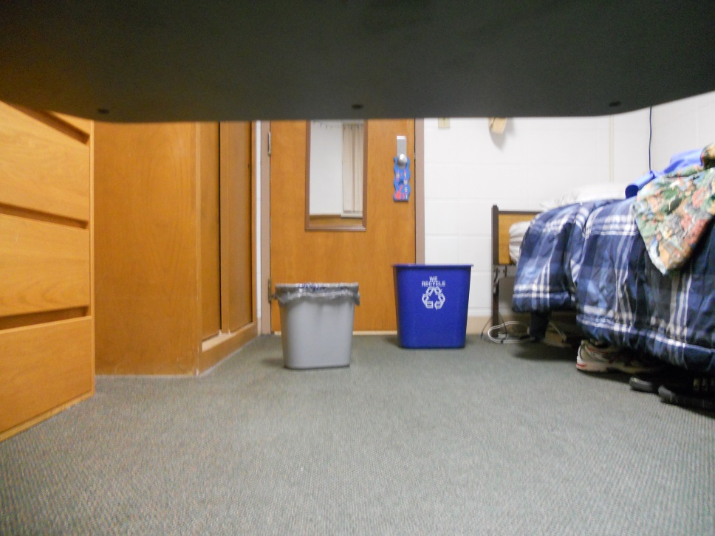
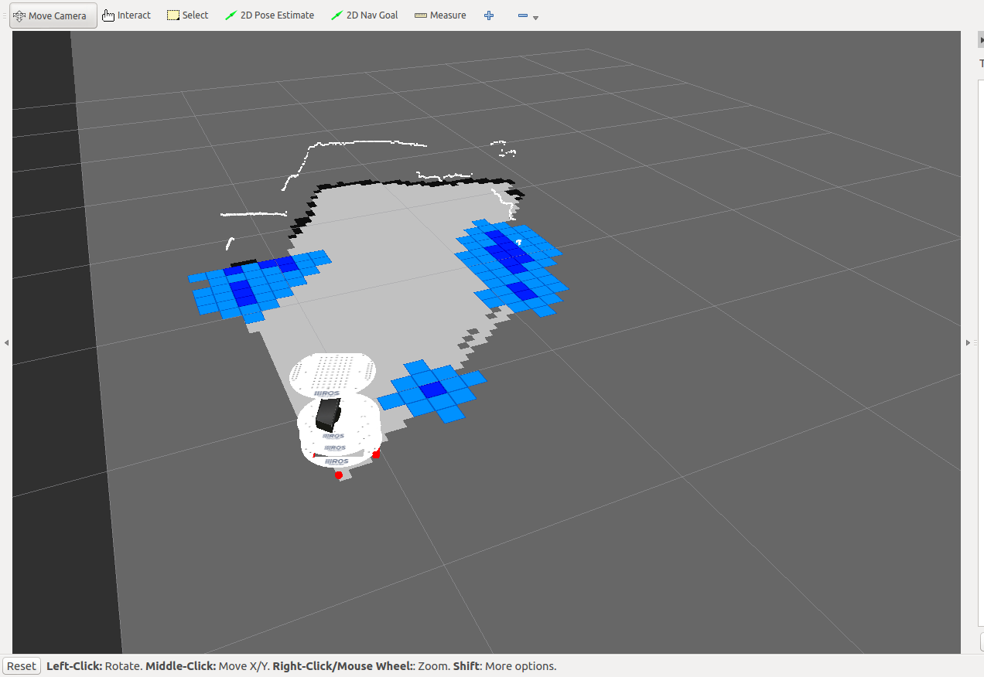

In this snapshot, the garbage can is not recognized by the Kinect sensor (it can only see so high and to a certain distance). However, the recycling bin can be seen. The sensor sees the recycling bin as part of the boundary, you can see that the white line towards the back of the map indents due to the recycling bin (it doesn’t display this as a blue object but as part of the boundary). The bed is still an object here as well as the dresser.

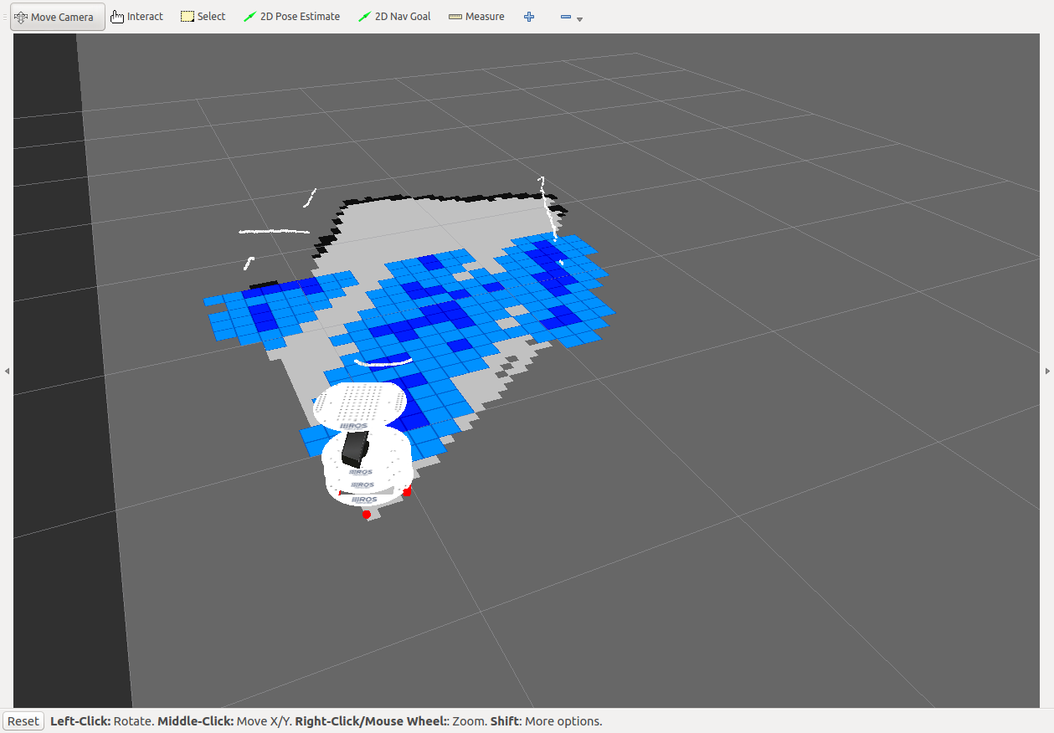
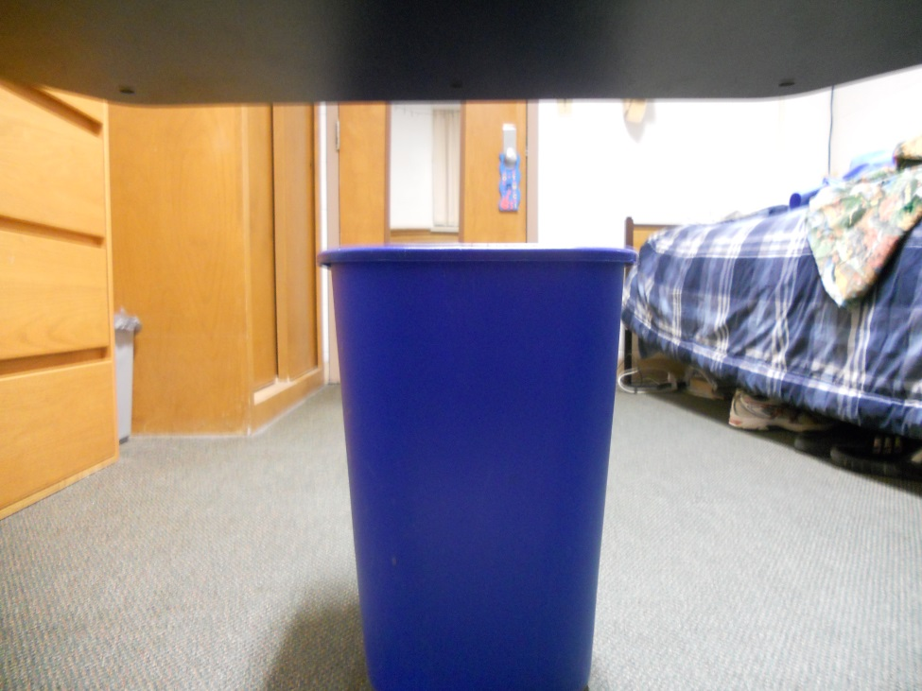

Well this is interesting. I put the recycling bin in front of the Kinect’s sensors. You can see that the laser scanner sees the object with a white line, however it cannot see the wall as the outer boundary as the recycling bin blocks its view. In addition, it doesn’t know what is behind the recycling bin, so it thinks that there are many objects behind it (in the dark and light blue colors). It has no knowledge of really anything but the recycling bin that’s in front of it. It can see the bed and dresser still, though.

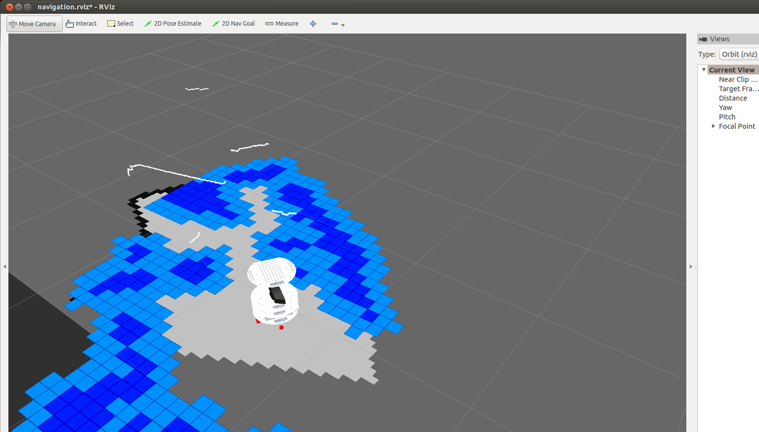
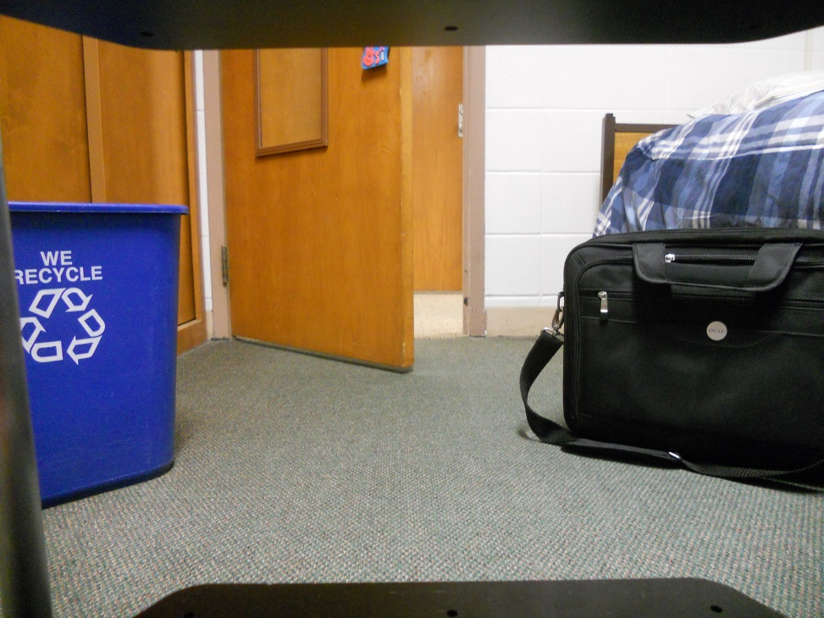

This is another very interesting scenario. I opened the door and the robot actually sees the wall behind the door as one of its boundaries. In addition, it picks up the laptop case as an object along with many things behind the case as objects. It also sees the recycling bin as an object and the open door as an object.

