HOW TO START UP THE TURTLEBOT AND USE NAVIGATION

Note: Commands are in Bold
1) Turn on both laptops in Ubuntu
2) Make sure both laptops are on the same wireless network
3) Make sure all of the environment variables are set up correctly (i.e. the IP addresses of both are correct) – See below for more information
4) Place the Turtlebot laptop (the Toshiba) on the Turtlebot and close the lid. Plug in the robot’s and the Kinect’s USB ports into the laptop. Turn on the robot.
5) Open a new terminal on the Workstation laptop
6) SSH into the Turtlebot: ssh turtlebot@IP_OF_TURTLEBOT
7) Then type: source ~/turtlebot-rosbuild/setup.bash
8) And: roslaunch turtlebot_bringup minimal.launch
9) Open a new terminal on the workstation laptop and type: rosrun rqt_gui rqt_gui –s “create_dashboard”
10) When that screen comes up, put the robot in “Full mode” by clicking on the settings icon and clicking “Full mode:”

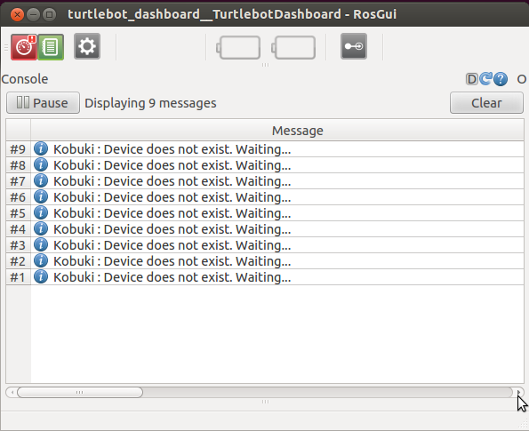

11) In a new terminal type:
roslaunch turtlebot_teleop keyboard_teleop.launch (Key presses in this terminal can now be used to control the robot.)
12) Open a new terminal and ssh into the turtlebot laptop: ssh turtlebot@IP_OF_TURTLEBOT
13) From that same type the following: roslaunch turtlebot_navigation gmapping_demo.launch
14) Open a new terminal and type: roslaunch turtlebot_rviz_launchers view_navigation.launch
15) Go back to the terminal that has the teleop command and drive the robot around the area you wish to map using the keyboard
16) When finished, Ctrl+C the terminal running the teleop, then type in the following command to save the map: rosrun map_server map_saver –f /tmp/map_name
17) After it says done, press Ctrl+C, then close the terminals.
18) DONE

TO NAVIGATE A SAVED MAP
1) Make sure steps 1-4 are completed from above
2) Open a new terminal on the Workstation laptop and type the following to SSH into the turtlebot laptop: ssh turtlebot@IP_OF_TURTLEBOT
3) Then type the following command in that terminal: roslaunch turtlebot_navigation amcl_demo.launch map_file:=/tmp/map_name.yaml
4) Open a new terminal and type: roslaunch turtlebot_rviz_launchers view_navigation.launch (This will open the rviz program)
5) In rviz, Click the “2D Pose Estimate” button and click on the map where the Turtlebot is approximately and drag in the direction that the Turtlebot is pointing.
6) To send the robot to a point on the map, click the “2D Nav Goal” button and click on the map where you want the Turtlebot to go to and drag in the direction the Turtlebot should be pointing once it gets to the destination. (NOTE: the turtlebot may not always be accurate and the bump sensors are not used when navigating)
7) DONE

Appendix: Setting up Environment Variables (IP Addresses)

1) Make sure you know the IP addresses of both laptops, the (known in this tutorial as IP_OF_TURTLEBOT and IP_OF_WORKSTATION), you can configure this out by doing the following:
In a terminal, type
- ifconfig
You will see something like:
- lo Link encap:Local Loopback
- inet addr:127.0.0.1 Mask:255.0.0.0
- inet6 addr: ::1/128 Scope:Host
- UP LOOPBACK RUNNING MTU:16436 Metric:1
- RX packets:6658055 errors:0 dropped:0 overruns:0 frame:0
- TX packets:6658055 errors:0 dropped:0 overruns:0 carrier:0
- collisions:0 txqueuelen:0
- RX bytes:587372914 (587.3 MB) TX bytes:587372914 (587.3 MB)

- wlan1 Link encap:Ethernet HWaddr 48:5d:60:75:58:90
- inet addr:10.0.129.17 Bcast:10.0.129.255 Mask:255.255.254.0
- inet6 addr: fe80::4a5d:60ff:fe75:5890/64 Scope:Link
- UP BROADCAST RUNNING MULTICAST MTU:1500 Metric:1
- RX packets:101983 errors:0 dropped:0 overruns:0 frame:0
- TX packets:37244 errors:0 dropped:0 overruns:0 carrier:0
- collisions:0 txqueuelen:1000
- RX bytes:49326141 (49.3 MB) TX bytes:7588044 (7.5 MB)
- the network interface for the wireless card is wlan1
- the IP address of the computer is 10.0.129.17

2) On the Turtlebot laptop (or by using SSH to the Turtlebot laptop), type the following command: echo export ROS_MASTER_URI=http://IP_OF_TURTLEBOT:11311 >> ~/rosbuild-catkin/setup.sh
3) Run this following command as well: echo export ROS_HOSTNAME=IP_OF _TURTLEBOT >> ~/rosbuild-catkin/setup.sh
4) On the Workstation laptop, type the following command: echo export ROS_MASTER_URI=http://IP_OF_TURTLEBOT:11311 >> .bashrc
5) Run this following command as well: echo export ROS_HOSTNAME=IP_OF_WORKSTATION >> .bashrc
6) On the Workstation laptop run source .bashrc
7) DONE.

