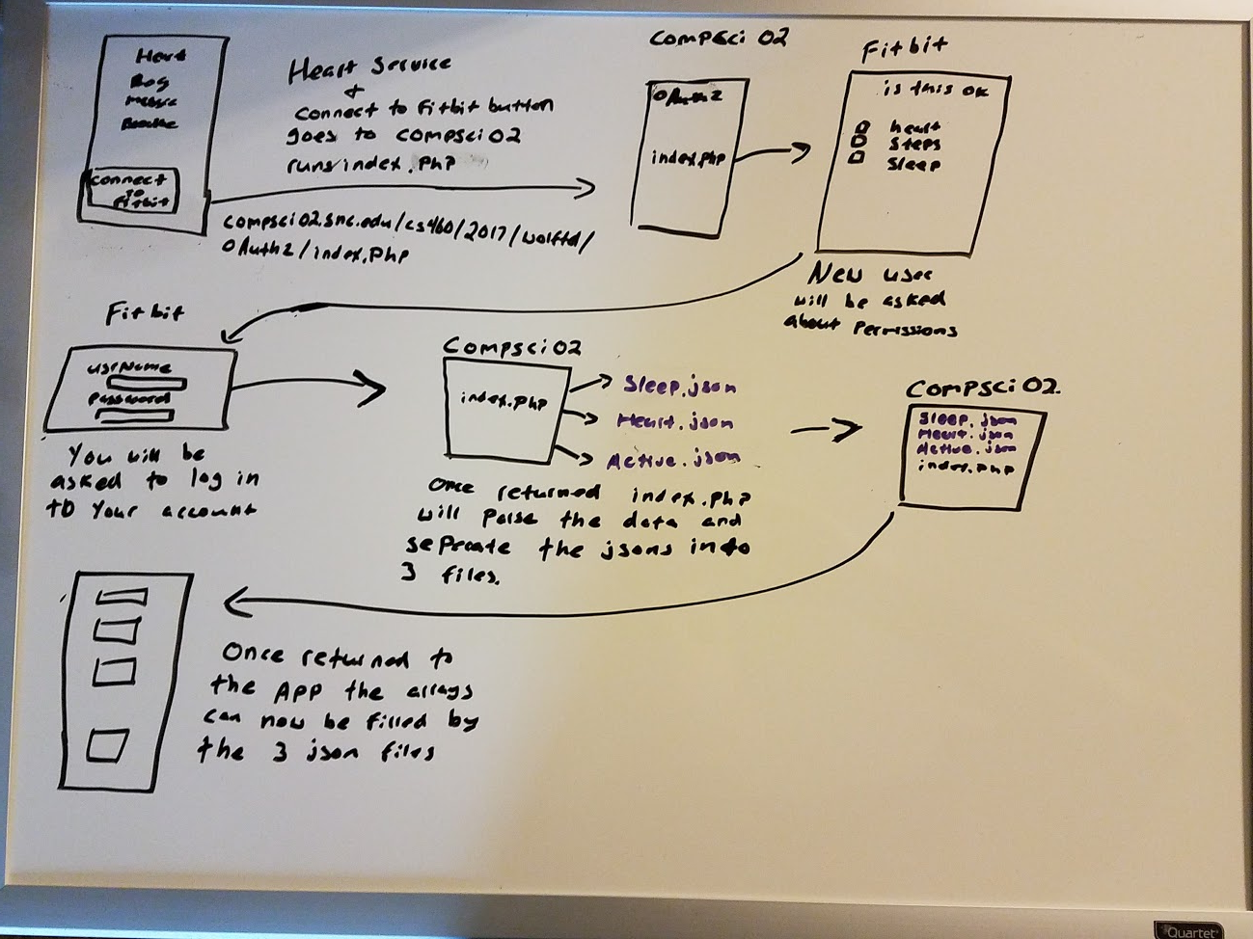

How the heart service and connect to fitbit button does. When you download and the app is first run on your pone it will make a call to index to php. This file resides at compsci02.snc.edu/cs460/2017/wolftd/oauth2/index.php.
Once index.php is running the phone will be directed to fit bit where ouath2 will exchange keys and tokens and prompt the user to grant the app permission to grab heart, steps, and sleep data.
Then the user will be asked to log into fit bit. As soon as the user is logged into their account you will be redericted back to compsci02 and index will let you know when it has finished parsing the data collected from fit bit.
Index.php will parse the data into 3 separate files also stored at the same location with the names of heart.json sleep.json and steps.json.
Once the user hits the back button to return to the app all functions in the asp will now work and the arrays will be updated with the correct data from each of the 3 json files.

