St. Norbert College CSCI 460

18
Shape Recognition Game Manual
By Robert Bengtson
Spring 2018

Table of Contents
- Project Description
- Project Instructions
  - First Time Install
  - Opening in Unity
  - Controls
  - Hints

First Time Install
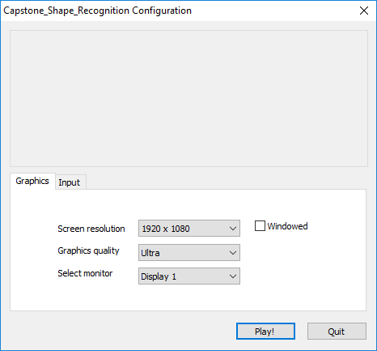
- The Project is in a self-contained exe simply download all the files (or if you are reading this it should already be on the flash stick!) and click the exe
- You will be presented with this screen you do not need to change anything just simply hit the play button! (it will load for it bit be patient!)

- You are Ready to PLAY! (You will have to end process to quit! Sorry!)
Opening The Project in Unity
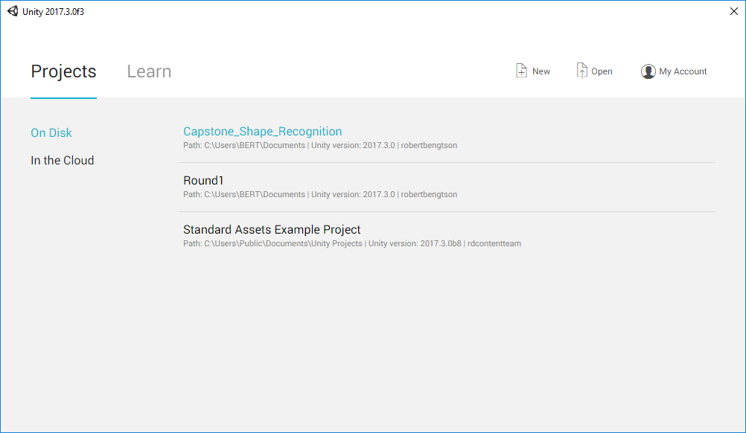
- Opening the project in Unity should be relatively easy. First have an install of Unity on the target computer.

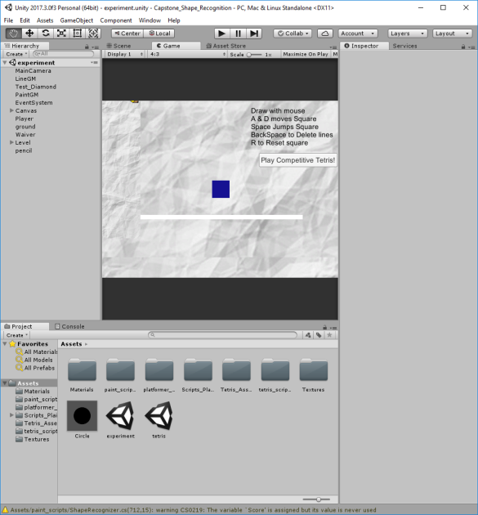
Once you are on this screen simply hit the open button and point to the project folder

YOU DID IT!
Controls
Experiment Level
Mouse- Left click to initiate drawing release to stop
- Move box left
D- move box right
R- reset box
Space- hop box
BackSpace- delete lines
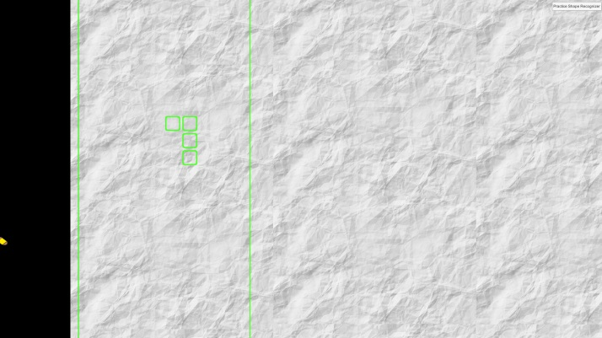
Tetris Level

Player 1 Mouse- Same as Experiment, draw shapes to have them enter Tetris field.
Player 2 Arrow Keys- move and rotate Tetris pieces
Hints
- The First line is normalized to a magnitude of 1 and used to compare to each line after, so the first line is the most important!!!
- Try not to leave the hexagon if you are not changing directions!
- The Better you draw the faster The Tetris pieces drop!

