PhotoSynthesis User Manual
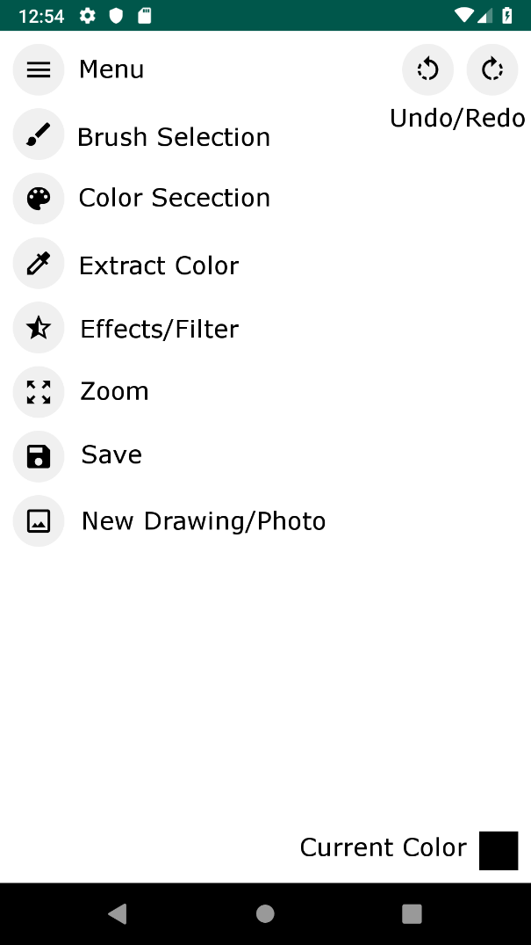
Menu
When the menu is hidden, clicking this button will drop down all the tool buttons that the user is able to use. When the menu is out, clicking this button will minimize all the tool buttons that the user is able to use.
Brush Selector
Clicking the brush selector tool will bring up the brush selection dialog. In this dialog the user can choose their brush shape and brush size. When the user is happy with their changes, they need to click the ‘confirm’ button in order to apply those changes. If the user is not happy with the changes, they can click outside the dialog to cancel the changes and dismiss the dialog.
Color Selector
Clicking the color selector tool will bring up the color wheel dialog. This dialog consists of a color wheel and three sliders, hue, saturation, and brightness. The user can select their color directly from the color wheel by clicking on it. They can also change the color further by using the sliders to affect the values of its hue, saturation, and brightness. When the user is happy with their changes, they need to click the ‘confirm’ button in order to apply those changes. If the user is not happy with the changes, they can click outside the dialog to cancel the changes and dismiss the dialog.
Extract Color
Clicking the extract color tool will change the active tool to the color extractor. This tool allows the user to click anywhere on their canvas and change the current color of their brush to the color of the point they just clicked. (If the user clicks outside the canvas the application will crash)
Effects/Filters
Clicking the effects/filters tool will bring up the effects dialog. This dialog contains all the effects that the user can apply to their canvas. Once an effect is chosen the dialog will be dismissed. (The Black and White affect runs slowly, after selecting it wait a couple seconds for it to take affect before doing anything)
Zoom
Clicking the zoom tool deactivates the brush or extractor and allows the user to zoom in and out of their canvas by using the pinch gesture.
Save
Clicking the save button brings up the save dialog. This dialog asks the user to confirm if they want to save their edited image to their phone’s gallery. By clicking ‘ok the image will be saved, and the dialog will be dismissed. By clicking ‘cancel’ the dialog will be dismissed without the image being saved.
New Drawing/Photo
Clicking the new drawing button opens the new dialog. This dialog has four options, blank canvas, upload image, take photo, and stock image. The user just has to click on one in order to select it. Choosing blank canvas will give the user a white canvas with nothing on it. Choosing upload image will allow the user to select an image from their phone to edit. Choosing take photo will allow the user to access their camera and take a photo to use in the application (Bug: first photo taken won’t show up). Lastly choosing stock image will bring up the stock image dialog which allows the user to choose from eight different photos to edit.
Undo/Redo
Undo keeps track of all the brush strokes and filters that the user has used. Redo keeps track of all the users undone brush strokes and filters. After undoing if the user draws or applies a new filter the redo is cleared out. Clicking these buttons will update the users canvas accordingly.

