Nathan Labott
SNC Lab Bot
Spring 2019
Initial Bot Set Up

- Depending on if the bot was already connected to a WIFI-connection, you may need to reset the bot to get it back into searching mode. So that it will look for another WIFI connection, instead of looking for the old one. To reset the bot you’ll want to, while the bot is either in power mode 1 or 2, press the reset button four times rapidly. The reset button is highlighted below in red.
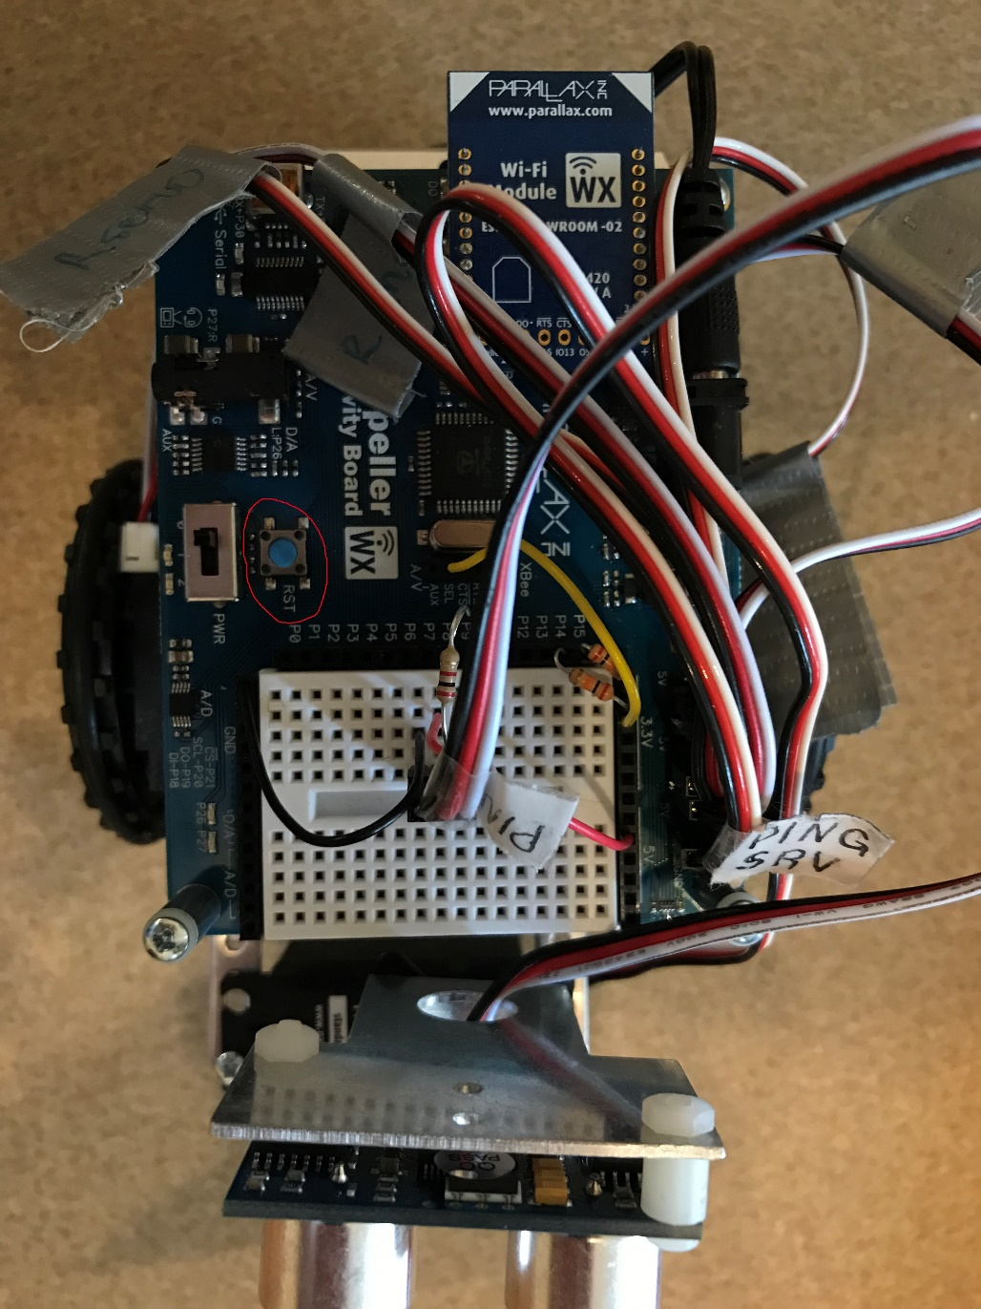

- You’ll know that the reset was complete when you see the bot’s own WIFI reception pop up in your list of possible WIFI connections. This can be seen below.

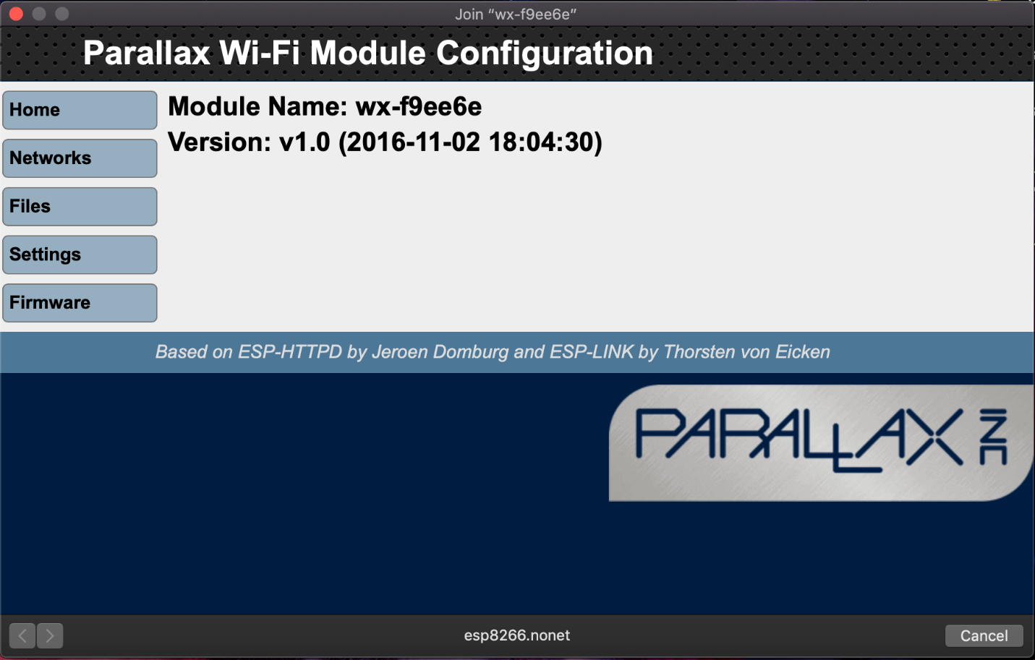
- Once you connect to the above wifi network, a dialogue box should open looking something like the below image.

If for some reason the dialogue box does not open, in your browser in the URL type in: http://192.168.4.1
The machine you are on has to be connected to the bot’s WIFI when you type this IP address into your URL.

- From here, click on the networks button on the left hand side.

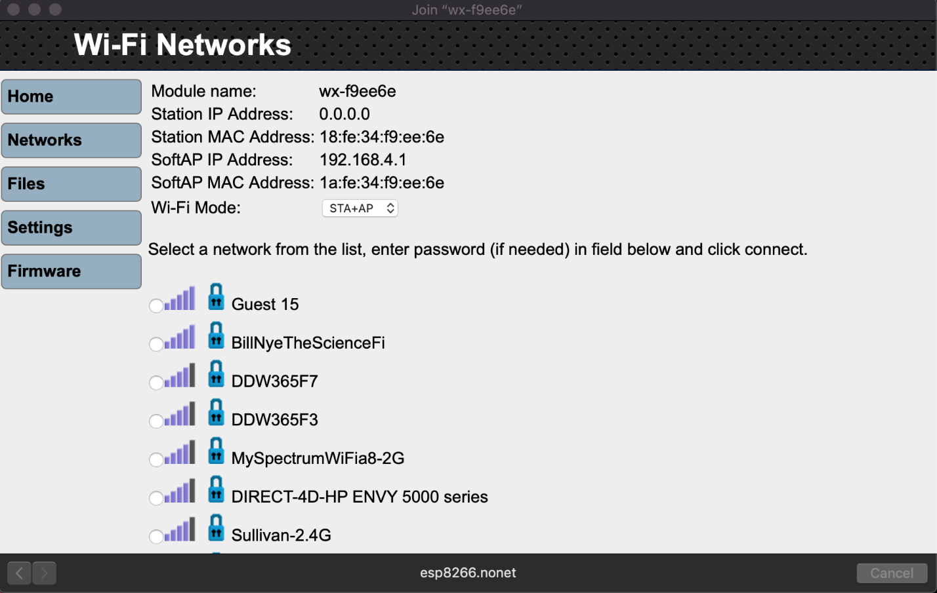

This is where you will select the network you want to join. At the bottom of the list you’ll have a textbox to enter your network’s password (if applicable). Once your bot joins a network successfully, it will be assigned an IP address. Take note of this immediately. When connecting to the bot in the future or accessing a webpage stored on the bot, you’ll need to enter this IP as a part of the file path.
For example, when accessing the bot control webpage, I would enter: 192.168.0.19/files/mainActivityBot.html
When setting up your bot, the IP address will be different but the rest of the path will be the same if accessing the control webpage of the bot.

To clear the bot file storage, or add a file, click on files on the left side of that interface. The button right below networks. Then you can either clear file storage or upload a new file. Then you would access that file the same way as described above, the IP address followed by files/YourFileName.
https://www.parallax.com/sites/default/files/downloads/32420-Parallax-WX-WiFi-Module-Guide-v1.0.pdf
The link above (from pages 6-9 in the PDF) describe what I have just described above.

The SimpleIDE Environment:

- https://learn.parallax.com/tutorials/language/propeller-c/propeller-c-set-simpleide
This link will teach you how to set up the environment for which the bot operates from. From this point on I will assume the user has followed these instructions and has their environment ready to go.
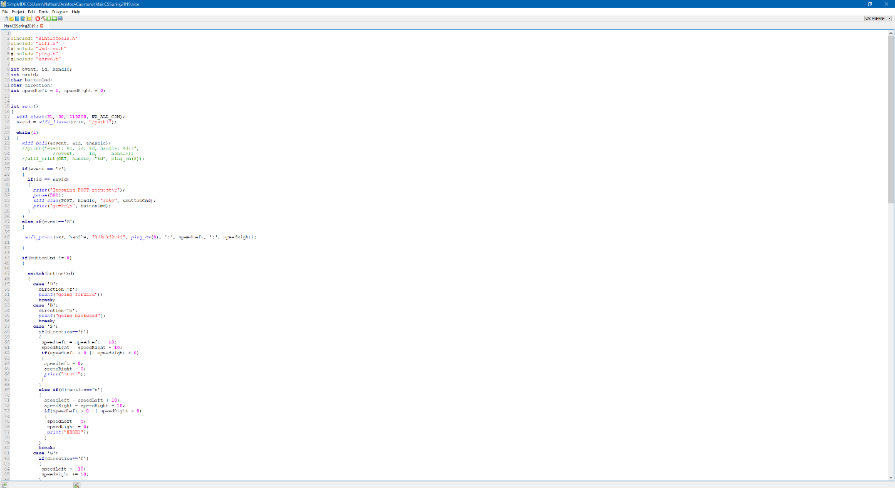

- Above is the SimpleIDE environment. In order to send something to the bot, you have to have the proper module selected. If your bot is connected via USB to micro USB, or not wireless you will need to select a COM port.
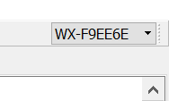

- Above is the port select dropdown. When you select the dropdown it will automatically search for ports. For the program to work, you must select the WIFI port shown above. If you plan to program without wireless capability, connect the USB to micro USB cord to the bot and the proper COM port will show in the dropdown.
- There are two ways to build, compile and the send the program to the bot:
  - BUILD and LOAD to EEPROM – this builds and sends the program to a more permanent storage on the bot. Do this when you know the program is more of a final product.
  - BUILD and LOAD to RAM – this builds and sends the program to a more temporary storage on the bot. Do this when you’re testing something.
- Running with terminal builds and sends to the bot’s RAM, allowing for terminal outputs within the SimpleIDE. Use this when your program has test outputs and different variables within the code.

