Nathan Labott
4/29/19
Lab Bot User Manual
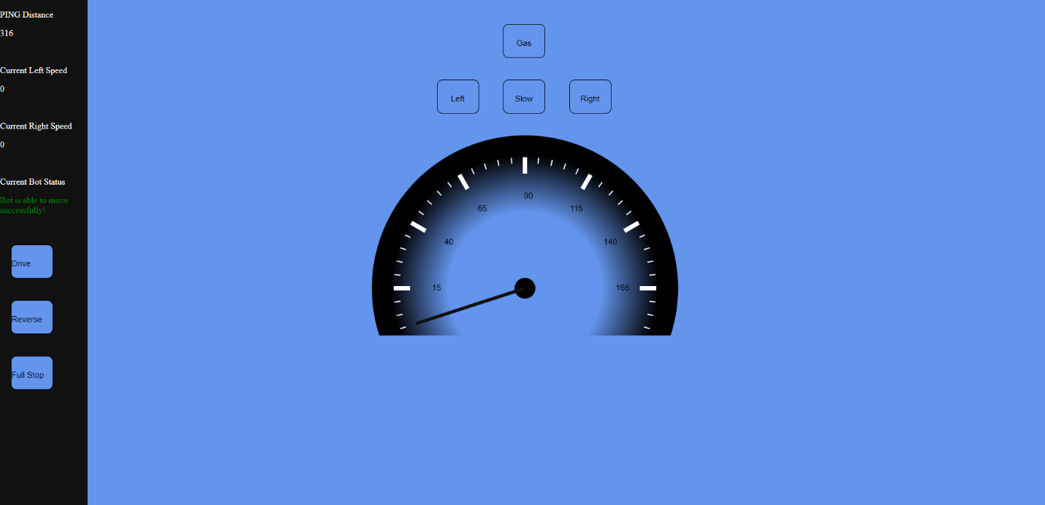

This is the bot’s main UI. It has a variety of features and abilities, so I’ll go one by one explaining everything.

- The Left-hand pane:
  - The PING Distance
    - This number gets updated every half second as the webpage requests distances from the bot. If the distance is less than 10 cm the bot will not move.
  - Current Left/Right Speed
    - This is the respective speeds of the left and right wheel. These two speed should remain the same unless moving left or right.
  - Current Bot Status
    - This message is for the user to know if the bot can move or not. If the text is green the bot can move, red the bot can’t. The text changes based on if it can move or not.
  - Drive
    - Sets the bot into the forward gear. This button or the reverse button must be pushed before making the bot move. Pressing gas or left or right before pressing the drive or reverse button will produce unintended/unpredictable movements.
  - Reserve
    - Sets the bot into the reverse gear. Same description as Drive above.
  - Full Stop
    - For emergencies. Completely stops the bot no matter what.
  - Gas
    - Depending on what gear the bot is in, forward or reverse, increases the speed of the left and right wheels by 10.
  - Slow
    - Is a sort of brake, decreases the left and right wheels by 10.
  - Left
    - Turns the bot left by decreasing the left wheel speed by 5.
  - Right
    - Turns the bot right by decreasing the right wheel speed by 5.

