GIVEN THE HIGH CORRELATION BETWEEN OUR PROJECTS AND THEIR IMPLEMENTATION, THIS “INITIAL BOT SET UP” IS A SLIGHTLY MODIFIED VERSION OF NATHAN LABOTT’S “INITIAL BOT SET UP” FROM THE 2019 SPRING SEMESTER. THE ORIGINAL VERSION OF NATHAN LABOTT’S “INITIAL BOT SET UP” CAN BE FOUND AT THE FOLLOWING URL LINK: http://compsci02.snc.edu/cs460/2019/labonw/uploads/1/2/4/1/124126046/initialbotsetuphowto.docx

Alan Deuchert
SNC Lab Bot
Spring 2020
Initial Bot Set Up

- Depending on if the bot was already connected to a Wi-Fi connection, you may need to reset the bot to get it back into searching mode so that it will look for another Wi-Fi connection, instead of the old one. To reset the bot, you will want to, while the bot is either in power mode 1 or 2, press the reset button four times rapidly. The reset button is highlighted below in red.
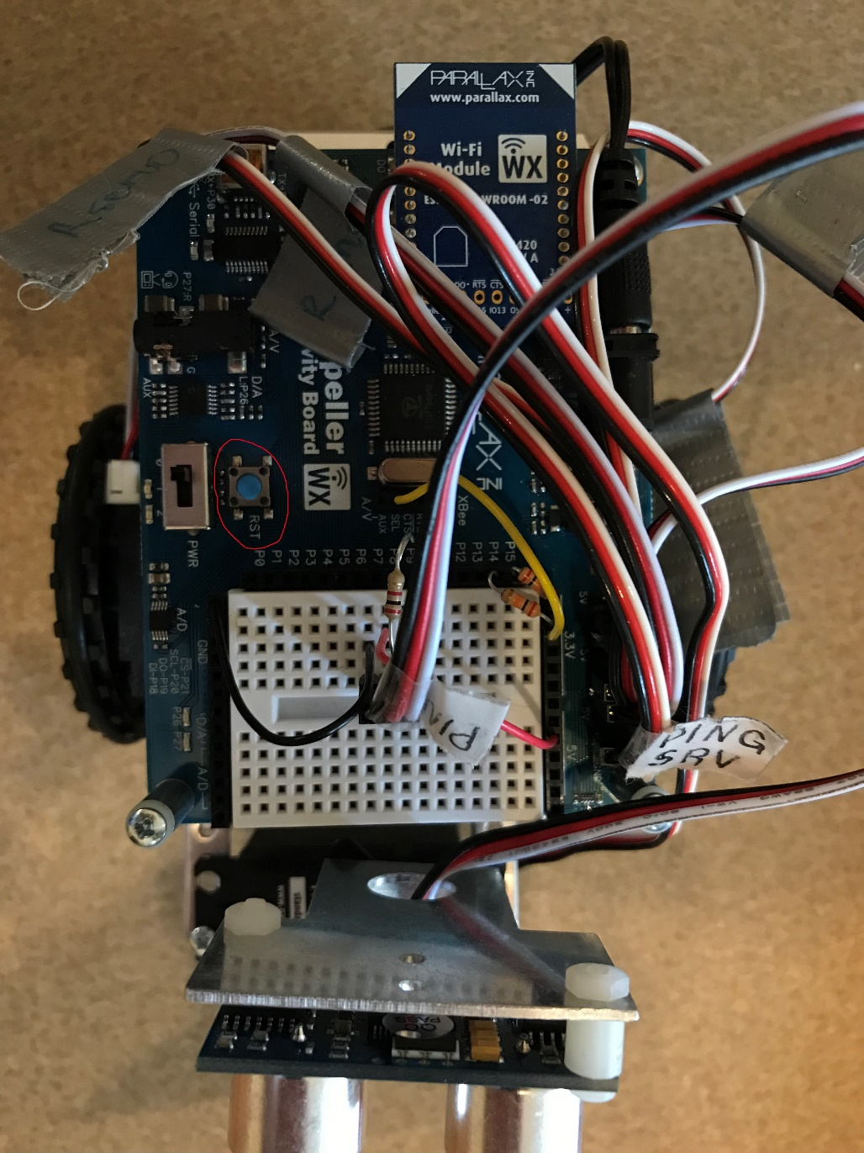

- You will know that the reset was complete when you see the bot’s own Wi-Fi reception pop up in your list of possible Wi-Fi connections. Select wx-f9ee6e.

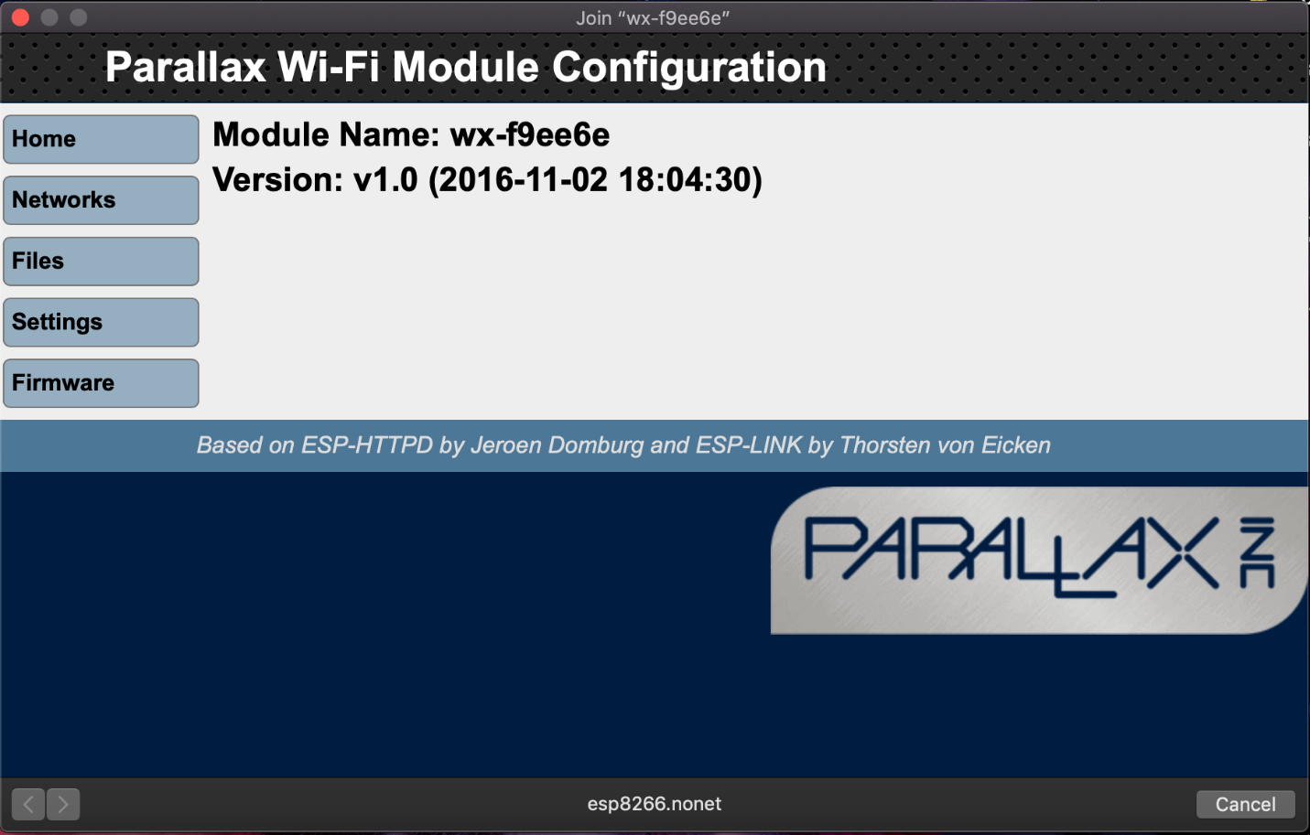
- Once you connect to the above Wi-Fi network, a dialogue box in your web browser should open looking something like the below image:

If for some reason the dialogue box does not open, in your browser in the URL type in: http://192.168.4.1
The machine you are on MUST be connected to the bot’s Wi-Fi when you type this IP address into your URL.

- From here, click on the networks button on the left hand side.

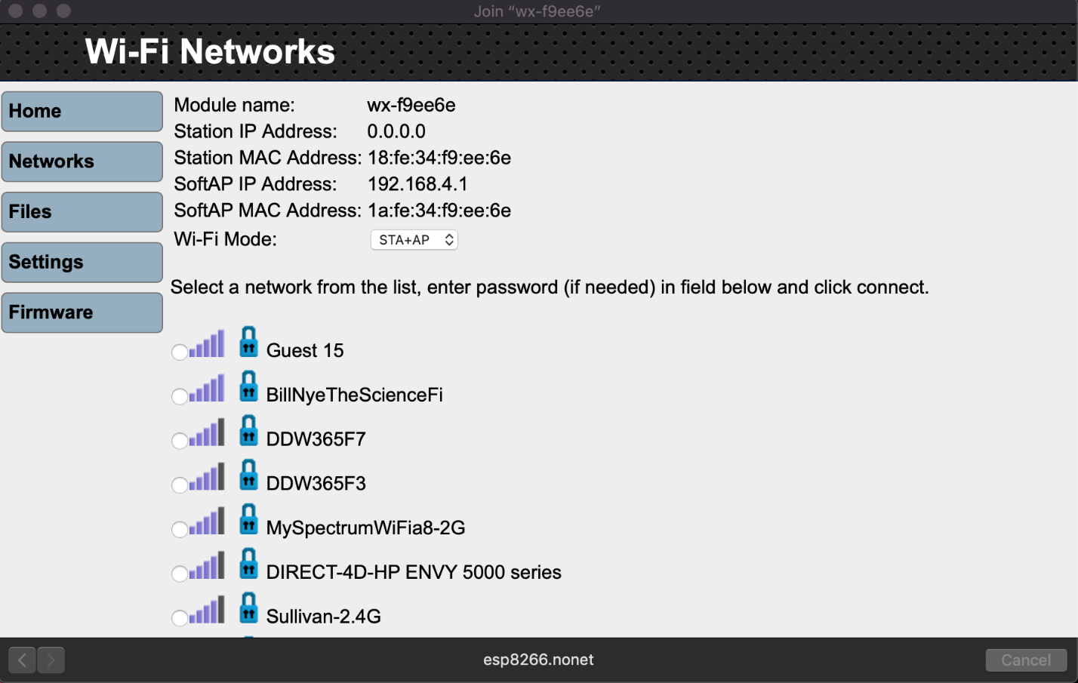

This is where you will select the network you want to join. At the bottom of the list you’ll have a textbox to enter your network’s password (if applicable). Once your bot joins a network successfully, it will be assigned an IP address. Take note of this immediately. When connecting to the bot in the future or accessing a webpage stored on the bot, you’ll need to enter this IP as a part of the file path.
When setting up your bot, the IP address will be different, but the rest of the path will be the same if accessing the control webpage of the bot.
To clear the bot file storage, or add a file, click on files on the left side of that interface. The button right below networks. Then you can either clear file storage or upload a new file. Then you would access that file the same way as described above, the IP address followed by files/YourFileName.
For example, when accessing the bot control webpage for automated control, I would upload auto.html and then enter 192.168.4.1/files/auto.html in my web browser to go to that html page.
https://www.parallax.com/sites/default/files/downloads/32420-Parallax-WX-WiFi-Module-Guide-v1.0.pdf
The link above (from pages 6-9 in the PDF) describe what I have just described above.

The SimpleIDE Environment:
- https://learn.parallax.com/tutorials/language/propeller-c/propeller-c-set-simpleide
This link will teach you how to set up the environment for which the bot operates from. From this point on I will assume the user has followed these instructions and has their environment ready to go.
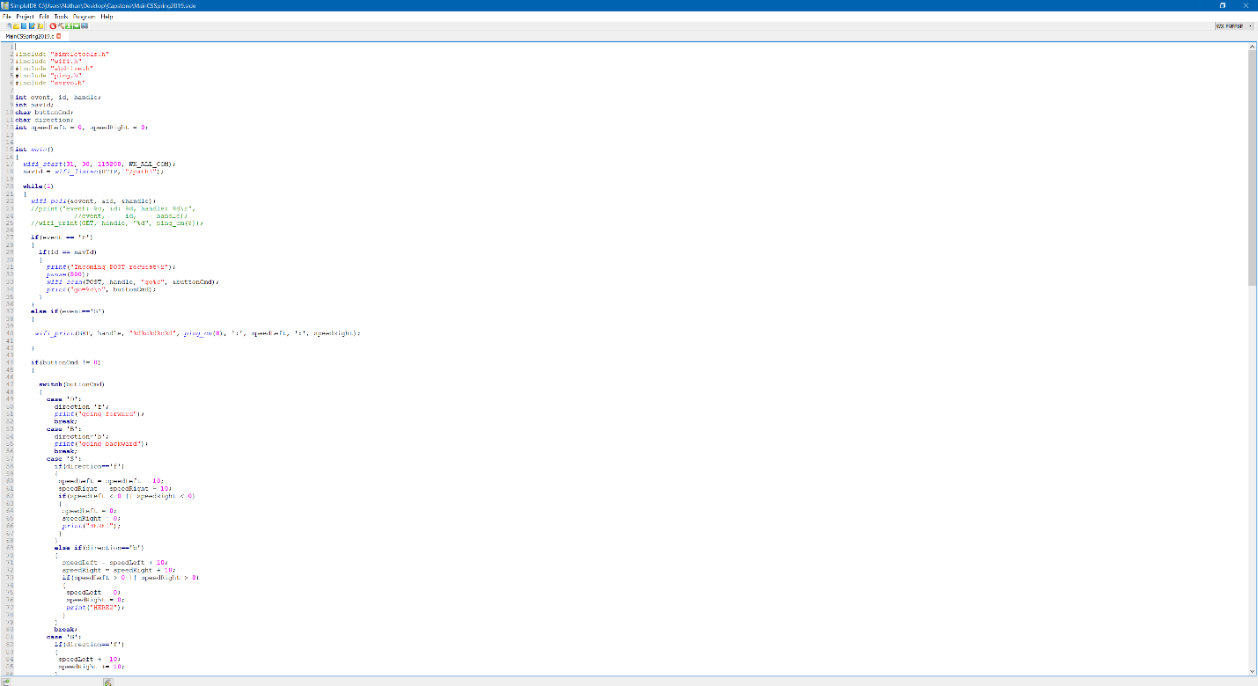

- Above is the SimpleIDE environment. To build and send C code over to the bot, you must have the proper module selected. If your bot is connected via USB to micro USB, or not wireless you will need to select a COM port.
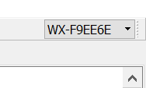

- Above is the port select dropdown. When you select the dropdown, it will automatically search for ports. For the program to work, you must select the Wi-Fi port shown above. If you plan to program without wireless capability, connect the USB to micro USB cord to the bot and the proper COM port will show in the dropdown.
- There are three ways to build, compile and the send the program to the bot:
  - BUILD and LOAD to EEPROM – this builds and sends the program to a more permanent storage on the bot. Do this only if you know the program is a final, working product.
  - BUILD and LOAD to RAM – this builds and sends the program to a more temporary storage on the bot. Do this when you are testing something.
  - BUILD and RUN with Terminal – this build and sends the program to the bot’s RAM, allowing for terminal outputs within the SimpleIDE. Use this when your program has test outputs and different variables within the code.
- Once the code has been executed, go to (or upload) the associated HTML file to the bot to begin operations
  - If auto.c is built and executed, go to the uploaded auto.html
  - If manual.c is built and executed, go to the uploaded manual.html

